Design of Data Warehouse

1.1 Logical Design

1.1.1 Original Database
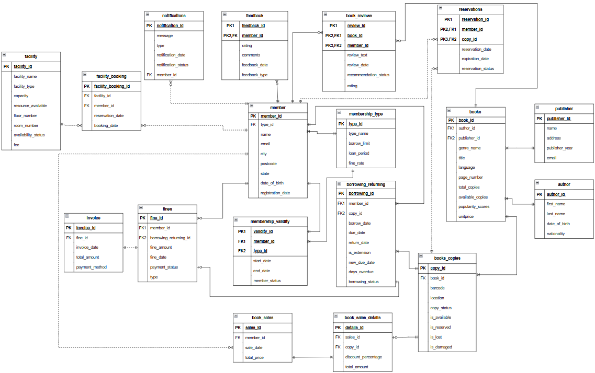

1.1.2 Star Schema Dimension and Fact Tables
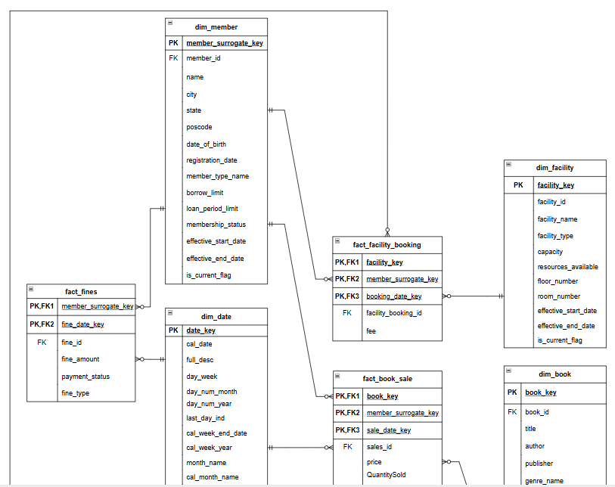
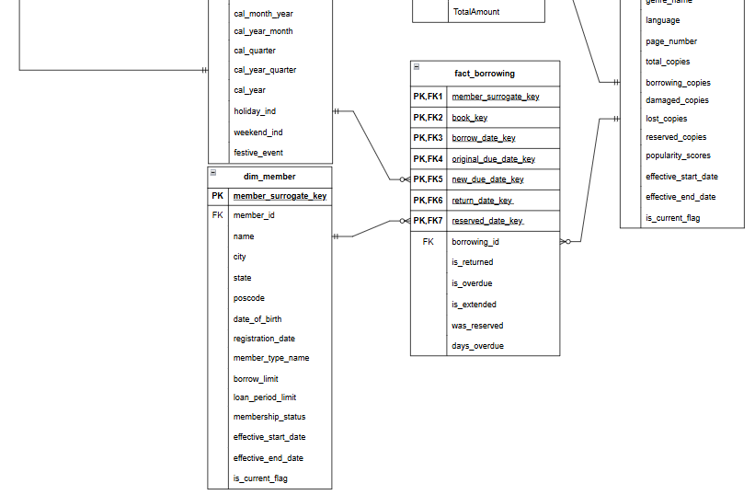

1.2 Physical Design

1.2.1 Dimension Tables

Date Dimension Table
CREATE TABLE dim_date (
date_key NUMBER NOT NULL,
cal_date DATE NOT NULL,
full_desc VARCHAR2(30) NOT NULL,
day_week NUMBER(1) NOT NULL,
day_num_month NUMBER(2) NOT NULL,
day_num_year NUMBER(3) NOT NULL,
last_day_ind CHAR(1) NOT NULL,
cal_week_end_date DATE NOT NULL,
cal_week_year NUMBER(2) NOT NULL,
cal_month_name VARCHAR2(9) NOT NULL,
cal_month_year NUMBER(2) NOT NULL,
cal_year_month CHAR(7) NOT NULL,
cal_quarter CHAR(2) NOT NULL,
cal_year_quarter CHAR(7) NOT NULL,
cal_year NUMBER(4) NOT NULL,
holiday_ind CHAR(1) NOT NULL,
weekend_ind CHAR(1) NOT NULL,
festive_event VARCHAR2(22) NOT NULL,
CONSTRAINT dim_date_pk PRIMARY KEY (date_key)
);

Member Dimension Table
CREATE TABLE dim_member (
member_surrogate_key NUMBER NOT NULL,
member_id VARCHAR2(10) NOT NULL,
name VARCHAR2(28) NOT NULL,
city VARCHAR2(20) NOT NULL,
state VARCHAR2(18) NOT NULL,
postcode VARCHAR2(9) NOT NULL,
date_of_birth DATE NOT NULL,
registration_date DATE NOT NULL,
member_type_name VARCHAR2(10) NOT NULL CHECK(member_type_name IN ('STANDARD', 'SILVER', 'PREMIUM', 'GOLD')),
borrow_limit NUMBER(2) NOT NULL CHECK(borrow_limit > 0),
loan_period_limit NUMBER(2) NOT NULL CHECK(loan_period_limit > 0),
membership_status VARCHAR2(10) NOT NULL CHECK(membership_status IN ('ACTIVE', 'INACTIVE', 'EXPIRED')),
effective_start_date DATE NOT NULL,
effective_end_date DATE DEFAULT TO_DATE('9999-12-31','YYYY-MM-DD') NOT NULL,
is_current_flag CHAR(1) DEFAULT 'Y' NOT NULL CHECK(is_current_flag IN ('Y', 'N')),
CONSTRAINT dim_member_pk PRIMARY KEY (member_surrogate_key),
CONSTRAINT dim_member_fk FOREIGN KEY (member_id) REFERENCES member (member_id)
);

Facility Dimension Table
CREATE TABLE dim_facility (
facility_key NUMBER NOT NULL,
facility_id VARCHAR2(7) NOT NULL,
facility_name VARCHAR2(50) NOT NULL,
facility_type VARCHAR2(18) NOT NULL,
capacity NUMBER(2) NOT NULL CHECK(capacity > 0),
resources_available VARCHAR2(40) NOT NULL,
floor_number NUMBER(1) NOT NULL CHECK(floor_number BETWEEN 1 AND 3),
room_number VARCHAR2(5) NOT NULL,
effective_start_date DATE NOT NULL,
effective_end_date DATE DEFAULT TO_DATE('9999-12-31','YYYY-MM-DD') NOT NULL,
is_current_flag CHAR(1) DEFAULT 'Y' NOT NULL CHECK(is_current_flag IN ('Y', 'N')),
CONSTRAINT dim_facility_id_pk PRIMARY KEY (facility_key),
CONSTRAINT dim_facility_id_fk FOREIGN KEY (facility_id) REFERENCES facility (facility_id)
);

Book Dimension Table
CREATE TABLE dim_book (
book_key NUMBER NOT NULL,
book_id VARCHAR2(10) NOT NULL,
title VARCHAR2(40) NOT NULL,
author VARCHAR2(30) NOT NULL,
publisher VARCHAR2(38) NOT NULL,
genre_name VARCHAR2(20) NOT NULL,
language VARCHAR2(13) NOT NULL,
page_number NUMBER(3) NOT NULL CHECK(page_number > 49),
total_copies NUMBER(1) NOT NULL CHECK(total_copies > 0),
borrowing_copies NUMBER(1) NOT NULL CHECK(borrowing_copies >= 0),
damaged_copies NUMBER(1) NOT NULL CHECK(damaged_copies >= 0),
lost_copies NUMBER(1) NOT NULL CHECK(lost_copies >= 0),
reserved_copies NUMBER(1) NOT NULL CHECK(reserved_copies >= 0),
popularity_scores NUMBER(2,1) NOT NULL CHECK(popularity_scores > 0),
effective_start_date DATE NOT NULL,
effective_end_date DATE DEFAULT TO_DATE('9999-12-31','YYYY-MM-DD') NOT NULL,
is_current_flag CHAR(1) DEFAULT 'Y' NOT NULL CHECK(is_current_flag IN ('Y', 'N')),
CONSTRAINT dim_book_pk PRIMARY KEY (book_key),
CONSTRAINT dim_book_fk FOREIGN KEY (book_id) REFERENCES books (book_id)
);

1.2.2 Fact Table
Fines Fact
CREATE TABLE fact_fines (
member_surrogate_key NUMBER NOT NULL,
fine_date_key NUMBER NOT NULL,
fine_id VARCHAR2(10) NOT NULL,
fine_amount NUMBER(6,2) NOT NULL CHECK(fine_amount > 0),
payment_status VARCHAR2(18) NOT NULL CHECK(payment_status IN ('PAID', 'UNPAID')),
fine_type VARCHAR2(12) NOT NULL CHECK(fine_type IN ('LATE_RETURN', 'LOST_BOOK', 'DAMAGED')),
CONSTRAINT fact_fines_pk PRIMARY KEY (member_surrogate_key, fine_date_key, fine_id),
CONSTRAINT fact_fines_member_fk FOREIGN KEY (member_surrogate_key) REFERENCES dim_member (member_surrogate_key),
CONSTRAINT fact_fines_date_fk FOREIGN KEY (fine_date_key) REFERENCES dim_date (date_key),
CONSTRAINT fact_fines_fk FOREIGN KEY (fine_id) REFERENCES fines (fine_id)
);

Facility Booking Fact
CREATE TABLE fact_facility_booking (
facility_key NUMBER NOT NULL,
member_surrogate_key NUMBER NOT NULL,
booking_date_key NUMBER NOT NULL,
facility_booking_id VARCHAR2(10) NOT NULL,
fee NUMBER(2) NOT NULL CHECK(fee > 0),
CONSTRAINT fact_fbooking_pk PRIMARY KEY (facility_key, member_surrogate_key, booking_date_key, facility_booking_id),
CONSTRAINT fact_fbooking_facility_pk FOREIGN KEY (facility_key) REFERENCES dim_facility(facility_key),
CONSTRAINT fact_fbooking_member_pk FOREIGN KEY (member_surrogate_key) REFERENCES dim_member(member_surrogate_key),
CONSTRAINT fact_fbooking_date_pk FOREIGN KEY (booking_date_key) REFERENCES dim_date(date_key),
CONSTRAINT fact_fbooking_fk FOREIGN KEY (facility_booking_id) REFERENCES facility_booking (facility_booking_id)
);

Book Sales Fact
CREATE TABLE fact_book_sale (
book_key NUMBER NOT NULL,
member_surrogate_key NUMBER NOT NULL,
sale_date_key NUMBER NOT NULL,
sales_id VARCHAR2(7) NOT NULL,
unitprice NUMBER(4,1) NOT NULL,
QuantitySold NUMBER(1) NOT NULL CHECK(QuantitySold > 0),
discount_percentage NUMBER(3) NOT NULL CHECK(discount_percentage > 0),
TotalAmount NUMBER(5,2) NOT NULL CHECK(TotalAmount > 0),
CONSTRAINT fact_sale_pk PRIMARY KEY (book_key, member_surrogate_key, sale_date_key, sales_id),
CONSTRAINT fact_sale_book_fk FOREIGN KEY (book_key) REFERENCES dim_book (book_key),
CONSTRAINT fact_sale_member_fk FOREIGN KEY (member_surrogate_key) REFERENCES dim_member (member_surrogate_key),
CONSTRAINT fact_sale_date_fk FOREIGN KEY (sale_date_key) REFERENCES dim_date (date_key),
CONSTRAINT fact_sale_fk FOREIGN KEY (sales_id) REFERENCES book_sales (sales_id)
);

Borrowing Fact
CREATE TABLE fact_borrowing (
member_surrogate_key NUMBER NOT NULL,
book_key NUMBER NOT NULL,
borrow_date_key NUMBER NOT NULL,
original_due_date_key NUMBER NOT NULL,
new_due_date_key NUMBER,
return_date_key NUMBER,
reserved_date_key NUMBER,
borrowing_id VARCHAR2(8) NOT NULL,
is_returned CHAR(1) NOT NULL CHECK(is_returned IN ('Y', 'N')),
is_overdue CHAR(1) NOT NULL CHECK(is_overdue IN ('Y', 'N')),
is_extended CHAR(1) NOT NULL CHECK(is_extended IN ('Y', 'N')),
was_reserved CHAR(1) NOT NULL CHECK(was_reserved IN ('Y', 'N')),
days_overdue NUMBER NOT NULL CHECK(days_overdue >= 0),
CONSTRAINT fact_borrowing_pk PRIMARY KEY (member_surrogate_key, book_key, borrow_date_key, borrowing_id),
CONSTRAINT fact_borrowing_member_fk FOREIGN KEY (member_surrogate_key) REFERENCES dim_member (member_surrogate_key),
CONSTRAINT fact_borrowing_book_fk FOREIGN KEY (book_key) REFERENCES dim_book (book_key),
CONSTRAINT fact_borrowing_date_fk FOREIGN KEY (borrow_date_key) REFERENCES dim_date (date_key),
CONSTRAINT fact_borrowing_originaldue_fk FOREIGN KEY (original_due_date_key) REFERENCES dim_date (date_key),
CONSTRAINT fact_borrowing_newdue_fk FOREIGN KEY (new_due_date_key) REFERENCES dim_date (date_key),
CONSTRAINT fact_borrowing_return_fk FOREIGN KEY (return_date_key) REFERENCES dim_date (date_key),
CONSTRAINT fact_borrowing_reserved_fk FOREIGN KEY (reserved_date_key) REFERENCES dim_date (date_key),
CONSTRAINT fact_borrowing_fk FOREIGN KEY (borrowing_id) REFERENCES borrowing_returning (borrowing_id)
);

Extract, Transform, Load Process

2.1 Script for initial loading

Date Dimension Table
DROP SEQUENCE dim_date_seq;
CREATE SEQUENCE dim_date_seq
START WITH 100001
INCREMENT BY 1
NOCACHE;

DECLARE
-- Define the start and end date for the loop
v_start_date DATE := DATE '2016-01-01';
v_end_date DATE := DATE '2026-12-31';

-- Variables to hold calculated calendar attributes
v_date DATE;
v_full_desc VARCHAR2(40);
v_day_week NUMBER(1);
v_day_num_month NUMBER(2);
v_day_num_year NUMBER(3);
v_last_day_ind CHAR(1);
v_cal_week_end_date DATE;
v_cal_week_year NUMBER(2);
v_cal_month_name VARCHAR2(9);
v_cal_month_year NUMBER(2);
v_cal_year_month CHAR(7);
v_cal_quarter CHAR(2);
v_cal_year_quarter CHAR(7);
v_cal_year NUMBER(4);
v_holiday_ind CHAR(1);
v_weekend_ind CHAR(1);
v_festive_event VARCHAR2(50);
BEGIN
v_date := v_start_date;
WHILE v_date <= v_end_date LOOP
v_full_desc := TO_CHAR(v_date, 'FMDay, DD FMMonth YYYY');
-- of week (1=Monday..7=Sunday)
v_day_week := TO_CHAR(v_date, 'D');
v_day_num_month := TO_NUMBER(TO_CHAR(v_date,'DD'));
v_day_num_year := TO_NUMBER(TO_CHAR(v_date,'DDD'));
v_last_day_ind := CASE WHEN v_date = LAST_DAY(v_date) THEN 'Y' ELSE 'N' END;
v_cal_week_end_date := v_date + (7 - v_day_week);
v_cal_week_year := TO_NUMBER(TO_CHAR(v_date,'WW'));
v_cal_month_name := TO_CHAR(v_date,'Month');
v_cal_month_year := TO_NUMBER(TO_CHAR(v_date,'MM'));
v_cal_quarter := 'Q' || TO_CHAR(v_date,'Q');
v_cal_year := TO_NUMBER(TO_CHAR(v_date,'YYYY'));
v_cal_year_month := TO_CHAR(v_date,'YYYY') || '-' || TO_CHAR(v_date,'MM');
v_cal_year_quarter := TO_CHAR(v_date,'YYYY') || '-' || v_cal_quarter;
v_holiday_ind := 'N';
v_weekend_ind := CASE WHEN v_day_week IN (1,7) THEN 'Y' ELSE 'N' END;
v_festive_event := 'NONE';

-- Festive events
IF TO_CHAR(v_date,'MM-DD') = '01-01' THEN
v_holiday_ind := 'Y'; v_festive_event := 'NEW YEAR';
ELSIF TO_CHAR(v_date,'MM-DD') BETWEEN '01-29' AND '01-30' THEN
v_holiday_ind := 'Y'; v_festive_event := 'CHINESE NEW YEAR';
ELSIF TO_CHAR(v_date,'MM-DD') = '05-01' THEN
v_holiday_ind := 'Y'; v_festive_event := 'LABOUR DAY';
ELSIF TO_CHAR(v_date,'MM-DD') = '08-31' THEN
v_holiday_ind := 'Y'; v_festive_event := 'NATIONAL DAY';
ELSIF TO_CHAR(v_date,'MM-DD') = '09-16' THEN
v_holiday_ind := 'Y'; v_festive_event := 'MALAYSIA DAY';
ELSIF TO_CHAR(v_date,'MM-DD') = '12-25' THEN
v_holiday_ind := 'Y'; v_festive_event := 'CHRISTMAS';
ELSIF TO_CHAR(v_date,'MM-DD') BETWEEN '04-01' AND '04-02' THEN
v_holiday_ind := 'Y'; v_festive_event := 'HARI RAYA AIDILFITRI';
ELSIF TO_CHAR(v_date,'MM-DD') = '06-06' THEN
v_holiday_ind := 'Y'; v_festive_event := 'HARI RAYA HAJI';
ELSIF TO_CHAR(v_date,'MM-DD') = '07-27' THEN
v_holiday_ind := 'Y'; v_festive_event := 'AWAL MUHARRAM';
ELSIF TO_CHAR(v_date,'MM-DD') = '09-05' THEN
v_holiday_ind := 'Y'; v_festive_event := 'MAULIDUR RASUL';
ELSIF TO_CHAR(v_date,'MM-DD') = '05-12' THEN
v_holiday_ind := 'Y'; v_festive_event := 'WESAK';
ELSIF TO_CHAR(v_date,'MM-DD') = '01-14' THEN
v_holiday_ind := 'Y'; v_festive_event := 'THAIPUSAM';
ELSIF TO_CHAR(v_date,'MM-DD') = '10-20' THEN
v_holiday_ind := 'Y'; v_festive_event := 'DEEPAVALI';
END IF;

INSERT INTO dim_date (
date_key,
cal_date,
full_desc,
day_week,
day_num_month,
day_num_year,
last_day_ind,
cal_week_end_date,
cal_week_year,
cal_month_name,
cal_month_year,
cal_year_month,
cal_quarter,
cal_year_quarter,
cal_year,
holiday_ind,
weekend_ind,
festive_event
) VALUES (
dim_date_seq.NEXTVAL,
v_date,
v_full_desc,
v_day_week,
v_day_num_month,
v_day_num_year,
v_last_day_ind,
v_cal_week_end_date,
v_cal_week_year,
v_cal_month_name,
v_cal_month_year,
v_cal_year_month,
v_cal_quarter,
v_cal_year_quarter,
v_cal_year,
v_holiday_ind,
v_weekend_ind,
v_festive_event
);

v_date := v_date + 1;
END LOOP;

COMMIT;
END;
/

Member Dimension Table
DROP SEQUENCE dim_member_seq;
CREATE SEQUENCE dim_member_seq
START WITH 100001
INCREMENT BY 1
NOCACHE;

INSERT INTO dim_member (
member_surrogate_key,
member_id,
name,
city,
state,
postcode,
date_of_birth,
registration_date,
member_type_name,
borrow_limit,
loan_period_limit,
membership_status,
effective_start_date,
effective_end_date,
is_current_flag
)
SELECT dim_member_seq.NEXTVAL,
m.member_id,
UPPER(TRIM(m.name)),
UPPER(TRIM(m.city)),
UPPER(TRIM(m.state)),
m.postcode,
m.date_of_birth,
m.registration_date,
UPPER(TRIM(t.type_name)),
t.borrow_limit,
t.loan_period,
UPPER(v.member_status),
v.start_date,
NVL(v.end_date, DATE '9999-12-31'),
'Y'
FROM member m
JOIN membership_type t ON m.type_id = t.type_id
JOIN membership_validity v ON m.member_id = v.member_id;

Facility Dimension Table
DROP SEQUENCE dim_facility_seq;
CREATE SEQUENCE dim_facility_seq
START WITH 100001
INCREMENT BY 1
NOCACHE;

INSERT INTO dim_facility (
facility_key,
facility_id,
facility_name,
facility_type,
capacity,
resources_available,
floor_number,
room_number,
effective_start_date,
effective_end_date,
is_current_flag
)
SELECT dim_facility_seq.NEXTVAL,
f.facility_id,
UPPER(TRIM(f.facility_name)),
UPPER(TRIM(f.facility_type)),
f.capacity,
NVL(f.resources_available, 'NONE'),
f.floor_number,
f.room_number,
DATE '2016-01-01',
DATE '9999-12-31',
'Y'
FROM facility f;

Book Dimension Table
DROP SEQUENCE dim_book_seq;
CREATE SEQUENCE dim_book_seq
START WITH 100001
INCREMENT BY 1
NOCACHE;

INSERT INTO dim_book (
book_key,
book_id,
title,
author,
publisher,
genre_name,
language,
page_number,
total_copies,
borrowing_copies,
damaged_copies,
lost_copies,
reserved_copies,
popularity_scores,
effective_start_date,
effective_end_date,
is_current_flag
)
SELECT dim_book_seq.NEXTVAL,
b.book_id,
UPPER(TRIM(b.title)) AS title,
UPPER(a.first_name || ' ' || a.last_name) AS author,
UPPER(TRIM(p.name)) AS publisher,
UPPER(TRIM(b.genre_name)) AS genre_name,
UPPER(TRIM(b.language)) AS language,
b.page_number,
b.total_copies,
bc.borrowing_copies,
bc.damaged_copies,
bc.lost_copies,
bc.reserved_copies,
b.popularity_scores,
DATE '2016-01-01',
DATE '9999-12-31',
'Y' AS is_current_flag
FROM books b
JOIN author a ON b.author_id = a.author_id
JOIN publisher p ON b.publisher_id = p.publisher_id
JOIN (
SELECT book_id,
SUM(CASE WHEN copy_status = 'BORROWED' THEN 1 ELSE 0 END) AS borrowing_copies,
SUM(CASE WHEN copy_status = 'DAMAGED' THEN 1 ELSE 0 END) AS damaged_copies,
SUM(CASE WHEN copy_status = 'LOST' THEN 1 ELSE 0 END) AS lost_copies,
SUM(CASE WHEN copy_status = 'RESERVED' THEN 1 ELSE 0 END) AS reserved_copies
FROM books_copies
GROUP BY book_id
) bc ON b.book_id = bc.book_id;

Fines Fact
INSERT INTO fact_fines (
member_surrogate_key,
fine_date_key,
fine_id,
fine_amount,
payment_status,
fine_type
)
SELECT dm.member_surrogate_key,
dd.date_key,
f.fine_id,
f.fine_amount,
UPPER(TRIM(f.payment_status)),
UPPER(TRIM(f.type))
FROM fines f
JOIN dim_member dm ON dm.member_id = f.member_id
JOIN dim_date dd ON dd.cal_date = f.fine_date;

Facility Booking Fact
INSERT INTO fact_facility_booking (
facility_key,
member_surrogate_key,
booking_date_key,
facility_booking_id,
fee
)
SELECT df.facility_key,
dm.member_surrogate_key,
dd.date_key,
fb.facility_booking_id,
f.fee
FROM facility_booking fb
JOIN facility f ON fb.facility_id = f.facility_id
JOIN dim_facility df ON df.facility_id = f.facility_id
JOIN member m ON fb.member_id = m.member_id
JOIN dim_member dm ON dm.member_id = m.member_id
JOIN dim_date dd ON dd.cal_date = fb.booking_date;

Book Sales Fact
INSERT INTO fact_book_sale (
book_key,
member_surrogate_key,
sale_date_key,
sales_id,
unitprice,
quantitysold,
discount_percentage,
totalamount
)
SELECT db.book_key,
dm.member_surrogate_key,
dd.date_key,
s.sales_id,
b.unitprice,
COUNT(c.copy_id) AS quantitysold,
d.discount_percentage,
SUM(d.total_amount) AS totalamount
FROM book_sales s
JOIN book_sales_details d ON s.sales_id = d.sales_id
JOIN books_copies c ON d.copy_id = c.copy_id
JOIN books b ON c.book_id = b.book_id
JOIN dim_book db ON db.book_id = b.book_id
JOIN member m ON s.member_id = m.member_id
JOIN dim_member dm ON dm.member_id = m.member_id
JOIN dim_date dd ON dd.cal_date = s.sales_date
GROUP BY db.book_key, dm.member_surrogate_key, dd.date_key, s.sales_id, b.unitprice, d.discount_percentage;

Borrowing Fact
INSERT INTO fact_borrowing (
member_surrogate_key,
book_key,
borrow_date_key,
original_due_date_key,
new_due_date_key,
return_date_key,
reserved_date_key,
borrowing_id,
is_returned,
is_overdue,
is_extended,
was_reserved,
days_overdue
)
SELECT dm.member_surrogate_key,
db.book_key,
dd_borrow.date_key,
dd_due.date_key,
dd_newdue.date_key,
dd_return.date_key,
dd_res.date_key,
br.borrowing_id,
CASE WHEN br.return_date IS NOT NULL THEN 'Y' ELSE 'N' END AS is_returned,
CASE WHEN NVL(br.days_overdue,0) > 0 THEN 'Y' ELSE 'N' END AS is_overdue,
br.is_extension AS is_extended,
CASE WHEN r.reservation_id IS NOT NULL THEN 'Y' ELSE 'N' END AS was_reserved,
NVL(br.days_overdue,0) AS days_overdue
FROM borrowing_returning br
JOIN member m ON br.member_id = m.member_id
JOIN dim_member dm ON dm.member_id = m.member_id AND dm.is_current_flag = 'Y'
JOIN books_copies c ON br.copy_id = c.copy_id
JOIN books b ON c.book_id = b.book_id
JOIN dim_book db ON db.book_id = b.book_id AND db.is_current_flag = 'Y'
JOIN dim_date dd_borrow ON dd_borrow.cal_date = br.borrow_date
JOIN dim_date dd_due ON dd_due.cal_date = br.due_date
LEFT JOIN dim_date dd_newdue ON dd_newdue.cal_date = br.new_due_date
LEFT JOIN dim_date dd_return ON dd_return.cal_date = br.return_date
LEFT JOIN reservations r ON r.copy_id = br.copy_id AND r.member_id = br.member_id
LEFT JOIN dim_date dd_res ON dd_res.cal_date = r.reservation_date;

2.2 Script for subsequent loading
Date Dimension Table
DROP PROCEDURE load_dim_date;
CREATE OR REPLACE PROCEDURE load_dim_date AS
v_start_date DATE := DATE '2016-01-01';
v_end_date DATE := DATE '2027-12-31';
v_date DATE := v_start_date;
v_count NUMBER;
BEGIN
WHILE v_date <= v_end_date LOOP
-- Check if date already exists using PL/SQL syntax
SELECT COUNT(*) INTO v_count
FROM dim_date
WHERE cal_date = v_date;

IF v_count = 0 THEN
INSERT INTO dim_date (
date_key,
cal_date,
full_desc,
day_week,
day_num_month,
day_num_year,
last_day_ind,
cal_week_end_date,
cal_week_year,
cal_month_name,
cal_month_year,
cal_year_month,
cal_quarter,
cal_year_quarter,
cal_year,
holiday_ind,
weekend_ind,
festive_event
)
VALUES (
dim_date_seq.NEXTVAL,
v_date,
TO_CHAR(v_date, 'FMDay, DD FMMonth YYYY'),
TO_CHAR(v_date, 'D'),
TO_NUMBER(TO_CHAR(v_date,'DD')),
TO_NUMBER(TO_CHAR(v_date,'DDD')),
CASE WHEN v_date = LAST_DAY(v_date) THEN 'Y' ELSE 'N' END,
NEXT_DAY(v_date, 'SATURDAY'),
TO_NUMBER(TO_CHAR(v_date,'WW')),
TO_CHAR(v_date,'Month'),
TO_NUMBER(TO_CHAR(v_date,'MM')),
TO_CHAR(v_date,'YYYY') || '-' || TO_CHAR(v_date,'MM'),
'Q' || TO_CHAR(v_date,'Q'),
TO_CHAR(v_date,'YYYY') || '-' || 'Q' || TO_CHAR(v_date,'Q'),
TO_NUMBER(TO_CHAR(v_date,'YYYY')),
'N',
CASE WHEN TO_CHAR(v_date,'D') IN ('1','7') THEN 'Y' ELSE 'N' END,
'NONE'
);
END IF;
v_date := v_date + 1;
END LOOP;
COMMIT;
END load_dim_date;
/

Member Dimension Table
DROP PROCEDURE load_dim_member;
CREATE OR REPLACE PROCEDURE load_dim_member AS
BEGIN
INSERT INTO dim_member (
member_surrogate_key,
member_id,
name,
city,
state,
postcode,
date_of_birth,
registration_date,
member_type_name,
borrow_limit,
loan_period_limit,
membership_status,
effective_start_date,
effective_end_date,
is_current_flag
)
SELECT dim_member_seq.NEXTVAL,
m.member_id,
UPPER(TRIM(m.name)),
UPPER(TRIM(m.city)),
UPPER(TRIM(m.state)),
m.postcode,
m.date_of_birth,
m.registration_date,
UPPER(TRIM(t.type_name)),
t.borrow_limit,
t.loan_period,
UPPER(v.member_status),
v.start_date,
NVL(v.end_date, DATE '9999-12-31'),
'Y'
FROM member m
JOIN membership_type t
ON m.type_id = t.type_id
JOIN membership_validity v
ON m.member_id = v.member_id
WHERE NOT EXISTS (
SELECT 1
FROM dim_member d
WHERE d.member_id = m.member_id
);

COMMIT;
END;
/

Facility Dimension Table
DROP PROCEDURE load_dim_facility;
CREATE OR REPLACE PROCEDURE load_dim_facility AS
BEGIN
INSERT INTO dim_facility (
facility_key,
facility_id,
facility_name,
facility_type,
capacity,
resources_available,
floor_number,
room_number,
effective_start_date,
effective_end_date,
is_current_flag
)
SELECT dim_facility_seq.NEXTVAL,
f.facility_id,
UPPER(TRIM(f.facility_name)),
UPPER(TRIM(f.facility_type)),
f.capacity,
NVL(f.resources_available,'NONE'),
f.floor_number,
f.room_number,
SYSDATE,
DATE '9999-12-31',
'Y'
FROM facility f
WHERE NOT EXISTS (
SELECT 1
FROM dim_facility d
WHERE d.facility_id = f.facility_id
);

COMMIT;
END;
/

Book Dimension Table
DROP PROCEDURE load_dim_book;
CREATE OR REPLACE PROCEDURE load_dim_book AS
BEGIN
INSERT INTO dim_book (
book_key,
book_id,
title,
author,
publisher,
genre_name,
language,
page_number,
total_copies,
borrowing_copies,
damaged_copies,
lost_copies,
reserved_copies,
popularity_scores,
effective_start_date,
effective_end_date,
is_current_flag
)
SELECT
dim_book_seq.NEXTVAL,
b.book_id,
b.title,
a.first_name || ' ' || a.last_name AS author,
p.name AS publisher,
b.genre_name,
b.language,
b.page_number,
b.total_copies,
CASE WHEN c.copy_status = 'BORROWED' THEN 1 ELSE 0 END AS borrowing_copies,
CASE WHEN c.copy_status = 'DAMAGED' THEN 1 ELSE 0 END AS damaged_copies,
CASE WHEN c.copy_status = 'LOST' THEN 1 ELSE 0 END AS lost_copies,
CASE WHEN c.copy_status = 'RESERVED' THEN 1 ELSE 0 END AS reserved_copies,
b.popularity_scores,
SYSDATE,
DATE '9999-12-31',
'Y'
FROM books b
JOIN books_copies c ON b.book_id = c.book_id
JOIN author a ON b.author_id = a.author_id
JOIN publisher p ON b.publisher_id = p.publisher_id
WHERE NOT EXISTS (
SELECT 1
FROM dim_book d
WHERE d.book_id = b.book_id
);

COMMIT;
END;
/

Fines Fact
DROP PROCEDURE load_fact_fines;
CREATE OR REPLACE PROCEDURE load_fact_fines AS
BEGIN
INSERT INTO fact_fines (
member_surrogate_key,
fine_date_key,
fine_id,
fine_amount,
payment_status,
fine_type
)
SELECT dm.member_surrogate_key,
dd.date_key,
f.fine_id,
f.fine_amount,
UPPER(TRIM(f.payment_status)),
UPPER(TRIM(f.type))
FROM fines f
JOIN dim_member dm ON dm.member_id = f.member_id AND dm.is_current_flag = 'Y'
JOIN dim_date dd ON dd.cal_date = f.fine_date
WHERE NOT EXISTS (
SELECT 1 FROM fact_fines ff WHERE ff.fine_id = f.fine_id
);

COMMIT;
END;
/

Facility Booking Fact
DROP PROCEDURE load_fact_facility_booking;
CREATE OR REPLACE PROCEDURE load_fact_facility_booking AS
BEGIN
INSERT INTO fact_facility_booking (
facility_key,
member_surrogate_key,
booking_date_key,
facility_booking_id,
fee
)
SELECT df.facility_key,
dm.member_surrogate_key,
dd.date_key,
fb.facility_booking_id,
f.fee
FROM facility_booking fb
JOIN facility f ON fb.facility_id = f.facility_id
JOIN dim_facility df ON df.facility_id = f.facility_id
JOIN member m ON fb.member_id = m.member_id
JOIN dim_member dm ON dm.member_id = m.member_id
JOIN dim_date dd ON dd.cal_date = fb.booking_date
WHERE NOT EXISTS (
SELECT 1
FROM fact_facility_booking ff
WHERE ff.facility_booking_id = fb.facility_booking_id
);

COMMIT;
END;
/

Book Sales Fact
DROP PROCEDURE load_fact_book_sale;
CREATE OR REPLACE PROCEDURE load_fact_book_sale AS
BEGIN
INSERT INTO fact_book_sale (
book_key,
member_surrogate_key,
sale_date_key,
sales_id,
unitprice,
quantitysold,
discount_percentage,
totalamount
)
SELECT db.book_key,
dm.member_surrogate_key,
dd.date_key,
s.sales_id,
b.unitprice,
COUNT(c.copy_id) AS quantitysold,
d.discount_percentage,
ROUND(b.unitprice * COUNT(c.copy_id) * (1 - (d.discount_percentage/100)),1) AS totalamount
FROM book_sales s
JOIN book_sales_details d ON s.sales_id = d.sales_id
JOIN books_copies c ON d.copy_id = c.copy_id
JOIN books b ON c.book_id = b.book_id
JOIN dim_book db ON db.book_id = b.book_id
JOIN member m ON s.member_id = m.member_id
JOIN dim_member dm ON dm.member_id = m.member_id
JOIN dim_date dd ON dd.cal_date = s.sales_date
WHERE NOT EXISTS (
SELECT 1
FROM fact_book_sale f
WHERE f.sales_id = s.sales_id
)
GROUP BY db.book_key, dm.member_surrogate_key, dd.date_key, s.sales_id, b.unitprice, d.discount_percentage;

COMMIT;
END;
/

Borrowing Fact
DROP PROCEDURE load_fact_borrowing;
CREATE OR REPLACE PROCEDURE load_fact_borrowing AS
BEGIN
INSERT INTO fact_borrowing (
member_surrogate_key,
book_key,
borrow_date_key,
original_due_date_key,
new_due_date_key,
return_date_key,
reserved_date_key,
borrowing_id,
is_returned,
is_overdue,
is_extended,
was_reserved,
days_overdue
)
SELECT dm.member_surrogate_key,
db.book_key,
dd_borrow.date_key,
dd_due.date_key,
dd_newdue.date_key,
dd_return.date_key,
dd_res.date_key,
br.borrowing_id,
CASE WHEN br.return_date IS NOT NULL THEN 'Y' ELSE 'N' END,
CASE WHEN NVL(br.days_overdue,0) > 0 THEN 'Y' ELSE 'N' END,
br.is_extension,
CASE WHEN r.reservation_id IS NOT NULL THEN 'Y' ELSE 'N' END,
NVL(br.days_overdue,0)
FROM borrowing_returning br
JOIN member m ON br.member_id = m.member_id
JOIN dim_member dm ON dm.member_id = m.member_id AND dm.is_current_flag = 'Y'
JOIN books_copies c ON br.copy_id = c.copy_id
JOIN books b ON c.book_id = b.book_id
JOIN dim_book db ON db.book_id = b.book_id AND db.is_current_flag = 'Y'
JOIN dim_date dd_borrow ON dd_borrow.cal_date = br.borrow_date
JOIN dim_date dd_due ON dd_due.cal_date = br.due_date
LEFT JOIN dim_date dd_newdue ON dd_newdue.cal_date = br.new_due_date
LEFT JOIN dim_date dd_return ON dd_return.cal_date = br.return_date
LEFT JOIN reservations r ON r.copy_id = br.copy_id AND r.member_id = br.member_id
LEFT JOIN dim_date dd_res ON dd_res.cal_date = r.reservation_date
WHERE NOT EXISTS (
SELECT 1 FROM fact_borrowing fb WHERE fb.borrowing_id = br.borrowing_id
);

COMMIT;
END;
/

-- Insert new members and membership_validity
DECLARE
v_member_seq_val1 VARCHAR2(10);
v_member_seq_val2 VARCHAR2(10);
v_validity_seq_val1 VARCHAR2(10);
v_validity_seq_val2 VARCHAR2(10);
BEGIN
v_member_seq_val1 := 'M' || LPAD(member_seq.NEXTVAL, 4, '0');
INSERT INTO member (member_id, type_id, name, email, city, postcode, state, date_of_birth, registration_date)
VALUES (v_member_seq_val1, 'MT002', 'Jane Lo', 'janelo@gmail.com', 'Sibu', 96000, 'Sarawak', TO_DATE('1999-01-01','YYYY-MM-DD'), TO_DATE('2025-09-01','YYYY-MM-DD'));

v_validity_seq_val1 := 'V' || LPAD(member_seq.CURRVAL, 4, '0');
INSERT INTO membership_validity (validity_id, member_id, type_id, start_date, end_date, member_status)
VALUES (v_validity_seq_val1, v_member_seq_val1, 'MT002', TO_DATE('2025-09-01','YYYY-MM-DD'), TO_DATE('2026-09-01','YYYY-MM-DD'), 'Active');

v_member_seq_val2 := 'M' || LPAD(member_seq.NEXTVAL, 4, '0');
INSERT INTO member (member_id, type_id, name, email, city, postcode, state, date_of_birth, registration_date)
VALUES (v_member_seq_val2, 'MT004', 'Shereen Foo', 'shereenfoo@gmail.com', 'Kluang', 86000, 'Johor', TO_DATE('1992-11-13','YYYY-MM-DD'), TO_DATE('2025-09-03','YYYY-MM-DD'));

v_validity_seq_val2 := 'V' || LPAD(member_seq.CURRVAL, 4, '0');
INSERT INTO membership_validity (validity_id, member_id, type_id, start_date, end_date, member_status)
VALUES (v_validity_seq_val2, v_member_seq_val2, 'MT004', TO_DATE('2025-09-03','YYYY-MM-DD'), TO_DATE('2026-09-03','YYYY-MM-DD'), 'Active');

COMMIT;
END;
/

-- Insert new facilities
BEGIN
INSERT INTO facility (facility_id, facility_name, facility_type, capacity, resources_available, floor_number, room_number, availability_status, fee)
VALUES ('FC041', 'Individual Study Room 11', 'Study Room', 1, NULL, 3, 'SR11', 'Available', 5);

INSERT INTO facility (facility_id, facility_name, facility_type, capacity, resources_available, floor_number, room_number, availability_status, fee)
VALUES ('FC042', 'Discussion Room 21', 'Discussion Room', 8, 'Two Desktop Computer', 1, 'DR21', 'Available', 18);

COMMIT;
END;
/

-- Insert new books and copies
DECLARE
v_book_id1 VARCHAR2(10);
v_copy_id1 VARCHAR2(7);
v_book_id2 VARCHAR2(10);
v_copy_id2 VARCHAR2(7);
BEGIN
v_book_id1 := 'B' || LPAD(books_seq.NEXTVAL, 5, '0');
INSERT INTO books (book_id, author_id, publisher_id, genre_name, title, language, page_number, total_copies, available_copies, popularity_scores, unitprice)
VALUES (v_book_id1, 'A0100', 'P020', 'Historical Fiction', 'The Underground Railroad', 'English', 250, 2, 2, 9.5, 80);

v_copy_id1 := 'C' || LPAD(copies_seq.NEXTVAL, 5, '0');
INSERT INTO books_copies (copy_id, book_id, barcode, location, copy_status, is_available, is_reserved, is_lost, is_damaged)
VALUES (v_copy_id1, v_book_id1, '291142669', 'Shelf D1', 'AVAILABLE', 'Y', 'N', 'N', 'N');

v_book_id2 := 'B' || LPAD(books_seq.NEXTVAL, 5, '0');
INSERT INTO books (book_id, author_id, publisher_id, genre_name, title, language, page_number, total_copies, available_copies, popularity_scores, unitprice)
VALUES (v_book_id2, 'A0085', 'P012', 'Adventure', 'Fantastic Mr Fox', 'English', 150, 2, 2, 9.2, 85);

v_copy_id2 := 'C' || LPAD(copies_seq.NEXTVAL, 5, '0');
INSERT INTO books_copies (copy_id, book_id, barcode, location, copy_status, is_available, is_reserved, is_lost, is_damaged)
VALUES (v_copy_id2, v_book_id2, '291142670', 'Shelf K1', 'AVAILABLE', 'Y', 'N', 'N', 'N');

COMMIT;
END;
/

-- Insert borrowing and fines
DECLARE
v_borrowing_id1 VARCHAR2(14);
v_borrowing_id2 VARCHAR2(14);
v_fine_id1 VARCHAR2(10);
v_fine_id2 VARCHAR2(10);
BEGIN
v_borrowing_id1 := 'R' || LPAD(borrowing_seq.NEXTVAL, 6, '0');
v_fine_id1 := 'FN' || LPAD(fines_seq.NEXTVAL, 5, '0');
INSERT INTO borrowing_returning (borrowing_id, member_id, copy_id, borrow_date, due_date, return_date, is_extension, new_due_date, days_overdue, borrowing_status)
VALUES (v_borrowing_id1, 'M2863', 'C15001', TO_DATE('2025-09-02','YYYY-MM-DD'), TO_DATE('2025-09-08','YYYY-MM-DD'), TO_DATE('2025-09-06','YYYY-MM-DD'), 'N', NULL, NULL, 'RETURNED_DAMAGED');
INSERT INTO fines (fine_id, member_id, borrowing_id, fine_amount, fine_date, payment_status, type)
VALUES (v_fine_id1, 'M2863', v_borrowing_id1, 80, TO_DATE('2025-09-06','YYYY-MM-DD'), 'Paid', 'DAMAGED');

v_borrowing_id2 := 'R' || LPAD(borrowing_seq.NEXTVAL, 6, '0');
v_fine_id2 := 'FN' || LPAD(fines_seq.NEXTVAL, 5, '0');
INSERT INTO borrowing_returning (borrowing_id, member_id, copy_id, borrow_date, due_date, return_date, is_extension, new_due_date, days_overdue, borrowing_status)
VALUES (v_borrowing_id2, 'M2889', 'C15002', TO_DATE('2025-09-03','YYYY-MM-DD'), TO_DATE('2025-09-12','YYYY-MM-DD'), TO_DATE('2025-09-10','YYYY-MM-DD'), 'N', NULL, NULL, 'RETURNED_DAMAGED');
INSERT INTO fines (fine_id, member_id, borrowing_id, fine_amount, fine_date, payment_status, type)
VALUES (v_fine_id2, 'M2889', v_borrowing_id2, 85, TO_DATE('2025-09-10','YYYY-MM-DD'), 'Unpaid', 'DAMAGED');

UPDATE books b
SET available_copies = b.total_copies - (
SELECT COUNT(*)
FROM books_copies c
JOIN borrowing_returning br ON br.copy_id = c.copy_id
WHERE c.book_id = b.book_id
AND br.borrowing_status IN ('RETURNED_DAMAGED','LOST_BOOK')
)
WHERE EXISTS (
SELECT 1
FROM books_copies c
JOIN borrowing_returning br ON br.copy_id = c.copy_id
WHERE c.book_id = b.book_id
AND br.borrowing_status IN ('RETURNED_DAMAGED','LOST_BOOK')
);

COMMIT;
END;
/

-- Insert facility bookings
DECLARE
v_booking_id1 VARCHAR2(10);
v_booking_id2 VARCHAR2(10);
BEGIN
v_booking_id1 := 'FB' || LPAD(booking_seq.NEXTVAL, 6, '0');
v_booking_id2 := 'FB' || LPAD(booking_seq.NEXTVAL, 6, '0');

INSERT INTO facility_booking (facility_booking_id, facility_id, member_id, reservation_date, booking_date)
VALUES (v_booking_id1, 'FC002', 'M1000', TO_DATE('2025-09-02','YYYY-MM-DD'), TO_DATE('2025-09-04','YYYY-MM-DD'));

INSERT INTO facility_booking (facility_booking_id, facility_id, member_id, reservation_date, booking_date)
VALUES (v_booking_id2, 'FC031', 'M2000', TO_DATE('2025-09-02','YYYY-MM-DD'), TO_DATE('2025-09-04','YYYY-MM-DD'));

COMMIT;
END;
/

-- Insert book sales and sales details
DECLARE
v_sales_id1 VARCHAR2(7);
v_sales_id2 VARCHAR2(7);
v_details_id1 VARCHAR2(10);
v_details_id2 VARCHAR2(10);
BEGIN
v_sales_id1 := 'S' || LPAD(sales_seq.NEXTVAL, 5, '0');
INSERT INTO book_sales (sales_id, member_id, sales_date, total_price)
VALUES (v_sales_id1, 'M2994', TO_DATE('2025-09-02','YYYY-MM-DD'), 70.5);

v_details_id1 := 'SD' || LPAD(sales_details_seq.NEXTVAL, 5, '0');
INSERT INTO book_sales_details (details_id, sales_id, copy_id, discount_percentage, total_amount)
VALUES (v_details_id1, v_sales_id1, 'C14998', 15, 70.5);

v_sales_id2 := 'S' || LPAD(sales_seq.NEXTVAL, 5, '0');
INSERT INTO book_sales (sales_id, member_id, sales_date, total_price)
VALUES (v_sales_id2, 'M2996', TO_DATE('2027-09-05','YYYY-MM-DD'), 68.5);

v_details_id2 := 'SD' || LPAD(sales_details_seq.NEXTVAL, 5, '0');
INSERT INTO book_sales_details (details_id, sales_id, copy_id, discount_percentage, total_amount)
VALUES (v_details_id2, v_sales_id2, 'C14997', 15, 77.9);

COMMIT;
END;
/

BEGIN
load_dim_date;
load_dim_member;
load_dim_facility;
load_dim_book;
load_fact_borrowing;
load_fact_fines;
load_fact_facility_booking;
load_fact_book_sale;
END;
/

2.3 Script for updating (Type 2 Changes)

2.3.1 Procedure to update member dimension table
DROP PROCEDURE prod_update_member_dim;
CREATE OR REPLACE PROCEDURE prod_update_member_dim (
v_member_id IN VARCHAR2,
v_name IN VARCHAR2,
v_city IN VARCHAR2,
v_state IN VARCHAR2,
v_postcode IN VARCHAR2,
v_date_of_birth IN DATE,
v_registration_date IN DATE,
v_member_type_name IN VARCHAR2,
v_borrow_limit IN NUMBER,
v_loan_period_limit IN NUMBER,
v_membership_status IN VARCHAR2,
v_validity_start IN DATE,
v_validity_end IN DATE
)
IS
v_current dim_member%ROWTYPE;
BEGIN
BEGIN
SELECT * INTO v_current
FROM dim_member
WHERE member_id = v_member_id AND is_current_flag = 'Y';

-- Compare fields
IF v_current.name != UPPER(TRIM(v_name)) OR
v_current.city != UPPER(TRIM(v_city)) OR
v_current.state != UPPER(TRIM(v_state)) OR
v_current.postcode != v_postcode OR
v_current.date_of_birth != v_date_of_birth OR
v_current.registration_date != v_registration_date OR
v_current.member_type_name != UPPER(TRIM(v_member_type_name)) OR
v_current.borrow_limit != v_borrow_limit OR
v_current.loan_period_limit != v_loan_period_limit OR
v_current.membership_status != UPPER(TRIM(v_membership_status)) OR
v_current.effective_start_date != v_validity_start OR
v_current.effective_end_date != NVL(v_validity_end, DATE '9999-12-31')
THEN
UPDATE dim_member
SET effective_end_date = SYSDATE,
is_current_flag = 'N'
WHERE member_surrogate_key = v_current.member_surrogate_key AND is_current_flag = 'Y';

INSERT INTO dim_member (
member_surrogate_key,
member_id,
name,
city,
state,
postcode,
date_of_birth,
registration_date,
member_type_name,
borrow_limit,
loan_period_limit,
membership_status,
effective_start_date,
effective_end_date,
is_current_flag
) VALUES (
dim_member_seq.NEXTVAL,
v_member_id,
UPPER(TRIM(v_name)),
UPPER(TRIM(v_city)),
UPPER(TRIM(v_state)),
v_postcode,
v_date_of_birth,
v_registration_date,
UPPER(TRIM(v_member_type_name)),
v_borrow_limit,
v_loan_period_limit,
UPPER(TRIM(v_membership_status)),
SYSDATE,
NVL(v_validity_end, DATE '9999-12-31'),
'Y'
);

COMMIT;
DBMS_OUTPUT.PUT_LINE('Member updated successfully.');
END IF;

EXCEPTION
WHEN NO_DATA_FOUND THEN
INSERT INTO dim_member (
member_surrogate_key,
member_id,
name,
city,
state,
postcode,
date_of_birth,
registration_date,
member_type_name,
borrow_limit,
loan_period_limit,
membership_status,
effective_start_date,
effective_end_date,
is_current_flag
) VALUES (
dim_member_seq.NEXTVAL,
v_member_id,
UPPER(TRIM(v_name)),
UPPER(TRIM(v_city)),
UPPER(TRIM(v_state)),
v_postcode,
v_date_of_birth,
v_registration_date,
UPPER(TRIM(v_member_type_name)),
v_borrow_limit,
v_loan_period_limit,
UPPER(TRIM(v_membership_status)),
SYSDATE,
NVL(v_validity_end, DATE '9999-12-31'),
'Y'
);

COMMIT;
DBMS_OUTPUT.PUT_LINE('New member inserted and no previous record found.');
END;

EXCEPTION
WHEN OTHERS THEN
ROLLBACK;
DBMS_OUTPUT.PUT_LINE('Error: ' || SQLERRM);
END prod_update_member_dim;
/

EXEC prod_update_member_dim('M3000', 'Louis Lo', 'Batu Pahat', 'Johor', 83000, TO_DATE('1999-01-02','YYYY-MM-DD'), TO_DATE('2025-09-07','YYYY-MM-DD'), 'STANDARD', 2, 3, 'Active', TO_DATE('2025-09-08','YYYY-MM-DD'), TO_DATE('2026-09-08','YYYY-MM-DD'));

2.3.2 Procedure to update facility dimension table
DROP PROCEDURE prod_update_facility_dim;

CREATE OR REPLACE PROCEDURE prod_update_facility_dim (
v_facility_id IN VARCHAR2,
v_new_name IN VARCHAR2,
v_new_type IN VARCHAR2,
v_new_capacity IN NUMBER,
v_new_resources IN VARCHAR2,
v_new_floor_number IN NUMBER,
v_new_room_number IN VARCHAR2
)
IS
v_current dim_facility%ROWTYPE;
BEGIN
BEGIN
SELECT * INTO v_current
FROM dim_facility
WHERE facility_id = v_facility_id AND is_current_flag = 'Y' ;

-- Compare each field
IF v_current.facility_name != UPPER(TRIM(v_new_name)) OR
v_current.facility_type != UPPER(TRIM(v_new_type)) OR
v_current.capacity != v_new_capacity OR
v_current.resources_available != NVL(v_new_resources, 'NONE') OR
v_current.floor_number != v_new_floor_number OR
v_current.room_number != v_new_room_number
THEN
UPDATE dim_facility
SET effective_end_date = SYSDATE,
is_current_flag = 'N'
WHERE facility_id = v_facility_id AND is_current_flag = 'Y';

INSERT INTO dim_facility (
facility_key,
facility_id,
facility_name,
facility_type,
capacity,
resources_available,
floor_number,
room_number,
effective_start_date,
effective_end_date,
is_current_flag
) VALUES (
dim_facility_seq.NEXTVAL,
v_facility_id,
UPPER(TRIM(v_new_name)),
UPPER(TRIM(v_new_type)),
v_new_capacity,
NVL(v_new_resources, 'NONE'),
v_new_floor_number,
v_new_room_number,
SYSDATE,
DATE '9999-12-31',
'Y'
);

COMMIT;
DBMS_OUTPUT.PUT_LINE('Facility updated successfully.');
END IF;

EXCEPTION
WHEN NO_DATA_FOUND THEN
-- No record found: insert as new
INSERT INTO dim_facility (
facility_key,
facility_id,
facility_name,
facility_type,
capacity,
resources_available,
floor_number,
room_number,
effective_start_date,
effective_end_date,
is_current_flag
) VALUES (
dim_facility_seq.NEXTVAL,
v_facility_id,
UPPER(TRIM(v_new_name)),
UPPER(TRIM(v_new_type)),
v_new_capacity,
NVL(v_new_resources, 'NONE'),
v_new_floor_number,
v_new_room_number,
SYSDATE,
DATE '9999-12-31',
'Y'
);

COMMIT;
DBMS_OUTPUT.PUT_LINE('New facility inserted and no previous record found.');
END;

EXCEPTION
WHEN OTHERS THEN
ROLLBACK;
DBMS_OUTPUT.PUT_LINE('Error: ' || SQLERRM);
END prod_update_facility_dim;
/

EXEC prod_update_facility_dim('FC040', 'Reading Room', 'Study Room', 1, NULL, 1, 'A1');

2.3.3 Procedure to update book dimension table
DROP PROCEDURE prod_update_book_dim;

CREATE OR REPLACE PROCEDURE prod_update_book_dim (
v_book_id IN VARCHAR2,
v_title IN VARCHAR2,
v_author IN VARCHAR2,
v_publisher IN VARCHAR2,
v_genre_name IN VARCHAR2,
v_language IN VARCHAR2,
v_page_number IN NUMBER,
v_total_copies IN NUMBER,
v_borrowing_copies IN NUMBER,
v_damaged_copies IN NUMBER,
v_lost_copies IN NUMBER,
v_reserved_copies IN NUMBER,
v_popularity_scores IN NUMBER
)
IS
v_current dim_book%ROWTYPE;
BEGIN
BEGIN
SELECT * INTO v_current
FROM dim_book
WHERE book_id = v_book_id AND is_current_flag = 'Y';

-- Compare all fields
IF v_current.title != UPPER(TRIM(v_title)) OR
v_current.author != UPPER(TRIM(v_author)) OR
v_current.publisher != UPPER(TRIM(v_publisher)) OR
v_current.genre_name != UPPER(TRIM(v_genre_name)) OR
v_current.language != UPPER(TRIM(v_language)) OR
v_current.page_number != v_page_number OR
v_current.total_copies != v_total_copies OR
v_current.borrowing_copies != v_borrowing_copies OR
v_current.damaged_copies != v_damaged_copies OR
v_current.lost_copies != v_lost_copies OR
v_current.reserved_copies != v_reserved_copies OR
v_current.popularity_scores != v_popularity_scores
THEN
UPDATE dim_book
SET effective_end_date = SYSDATE,
is_current_flag = 'N'
WHERE book_key = v_current.book_key AND is_current_flag = 'Y';

INSERT INTO dim_book (
book_key,
book_id,
title,
author,
publisher,
genre_name,
language,
page_number,
total_copies,
borrowing_copies,
damaged_copies,
lost_copies,
reserved_copies,
popularity_scores,
effective_start_date,
effective_end_date,
is_current_flag
) VALUES (
dim_book_seq.NEXTVAL,
v_book_id,
UPPER(TRIM(v_title)),
UPPER(TRIM(v_author)),
UPPER(TRIM(v_publisher)),
UPPER(TRIM(v_genre_name)),
UPPER(TRIM(v_language)),
v_page_number,
v_total_copies,
v_borrowing_copies,
v_damaged_copies,
v_lost_copies,
v_reserved_copies,
v_popularity_scores,
SYSDATE,
DATE '9999-12-31',
'Y'
);

COMMIT;
DBMS_OUTPUT.PUT_LINE('Book updated successfully.');
END IF;

EXCEPTION
WHEN NO_DATA_FOUND THEN
INSERT INTO dim_book (
book_key,
book_id,
title,
author,
publisher,
genre_name,
language,
page_number,
total_copies,
borrowing_copies,
damaged_copies,
lost_copies,
reserved_copies,
popularity_scores,
effective_start_date,
effective_end_date,
is_current_flag
) VALUES (
dim_book_seq.NEXTVAL,
v_book_id,
UPPER(TRIM(v_title)),
UPPER(TRIM(v_author)),
UPPER(TRIM(v_publisher)),
UPPER(TRIM(v_genre_name)),
UPPER(TRIM(v_language)),
v_page_number,
v_total_copies,
v_borrowing_copies,
v_damaged_copies,
v_lost_copies,
v_reserved_copies,
v_popularity_scores,
SYSDATE,
DATE '9999-12-31',
'Y'
);

COMMIT;
DBMS_OUTPUT.PUT_LINE('New book inserted and no previous record found.');
END;

EXCEPTION
WHEN OTHERS THEN
ROLLBACK;
DBMS_OUTPUT.PUT_LINE('Error: ' || SQLERRM);
END prod_update_book_dim;
/

EXEC prod_update_book_dim('B04999', 'The Art of Thinking Clearly', 'Nicole Smith', 'Hachette Book Group', 'Fiction', 'English', 220, 2, 0, 0, 0, 0, 9.5);

Business Analytics Reports

3.1.1 3-Year Book Sales Trend Analysis (2022 - 2024)
ACCEPT Start_Year PROMPT 'Enter the start year: '
ACCEPT End_Year PROMPT 'Enter the end year: '

SET PAGESIZE 35
SET LINESIZE 130

COLUMN genre_name FORMAT A20 HEADING 'Genre Name'
COLUMN year FORMAT 9999 HEADING 'Year'
COLUMN holiday_revenue FORMAT 999,990.99 HEADING 'Holiday|Revenue(RM)'
COLUMN regular_revenue FORMAT 999,990.99 HEADING 'Regular|Revenue(RM)'
COLUMN weekend_revenue FORMAT 999,990.99 HEADING 'Weekend|Revenue(RM)'
COLUMN total_revenue FORMAT 9,999,990.99 HEADING 'Total|Revenue(RM)'
COLUMN yoy_growth FORMAT 990.0 HEADING 'YoY|Growth(%)'
COLUMN contribution FORMAT 990.00 HEADING 'Contribution|(%)'

BREAK ON genre_name SKIP 1 ON REPORT
COMPUTE SUM LABEL 'Genre Total: ' OF holiday_revenue regular_revenue weekend_revenue total_revenue ON genre_name

TTITLE LEFT 'Date: ' _DATE SKIP 1 -
CENTER '3-Year Book Sales Trend Analysis (&Start_Year - &End_Year)' SKIP 1 -
RIGHT 'Page: ' SQL.PNO SKIP 2

CREATE OR REPLACE VIEW three_year_sales_trend_view AS
WITH yearly_sales AS (
SELECT
dd.cal_year,
SUM(fbs.TotalAmount) AS total_yearly_sales
FROM fact_book_sale fbs
JOIN dim_date dd ON fbs.sale_date_key = dd.date_key
WHERE dd.cal_year BETWEEN &Start_Year AND &End_Year
GROUP BY dd.cal_year
),
yearly_genre_data AS (
SELECT
dd.cal_year AS year,
db.genre_name,
SUM(CASE WHEN dd.holiday_ind = 'Y' THEN fbs.TotalAmount ELSE 0 END) AS holiday_revenue,
SUM(CASE WHEN dd.holiday_ind = 'N' AND dd.weekend_ind = 'N' THEN fbs.TotalAmount ELSE 0 END) AS regular_revenue,
SUM(CASE WHEN dd.weekend_ind = 'Y' AND dd.holiday_ind = 'N' THEN fbs.TotalAmount ELSE 0 END) AS weekend_revenue,
SUM(fbs.TotalAmount) AS total_revenue
FROM fact_book_sale fbs
JOIN dim_book db ON fbs.book_key = db.book_key
JOIN dim_date dd ON fbs.sale_date_key = dd.date_key
WHERE dd.cal_year BETWEEN &Start_Year AND &End_Year
GROUP BY dd.cal_year, db.genre_name
),
with_contribution AS (
SELECT
ygd.year,
ygd.genre_name,
ygd.holiday_revenue,
ygd.regular_revenue,
ygd.weekend_revenue,
ygd.total_revenue,
ROUND((ygd.total_revenue / ys.total_yearly_sales) * 100, 2) AS contribution
FROM yearly_genre_data ygd
JOIN yearly_sales ys ON ygd.year = ys.cal_year
),
with_growth AS (
SELECT
wc.*,
ROUND(((wc.total_revenue - LAG(wc.total_revenue)
OVER (PARTITION BY wc.genre_name ORDER BY wc.year)) /
NULLIF(LAG(wc.total_revenue)
OVER (PARTITION BY wc.genre_name ORDER BY wc.year), 0)) * 100, 1) AS yoy_growth
FROM with_contribution wc
)
SELECT
year,
genre_name,
holiday_revenue,
regular_revenue,
weekend_revenue,
total_revenue,
contribution,
yoy_growth
FROM with_growth
ORDER BY genre_name, year;

SELECT * FROM three_year_sales_trend_view;

SET FEEDBACK ON
TTITLE OFF
CLEAR COLUMNS
CLEAR BREAKS
CLEAR COMPUTES

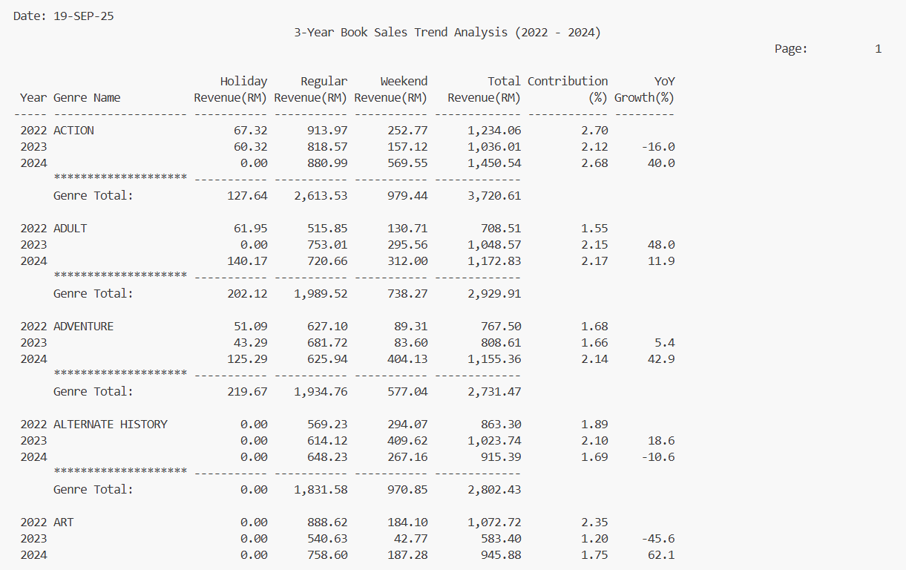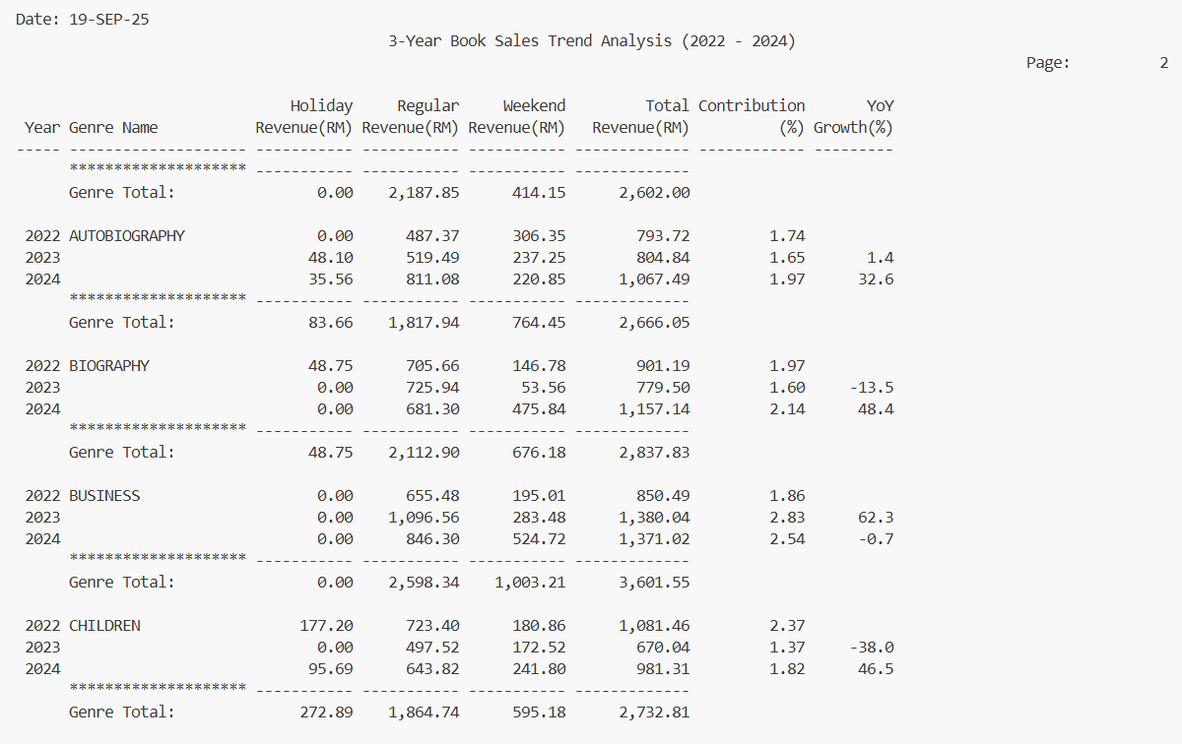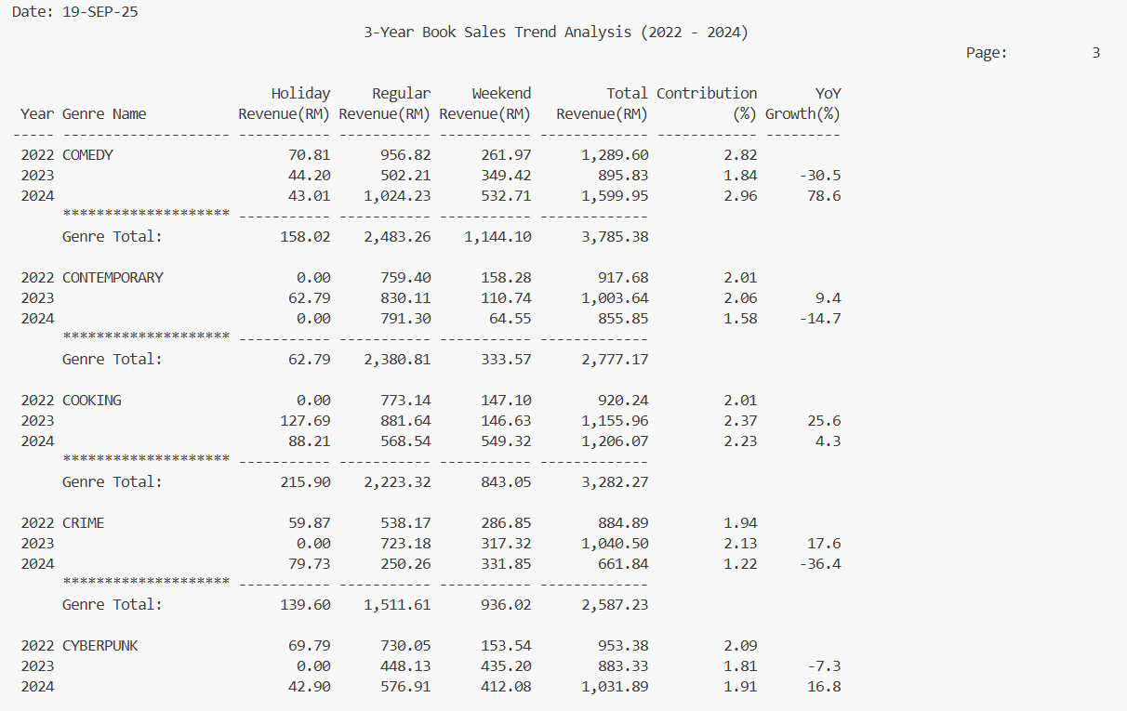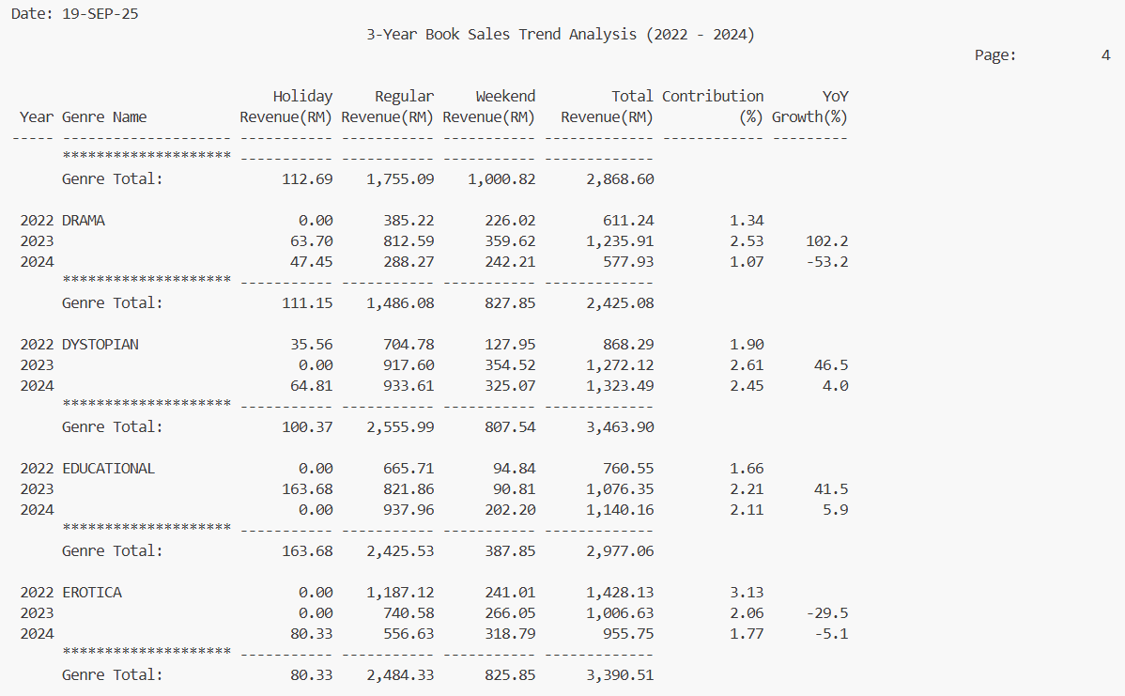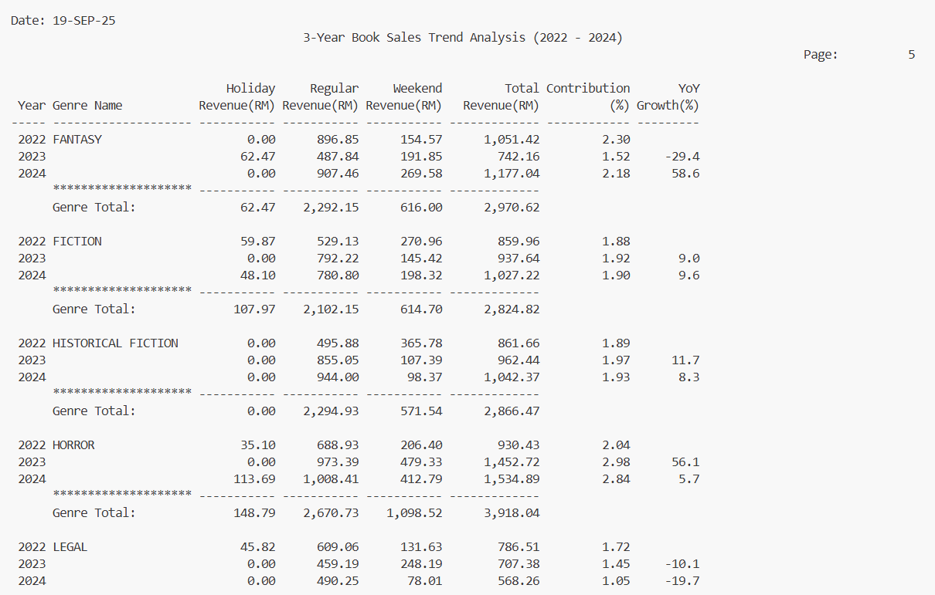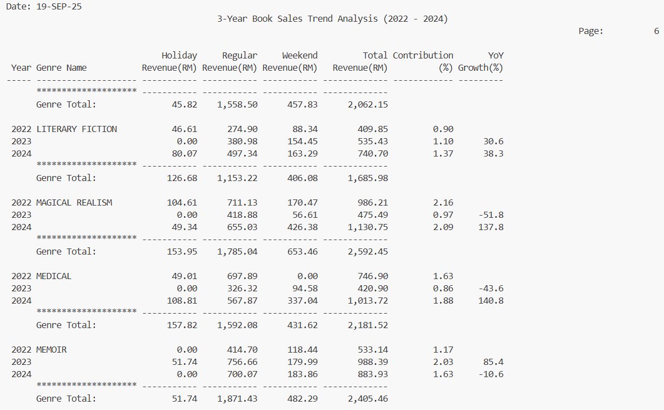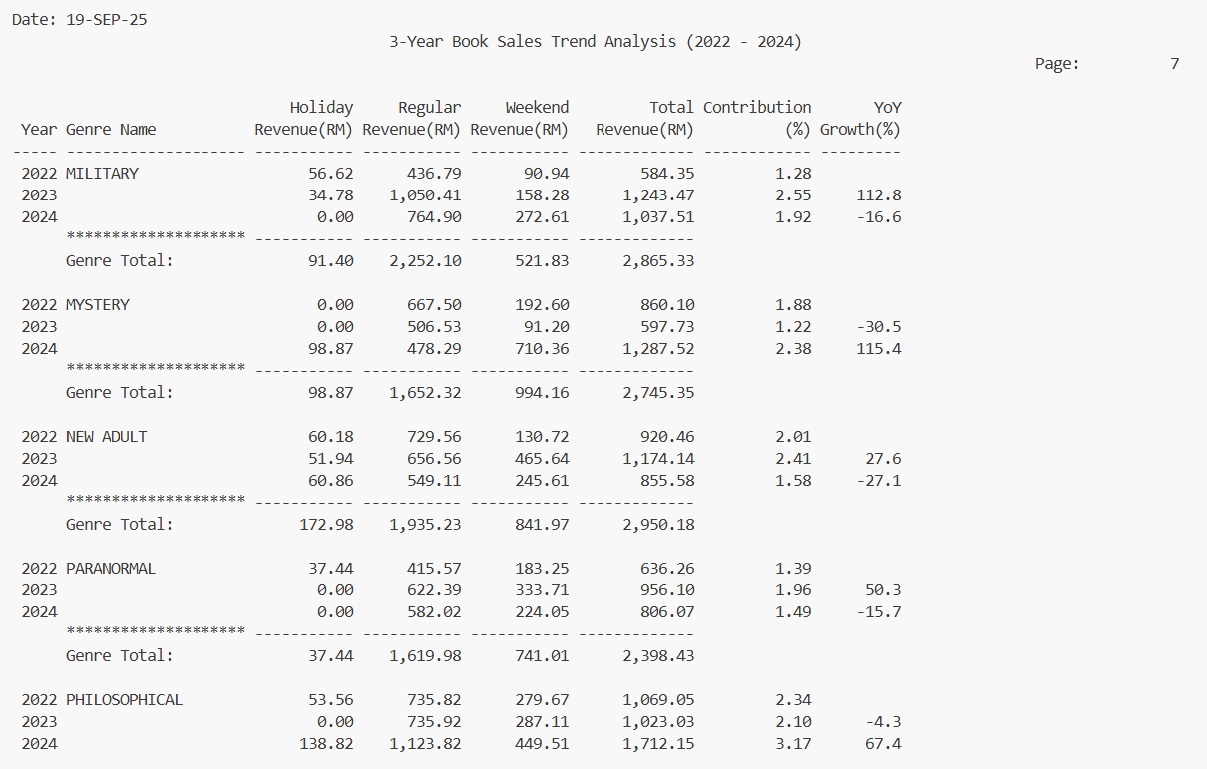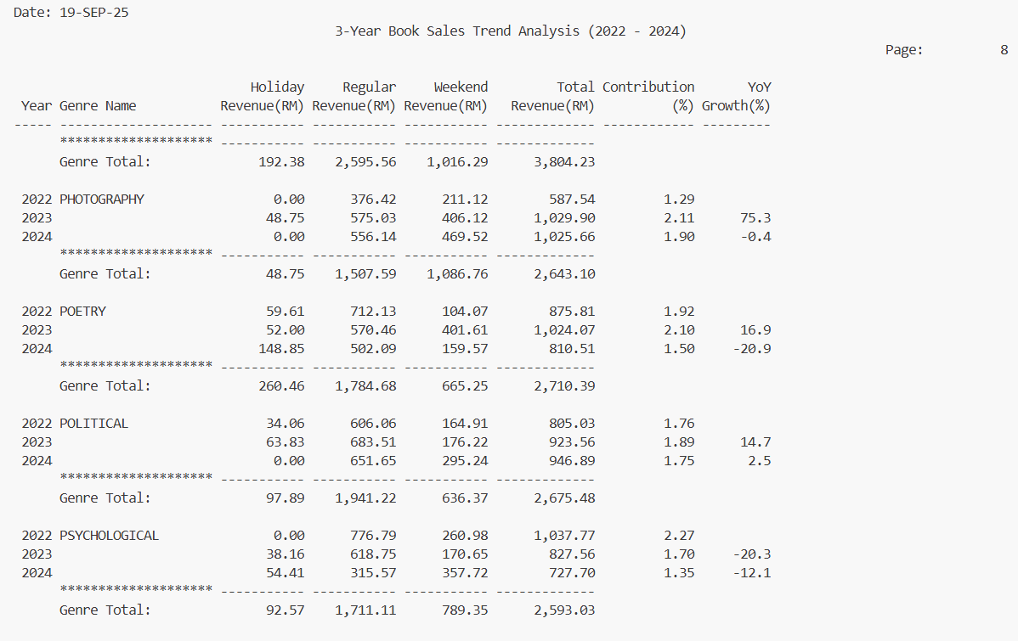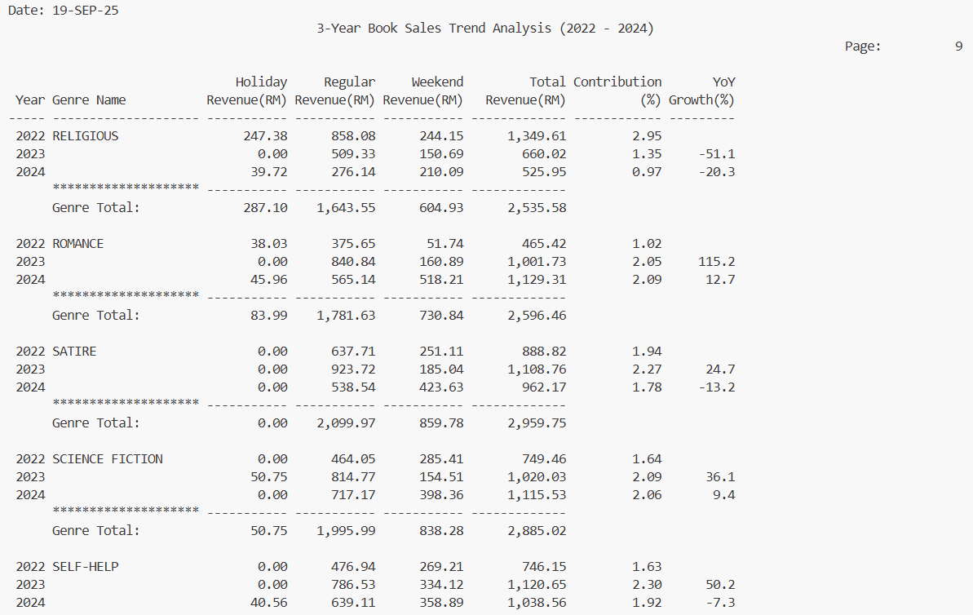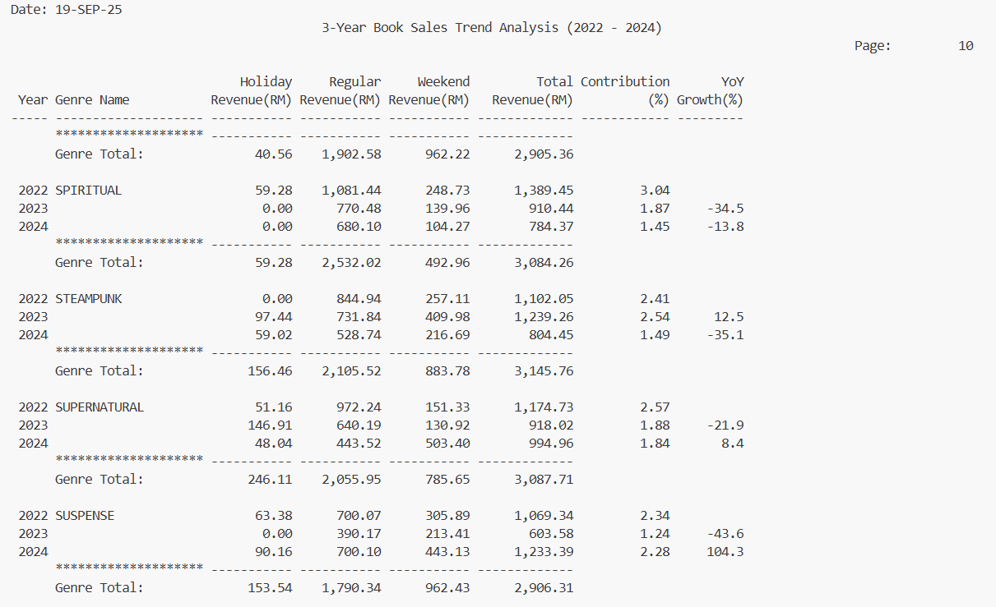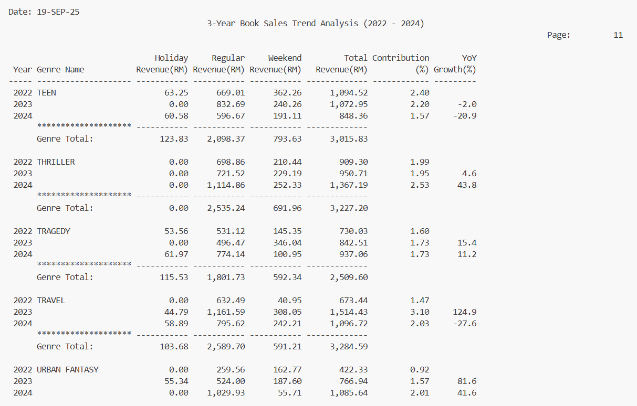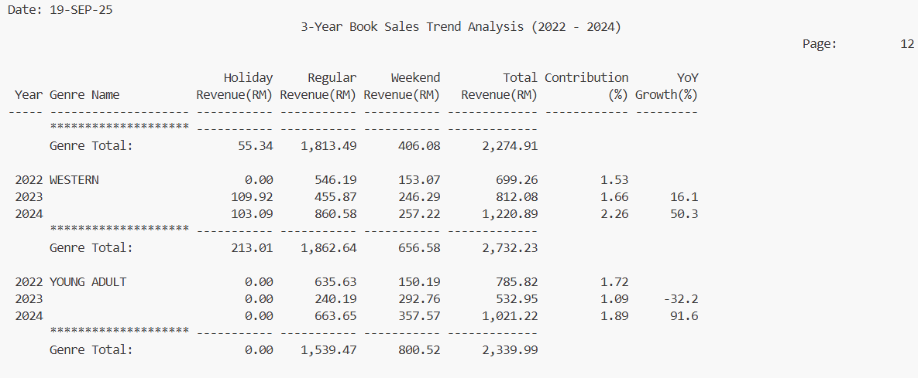

The 3-Year Book Sales Trend report reflects that the regular days continue to be the foundation of book sales in all genres, but the 2024 weekend/holiday spending spurt has shaken the buying time of members across most leisure genres, not the content itself. Some of the categories showed a high YoY in 2024- e.g. Medical ( +140.8%), Magical Realism ( +137.8%), Mystery ( +115.4%), Suspense ( +104.3% ), Young Adult ( +91.6% ), Comedy ( +78.6% ), Philosophical ( +67.4% ) and the upswing came more on weekends ( e.g. Action, Adventure, Biography, Cooking, Romance, Thriller). Conversely, some formerly-strong or study/faith-oriented genres weakened in 2024 Spiritual (-13.8%), Religious (-20.3%), Psychological (-12.1%), Self-Help (-7.3%), Travel (-27.6%), Memoir (-10.6%), Crime (-36.4%)--and Business stagnated (-0.7%), showing a shift away of subjects of demand in favor of the theme of improvement.

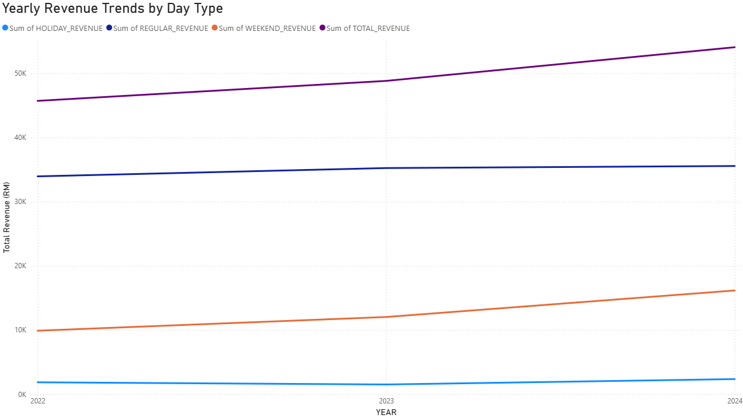
The line chart indicates consistent growth of the total revenue between 2022-24, but the primary driver each year is the Regular-day revenue and then the Weekend revenue, and as well as the Holiday revenue, though minimal, but increasing. This trend suggests that the library is still relying on the routine weekday traffic like borrow-to-buy conversions and everyday purchases as the main source of income, and discretionary time including weekends and holidays is becoming an increasingly influential accelerator. As an illustration, the library can implement such promotions as Weekend Family Packs which is discount packages on Children and Fiction titles, Holiday Reading Festivals is limited-time genre displays with bonus points on all purchases, or Borrow-and-Buy Deals which provides additional 10% off when a member purchases a book that he or she has previously borrowed on the weekend. The action should be conducted is continue to intensify the weekday engine such as availability and pricing of popular ex-borrowed titles and intentionally roll up weekend and holiday promotion to get into that rapid growth channel.
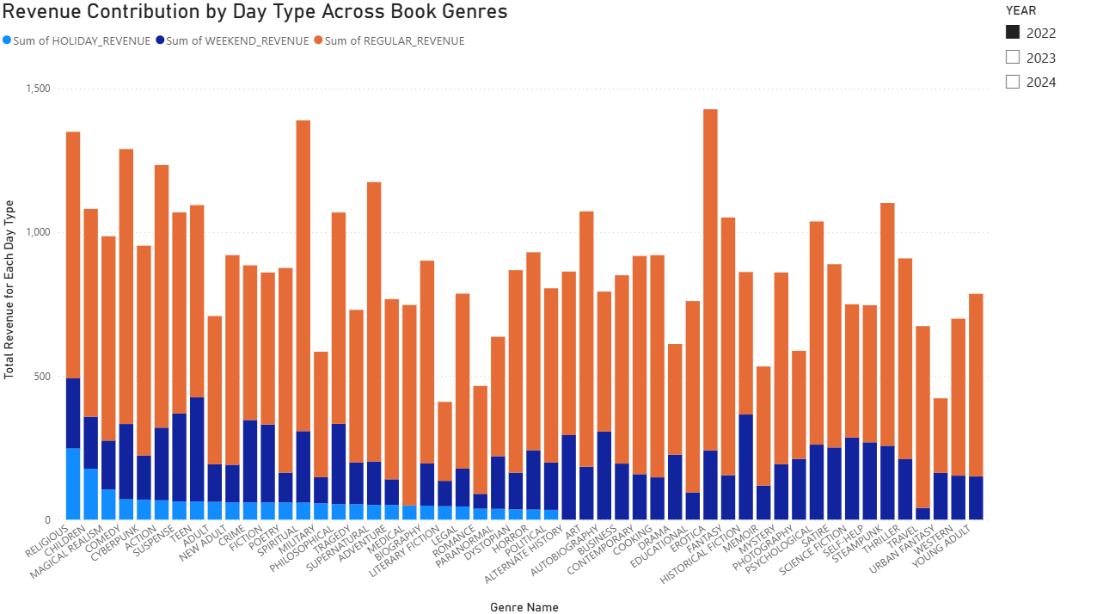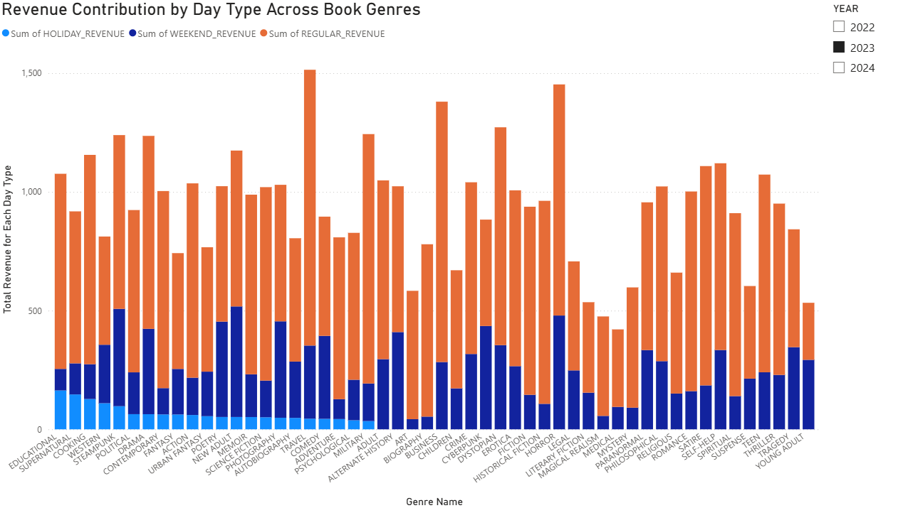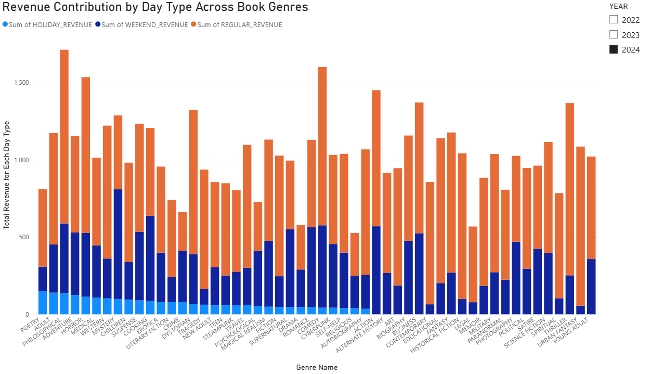Across the three graphs (2022–2024), the day-type pattern is clear but the leading genres change by year. In 2022, regular day revenue is anchored by Erotica, Spiritual, Supernatural, Comedy and Action, weekends peak for Historical Fiction, Teen, Autobiography, Suspense and Alternate History and holidays lift Religious, Children, Magical Realism, Comedy and Cyberpunk. In 2023, regular days shift toward Travel, Business, Military, Horror and Satire, weekends surge in Horror, New Adult, Cyberpunk, Steampunk and Alternate History and holidays favor Educational, Supernatural, Cooking, Western and Steampunk. In 2024, regular days are led by Philosophical, Thriller, Urban Fantasy, Comedy and Horror, weekends spike for Mystery, Action, Cooking, Comedy and Business, and holidays tilt to Poetry, Adult, Philosophical, Adventure and Horror. Regular days remain the reliable base each year, while weekends amplify leisure and discovery genres and holidays boost thematic or giftable categories so decisions should keep weekday bestsellers in stock and priced well, and time weekend and holiday bundles and spotlights around the specific high-response genres of each year.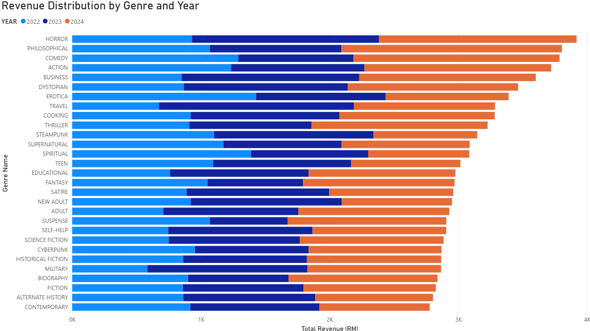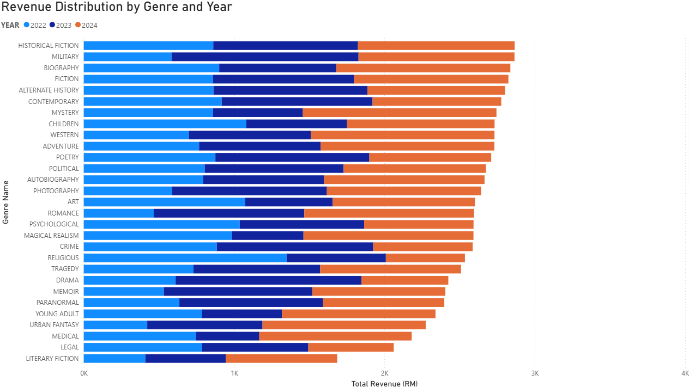The figure above is a stacked bar chart that displays revenue distribution in 2022 to 2024 by genre. Genres such as Horror, Action, Comedy, and Business have been steady top earners whilst such genres as Literacy Fiction have the cumulative lowest revenue in three year. The stable leaders show stable sources of revenues. whereas the middle range genres are those that can be cultivated through specific campaigns to enable the company to diversify its sources of revenue and avoid excessive dependence on select best selling genres.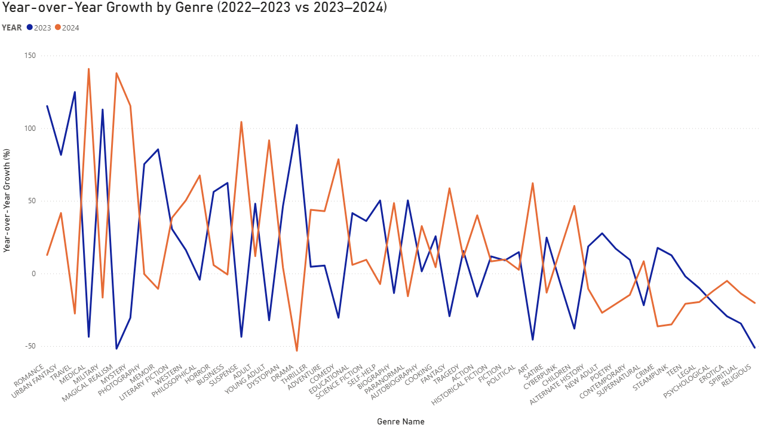The line chart reveals strong volatility in genre demand between the two windows with Travel, Romance, Military, Drama, and Memoir pushing upwards and Magical Realism, Religious, Art, Suspense, and Medical downwards, the opposite is true when comparing 2023 to 2024 as Medical and Magical Realism are on a strong rebound and Mystery, Suspense, Steampunk, Travel and Adult drop. These swings are evidence of changing tastes by the members based on seasonality, cultural and media releases and discovery effects. Strategy are add more front-of-store space, inventory and front-store promotions to the existing risers such as Medical, Magical Realism, Mystery, Suspense and Young Adult, make limited trials with bundle deals to near-riser neighbors.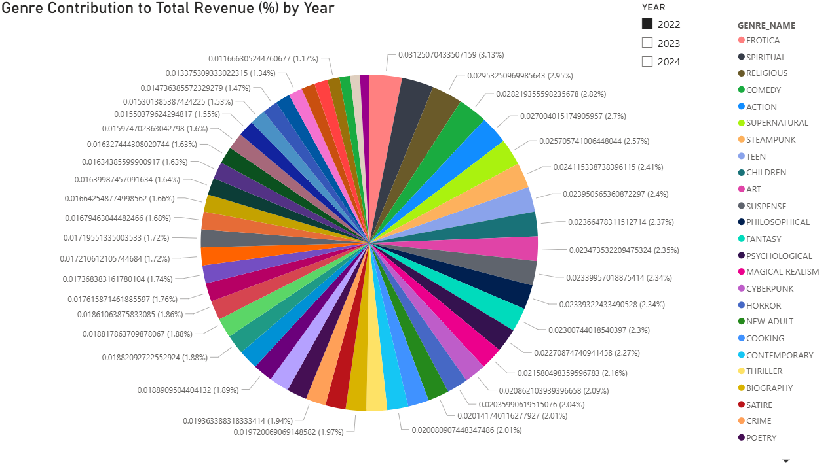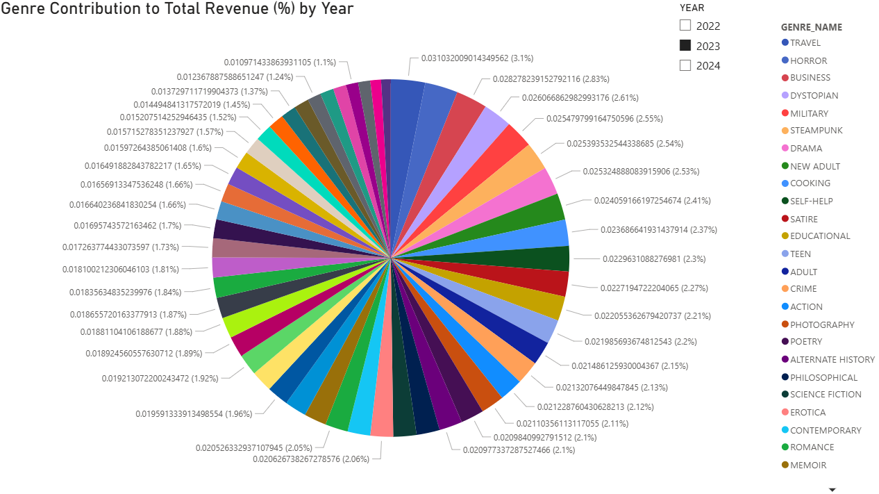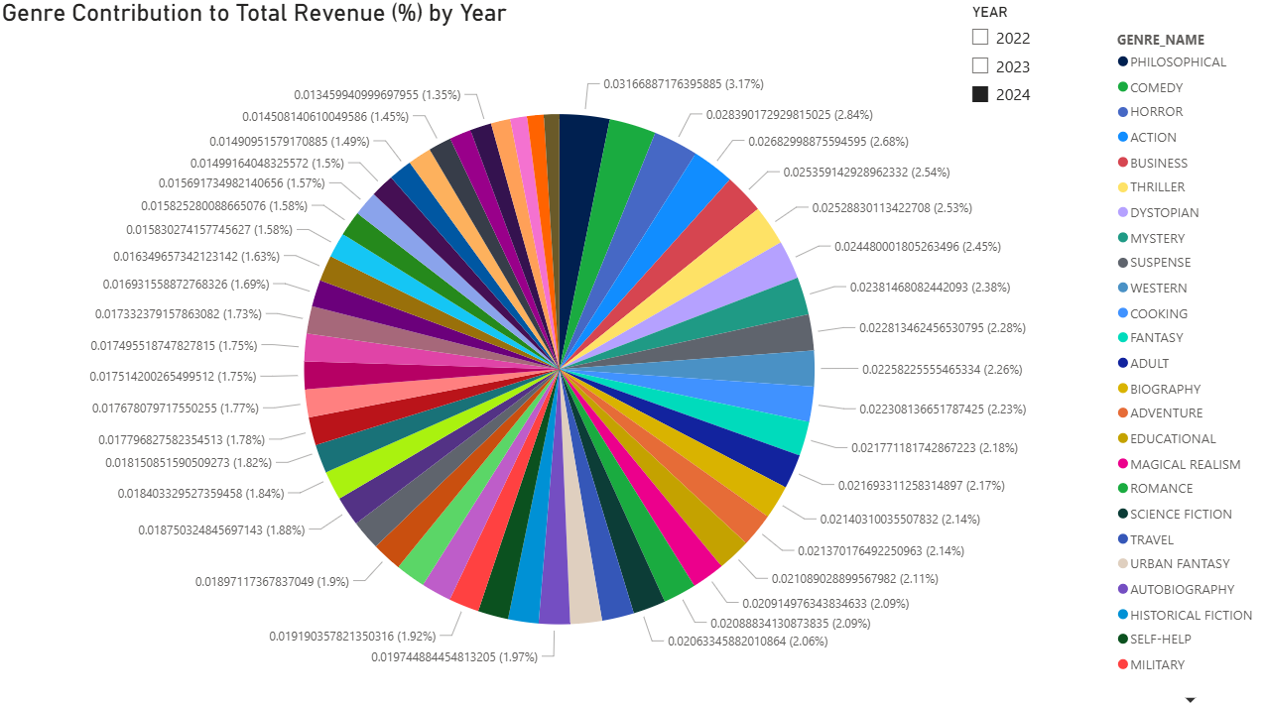

In the pie charts, we can see that there is no genre that dominates the total revenue in large numbers; the contributions are made in numerous genres. There are a few more shares in Action, Horror, Business, and Historical Fiction, but, in general, revenue is highly diversified. This averaged dispersion eliminates risk but also implies that the management is compelled to have a large number of offerings so as to accommodate various preferences of the members. Specializing in the most popular genres would put the risk of losing the niche segments that would make a major part of the revenues when put together.

Overall Insight:

On the whole, the dashboard indicates a robust three-year steady increase in the total revenue with Regular days on the top followed by weekends that are increasing the quickest and the Holidays that are increasing marginally meaning that everyday availability is still keeping the bills afloat but leisure windows are becoming the real booster. This change is important since shifting even a fraction of purchases to more active weekends/holidays would multiply revenue without increasing footprint. The trend was influenced by consistent borrow-to-buy translations on weekdays and the increased weekend traffic with events, free time, gifting, and genre influences. Some of the core genres are consistently strong but others are seasonal and cyclical. In the future, continue with depth and rapid processing of the core genres via a simple three-tier price schedule like list, member and clearance and then operate a Weekend and Holiday playbook: monthly weekend genre Spotlight, holiday packages and a borrow-Friday, buy-by-Sunday promotion. Monitor and steer with limited KPIs each month YoY growth, weekend contribution percentage, genre share shift, borrow to buy ratio, stock-out rate and allocate inventory and promos to the segments which exhibit a consistent uplift.

3.1.2 Fine Recovery Efficiency Report for Years 2022 to 2024
ACCEPT Start_Year PROMPT 'Enter the start year: '
ACCEPT End_Year PROMPT 'Enter the end year: '

SET PAGESIZE 35
SET LINESIZE 130
SET NEWPAGE 1

COLUMN cal_year FORMAT 9999 HEADING 'Year'
COLUMN cal_month_name FORMAT A14 HEADING 'Month'
COLUMN cal_quarter FORMAT A8 HEADING 'Quarter'
COLUMN total_fines FORMAT 9,999,999.99 HEADING 'Total Fines (RM)'
COLUMN collected_fines FORMAT 9,999,999.99 HEADING 'Collected Fines (RM)'
COLUMN outstanding_fines FORMAT 9,999,999.99 HEADING 'Outstanding Fines (RM)'
COLUMN recovery_rate FORMAT 990.00 HEADING 'Recovery|Rate (%)'
COLUMN unpaid_count FORMAT 999 HEADING 'Repeated Members with|Unpaid Cases'

BREAK ON cal_year SKIP PAGE ON REPORT
COMPUTE SUM LABEL 'Total (RM): ' OF total_fines collected_fines outstanding_fines unpaid_count ON cal_year

TTITLE LEFT 'Date: ' _DATE SKIP 1 -
CENTER 'Fine Recovery Efficiency Report for Years &Start_Year to &End_Year' SKIP 1 -
RIGHT 'Page: ' SQL.PNO SKIP 2

CREATE OR REPLACE VIEW fine_recovery_summary_view AS
WITH monthly_fines AS (
SELECT
dd.cal_year,
dd.cal_month_name,
dd.cal_quarter,
SUM(ff.fine_amount) AS total_fines,
SUM(CASE WHEN ff.payment_status = 'PAID' THEN ff.fine_amount ELSE 0 END) AS collected_fines,
SUM(CASE WHEN ff.payment_status = 'UNPAID' THEN ff.fine_amount ELSE 0 END) AS outstanding_fines
FROM fact_fines ff
JOIN dim_date dd ON ff.fine_date_key = dd.date_key
WHERE dd.cal_year BETWEEN &Start_Year AND &End_Year
GROUP BY dd.cal_year, dd.cal_month_name, dd.cal_quarter
),
unpaid_members AS (
SELECT
dd.cal_year,
dd.cal_month_name,
dd.cal_quarter,
fm.member_id,
COUNT(*) AS unpaid_count
FROM fact_fines ff
JOIN dim_member fm ON ff.member_surrogate_key = fm.member_surrogate_key
JOIN dim_date dd ON ff.fine_date_key = dd.date_key
WHERE dd.cal_year BETWEEN &Start_Year AND &End_Year
AND ff.payment_status = 'UNPAID'
GROUP BY dd.cal_year, dd.cal_month_name, dd.cal_quarter, fm.member_id
HAVING COUNT(*) >= 2
)
SELECT
mf.cal_year,
mf.cal_month_name,
mf.cal_quarter,
mf.total_fines,
mf.collected_fines,
mf.outstanding_fines,
ROUND((mf.collected_fines / NULLIF(mf.total_fines,0)) * 100, 2) AS recovery_rate,
NVL(COUNT(DISTINCT um.member_id),0) AS unpaid_count
FROM monthly_fines mf
LEFT JOIN unpaid_members um
ON mf.cal_year = um.cal_year
AND mf.cal_month_name = um.cal_month_name
AND mf.cal_quarter = um.cal_quarter
GROUP BY mf.cal_year, mf.cal_month_name, mf.cal_quarter,
mf.total_fines, mf.collected_fines, mf.outstanding_fines
ORDER BY mf.cal_year, TO_DATE(mf.cal_month_name, 'MONTH');

SELECT * FROM fine_recovery_summary_view;

SET FEEDBACK ON
TTITLE OFF
CLEAR COLUMNS
CLEAR BREAKS
CLEAR COMPUTES

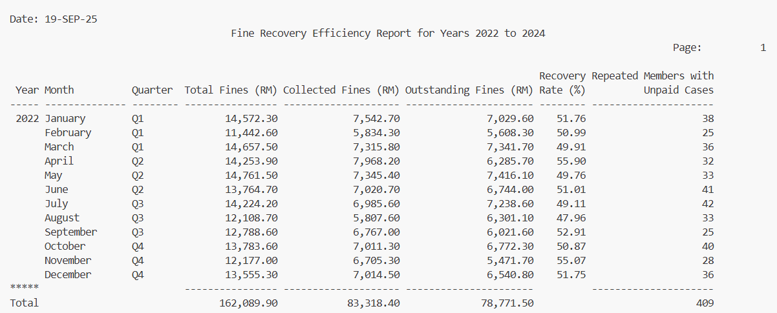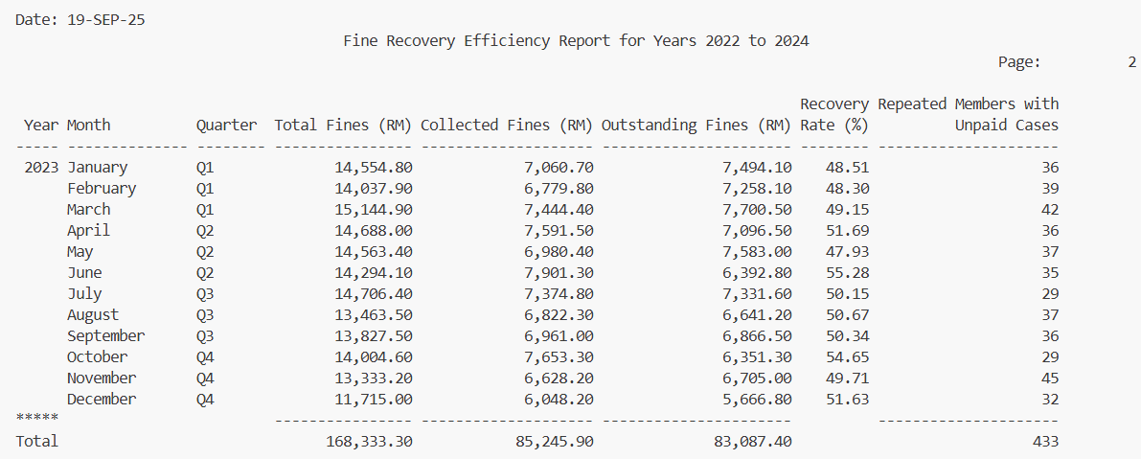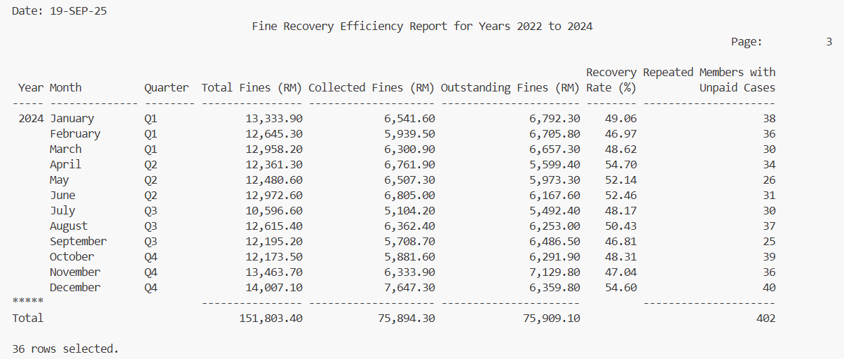
According to the Fine Recovery Efficiency Report (2022 to 2024), the total amount of fines issued was high as RM162089.90 in 2022, RM16833.30 in 2023 and RM151803.40 in 2024 but the recovery efficiency remained relatively low around 50% for each year and therefore the number of fines to be paid was very high almost the same in 2023 and in 2024. The recovery rates varied monthly with heights of over 55 in several months such as April 2022, October 2023 and lows of less than 48 in weakening months like February 2024. Repeated members by the number of cases that were not paid were always high with a high number of 409 in 2022, 433 in 2023, and 402 in 2024, which demonstrates that issues cannot be changed just with fines. Altogether, the report depicts the ongoing inefficiencies in the sphere of half of fines are not reclaimed, non-compliance is still observed, the stronger enforcement strategies are required, the recovery strategies should be more member-oriented, and they should be focused on reducing outstanding balances and increasing accountability.

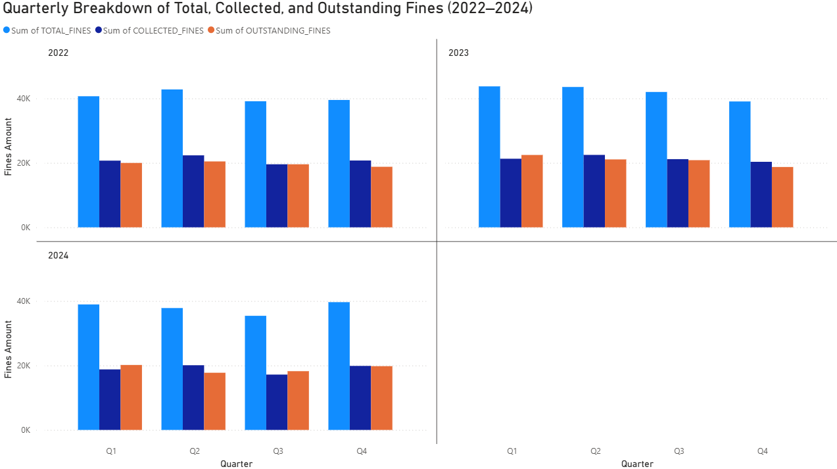As can be seen in this graph, total fines are high around 40K every quarter for these three years, although collected fines are also lower around 20K compared to the outstanding fines around 18- 20K. The minor downturns in Q3 may be an indication of the seasonal factors such as the semester breaks when a small number of students stay on campus. In certain quarters such as Q2 2023, the rise in penalties collected indicates better enforcement or payment efforts. The difference between total and collected values indicates that there is a continuing problem of collection and more powerful follow-ups may be required.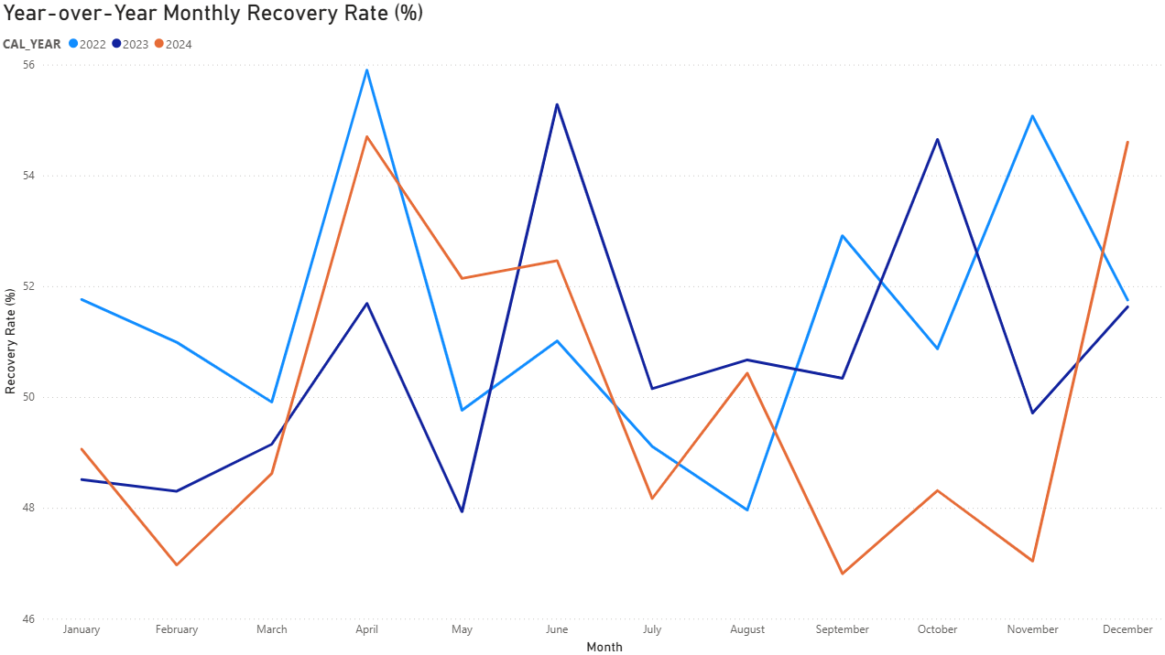The recovery rate does not have a steady positive trend but ranges between 48% to 56%. April peaks for these three years indicate that the enforcement or reminders can be targeted at that period; conversely, the semester holidays in July–August are associated with the dips in the payments paid by students. The importance is in the fact that financial predictability is undermined by inconsistent recovery. This volatility can probably be attributed to the irregular collection campaigns or academic schedules or due to the deferral of payments by members. Automated reminders and semester-specific deadlines due to which penalties should be implemented should be introduced to stabilize this.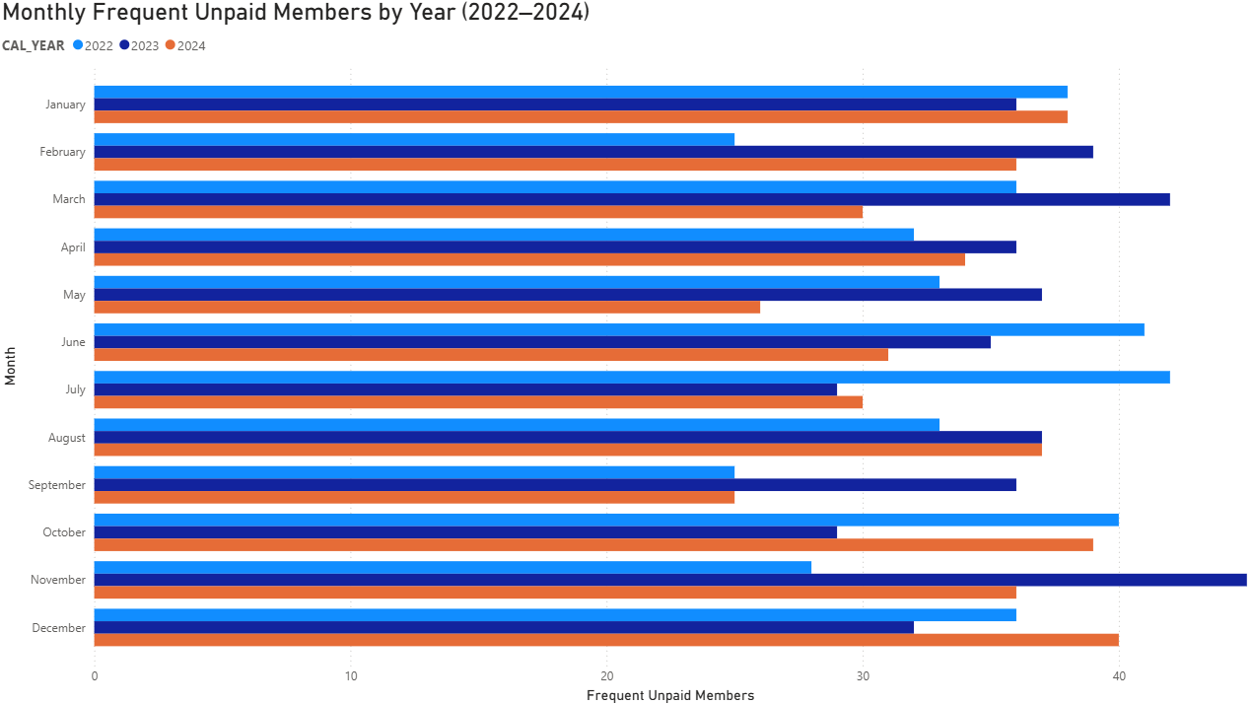As this chart indicates, the number of frequent unpaid members is always high around 25 to 40 a month on average, and there are some months when this number peaks such as March, June, July and December. The fact that repeat offenders persist means that, there is a systemic factor at play either there is no deterrent or there are weak enforcement policies.

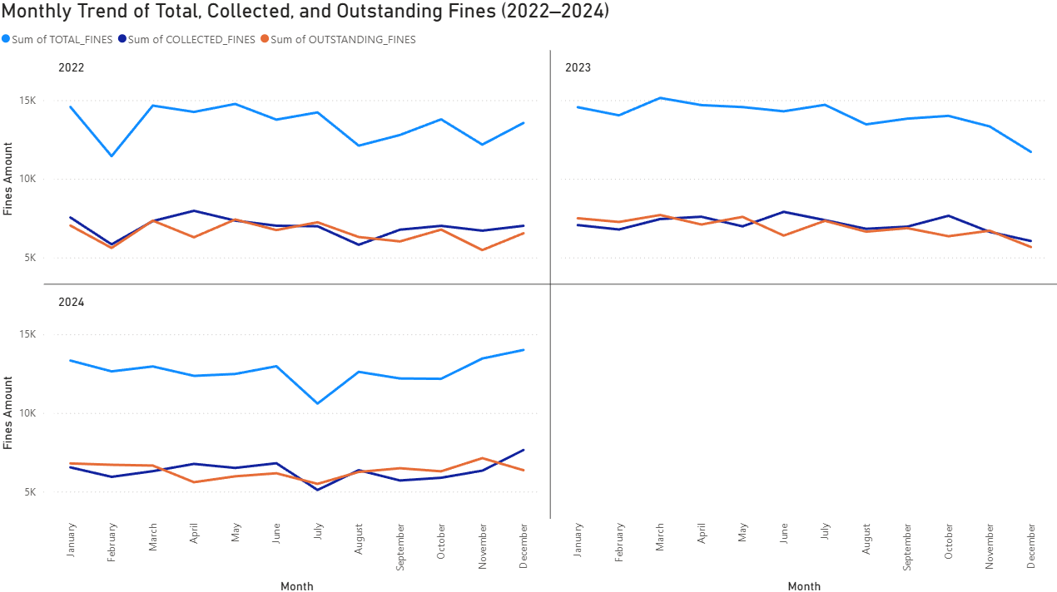
The trend lines of monthly trends indicate clearly that the collected and outstanding fines shift practically in parallel, and tend to be close in value which implies that almost half of the fines are not paid in spite of the total fines fluctuating. Increases in the middle of the year (March- June) indicate high levels of additional borrowing and late payments leading to an upsurge in the total fines. This is because the outstanding fines are directly proportional to the collected fines and this strongly demonstrates that the implementation capabilities have not changed significantly since the number of outstanding fines increases every time collected fines increase. To this end, the library ought to embrace specific enforcement measures including installment payments on heavy fines, tougher borrowing policies on returned offenders and automated warnings to enhance recovery and lower the accumulating fines.

Overall Insight:
The statistics inform us that total fines are not increasing, yet collection efficiency is low and recovery is fluctuating meaning a significant part of it is not paid in a year. The importance of the lost revenue and inefficient operations through habitual non-payment and seasonal decline is the financial impact. To guarantee improvement, the library needs to implement stricter borrowing policies on repeat offenders, automatic reminders and flexibility in payment and track the recovery KPIs every quarter. This converts the fines into a fixed penalty to a manageable predictable source of revenue that sustains the operation of the library.

3.1.3 Lost and Damaged Books Comparison 2023 vs 2024
ACCEPT Year1 PROMPT 'Enter the first year: '
ACCEPT Year2 PROMPT 'Enter the second year: '

SET PAGESIZE 35
SET LINESIZE 130

COLUMN cal_month_name FORMAT A17 HEADING 'Month'
COLUMN cal_quarter FORMAT A8 HEADING 'Quarter'
COLUMN lost_year1 FORMAT 999 HEADING 'Lost in &Year1'
COLUMN lost_year2 FORMAT 999 HEADING 'Lost in &Year2'
COLUMN lost_change FORMAT 999 HEADING 'Change'
COLUMN lost_pct_change FORMAT 999.99 HEADING 'Change(%)'
COLUMN damaged_year1 FORMAT 999 HEADING 'Damaged in &Year1'
COLUMN damaged_year2 FORMAT 999 HEADING 'Damaged in &Year2'
COLUMN damaged_change FORMAT 999 HEADING 'Change'
COLUMN damaged_pct_change FORMAT 999.99 HEADING 'Change(%)'

BREAK ON REPORT
COMPUTE SUM LABEL 'Grand Total (RM):' OF lost_year1 lost_year2 damaged_year1 damaged_year2 ON REPORT

TTITLE LEFT 'Date: ' _DATE SKIP 1 -
CENTER 'Lost and Damaged Books Comparison &Year1 vs &Year2' SKIP 1 -
RIGHT 'Page: ' SQL.PNO SKIP 2

CREATE OR REPLACE VIEW lost_damaged_comparison_view AS
WITH year_summary AS (
SELECT
d.cal_year,
d.cal_month_name,
d.cal_quarter,
SUM(CASE WHEN f.fine_type = 'LOST_BOOK' THEN 1 ELSE 0 END) AS total_lost,
SUM(CASE WHEN f.fine_type = 'DAMAGED' THEN 1 ELSE 0 END) AS total_damaged
FROM fact_fines f
JOIN dim_date d
ON f.fine_date_key = d.date_key
WHERE d.cal_year IN (&Year1, &Year2)
GROUP BY d.cal_year, d.cal_quarter, d.cal_month_name
)
SELECT
y1.cal_month_name,
y1.cal_quarter,
y1.total_lost AS lost_year1,
y2.total_lost AS lost_year2,
(y2.total_lost - y1.total_lost) AS lost_change,
ROUND(DECODE(y1.total_lost,0,NULL,(y2.total_lost - y1.total_lost)/y1.total_lost*100),1) AS lost_pct_change,
y1.total_damaged AS damaged_year1,
y2.total_damaged AS damaged_year2,
(y2.total_damaged - y1.total_damaged) AS damaged_change,
ROUND(DECODE(y1.total_damaged,0,NULL,(y2.total_damaged - y1.total_damaged)/y1.total_damaged*100),1) AS damaged_pct_change
FROM year_summary y1
JOIN year_summary y2
ON y1.cal_month_name = y2.cal_month_name
AND y1.cal_year = &Year1
AND y2.cal_year = &Year2
ORDER BY TO_DATE(y1.cal_month_name,'Month');

SELECT * FROM lost_damaged_comparison_view;

SET FEEDBACK ON
TTITLE OFF
CLEAR COLUMNS
CLEAR BREAKS
CLEAR COMPUTES

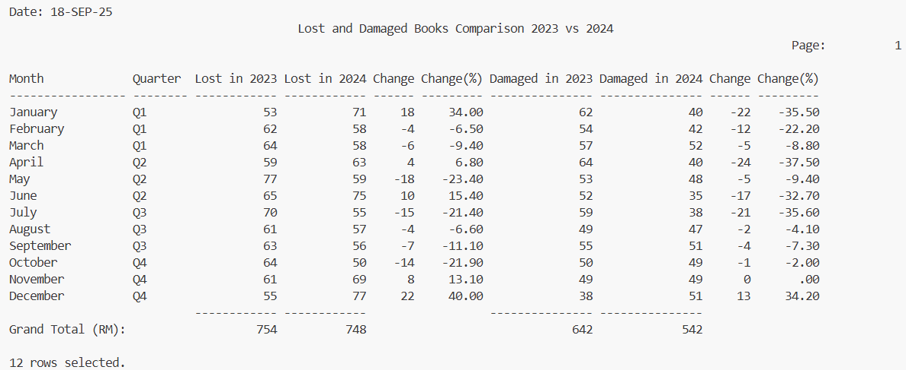

The Lost and Damaged Books Comparison (2023 vs 2024) shows the trend in both categories. In general, the number of lost books fell by a small margin (754 to 748 in 2023 and 2024 respectively), meaning that there is not much overall improvement. It can be observed that there is an increase and decrease in number of lost items every month: January and December experienced significant growth in lost items of +34% and +40% respectively, whereas in months such as May, July and October, the lost items decreased significantly of -23.4%, -21.4 and -21.9 respectively. For damaged books, there is clearer progress: totals dropped from 642 in 2023 to 542 in 2024 (-15.6%). Other months had lower damages with the highest being in April (-37.5%), June (-32.7%), and July (-35.6%). Nonetheless, December was the month when there was a drastic upswing in damages of +34.2%, in contrast to the positive development.

Overall, the trend of damaged books is stable, whereas that of lost books is unstable due to low performance during some months and high performance at both the beginning and the end of the year. This indicates that the management of practices and preservation procedures have been enhanced, however there should be enhanced control of member responsibility towards the lost items. In the future, it would be appropriate that the library continues practicing preservation and aims at preventing losses during the high-risk months (January and December) by ensuring more rigid return policies, reminders, and penalties.

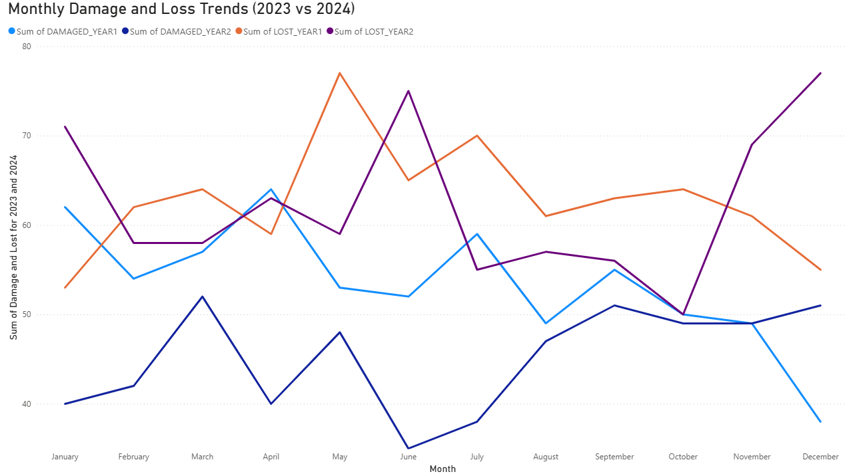
The line chart involves comparison of book damage and loss per month over two years. The damaged items distinguish a constant decrease in 2023 (light blue) which signifies a slow change towards better preservation. Conversely, there is a more unstable situation in 2024 (dark blue), as the damages would reach their lowest point in June but increase once again at the end of the year. The opposite is true of the lost items, where 2023 (orange) losses are highest in the middle of the year (May June), but they decrease afterwards, whereas 2024 (purple) losses are highly varied, with peaks in January, June, and December. In general, although damage appears a bit more manageable, in 2024, it is increasingly becoming more erratic.
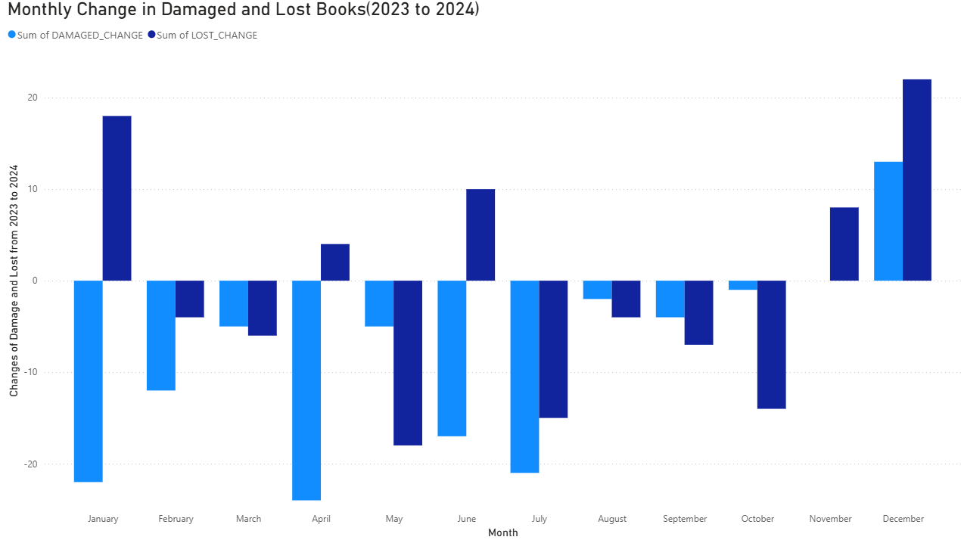
This bar chart brings to focus the change of the yearly monthly change. Most months have negative values, indicating that in 2024, the company collects higher damages and losses than in 2023, with the worst performance in such months as January, April, June, and July. There are positive gains in a few months (e.g., November, December) which are indicative of short-term interventions being effective. Nevertheless, the general direction is one of uneven policy implementation or alternating actions of members, rather than continuous improvement.
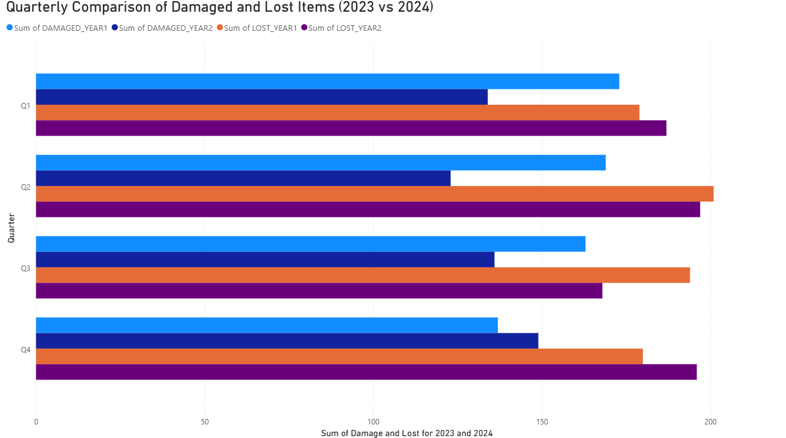
The comparison of the quarters shows that both damaged and lost items are the highest in Q2 and Q3 of both years that are in accordance with the highest borrowing levels. It is also notable that the number of lost items in 2024 is consistently more than in 2023 in virtually all quarters, which means that the problem of unreturned books declined in 2024. In the meantime, the trends of damaged items are mixed, showing somewhat improved trends in certain areas but deteriorated in others, which means that the measures of control are partially but unevenly applied.

Overall Insight:
The information informs us that although the damage to books is gradually decreasing, losses continue to be an increasing concern in 2024 and significant peaks of losses are observed in mid- and end-of-month. The growth is high since it indicates a long-standing issue of accountability of the members and potentially poorly tracked or enforced. This occurred because seasonal borrowing is at its highest and follow-up lapses on the items that are overdue or mishandled. To proceed, the library must focus on better implementation of returning policy, adding security and reminder services and initiating education on responsible borrowing. Regular audit of quarterly and specific monitoring in the months with the largest borrowing (Q2-Q3) would contribute to stabilization of the losses and keep the damages in the decreasing trend.

3.2.1 Overdue and Fine Collection Summary Analysis (2023-2024)
SQL CODE:
SET LINESIZE 130
SET PAGESIZE 35
SET VERIFY OFF
SET FEEDBACK OFF

COLUMN run_dt NEW_VALUE _run_dt
SELECT TO_CHAR(SYSDATE,'DD-MON-YYYY') run_dt FROM dual;

ACCEPT p_start_year NUMBER PROMPT "Enter Start Year: "
ACCEPT p_end_year NUMBER PROMPT "Enter End Year: "

TTITLE CENTER "Overdue and Fine Collection Summary Analysis from &p_start_year to &p_end_year" SKIP 1 -
CENTER "Date: &_run_dt" SKIP 1 -
CENTER "Page: " FORMAT 999 SQL.PNO SKIP 2

COLUMN year FORMAT 9999 HEADING 'Year'
COLUMN member_type_name FORMAT A12 HEADING 'Member Type'
COLUMN overdue_count FORMAT 9,999,990 HEADING 'Overdue Count'
COLUMN fine_paid FORMAT 999,999,990.00 HEADING 'Fines Paid (RM)'
COLUMN fine_unpaid FORMAT 999,999,990.00 HEADING 'Fines Unpaid (RM)'
COLUMN outstanding_pct FORMAT 990.0 HEADING 'Outstanding %'

CREATE OR REPLACE VIEW vw_overdue_fines AS
SELECT
m.member_type_name,
EXTRACT(YEAR FROM d.cal_date) AS year,
COUNT(CASE WHEN fb.is_overdue = 'Y' THEN 1 END) AS overdue_count,
SUM(CASE WHEN f.payment_status = 'PAID' THEN f.fine_amount ELSE 0 END) AS fine_paid,
SUM(CASE WHEN f.payment_status = 'UNPAID' THEN f.fine_amount ELSE 0 END) AS fine_unpaid
FROM fact_borrowing fb
JOIN dim_member m ON fb.member_surrogate_key = m.member_surrogate_key
JOIN dim_date d ON fb.borrow_date_key = d.date_key
LEFT JOIN fact_fines f ON fb.member_surrogate_key = f.member_surrogate_key
AND fb.borrow_date_key = f.fine_date_key
GROUP BY m.member_type_name, EXTRACT(YEAR FROM d.cal_date);

BREAK ON year SKIP 1
COMPUTE SUM OF overdue_count fine_paid fine_unpaid ON year
COMPUTE SUM OF overdue_count fine_paid fine_unpaid ON REPORT

SELECT
year,
member_type_name,
overdue_count,
fine_paid,
fine_unpaid,
CASE
WHEN (fine_paid + fine_unpaid) = 0 THEN 0
ELSE ROUND(100 * fine_unpaid / (fine_paid + fine_unpaid), 1)
END AS outstanding_pct
FROM vw_overdue_fines
WHERE year BETWEEN &p_start_year AND &p_end_year
ORDER BY year, member_type_name;

CLEAR COLUMNS
CLEAR COMPUTES
TTITLE OFF
BTITLE OFF

SQL Output:
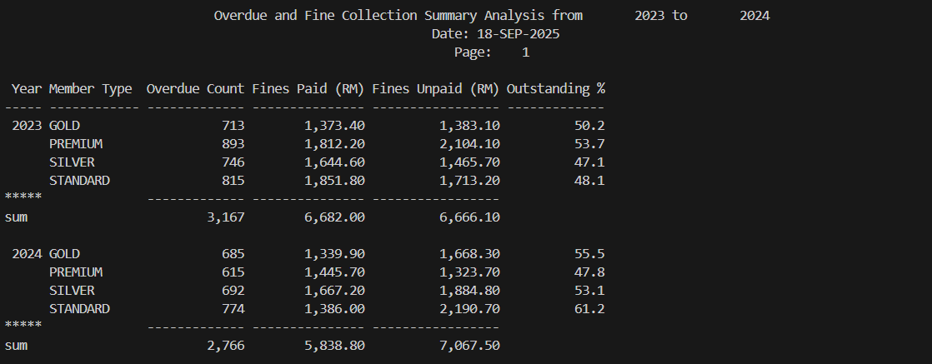
The query indicates a definite change. The total amount of overdue count decreased by 3,167 to 2,766 (-12.7%), and the amount paid fines fell by RM6,682.00 to RM5,838.80 (-12.6%). Unpaid fines however rose by RM6,666.1 to RM7,067.5 by 6.0%. This is to say that our overdue balances were reduced, however, at the expense of the recovery rate. If classified by member type, it was Standard members who had the greatest deterioration with an outstanding rate of 61.2% with outstanding fines increasing to RM2,190.70. The same happened to Gold and Silver members, to 55.5% and 53.1% respectively. There was some improvement in the Premium members that had the outstanding rate of 47.8% and outstanding fines of RM1,323.70.

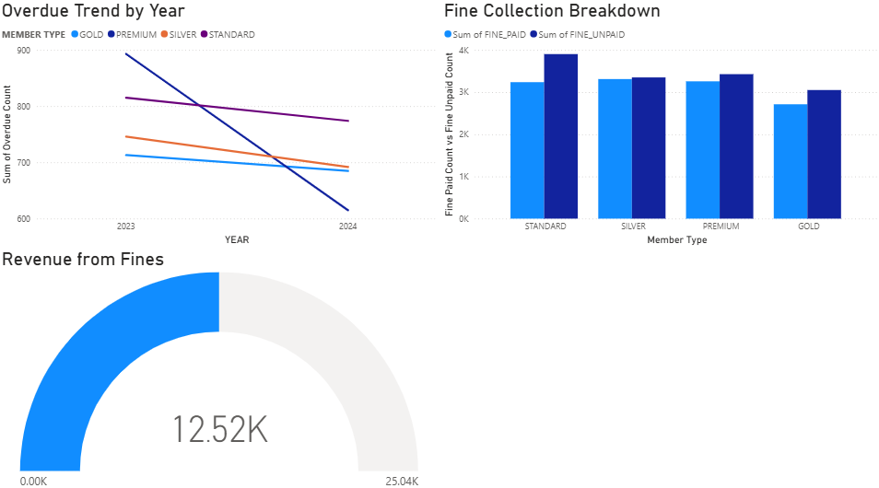
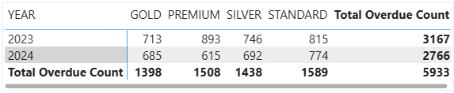
The visualizations above support the report, the Overdue Trend decreases between 2023 and 2024 between member types, the largest decrease in Premium, nearly 31%, but the Fine Collection Breakdown displays unpaid bars equal to or greater than paid in Standard, Silver, Gold, which shows that the efficiency of collection declined when the volumes decreased. The Revenue from Fines indicator (RM12.52K) testifies to the claim that the portion of fines is a significant revenue category, yet the amount of unpaid portfolio is against the cash recovery and promoting repeat non-payment. It must be a dashboard driver operationally, add cards to the outstandings percentage, Paid/Unpaid ratio, Average Days-to-Pay, enable drill-through to monthly defaulter lists on Standard or Gold, have templates of templates to A/B-test reminders and send times and have explicit targets such as outstanding 45% and paid 1.2 on average across all members next term. Add quick wins like add default QR or e-wallet links to reminders, a one-off amnesty or settle day to clear legacies, and, where needed, loan-period or renewal tops to crushingly non-performing groups. Collectively these measures will transform the insights into tangible policy and process changes to make collections stronger and healthier.

3.2.2 Revenue Mix Analysis (2024)
SQL CODE:
SET LINESIZE 130
SET PAGESIZE 35
SET VERIFY OFF
SET FEEDBACK OFF
SET SQLBLANKLINES ON
SET TAB OFF

COLUMN run_dt NEW_VALUE _run_dt
SELECT TO_CHAR(SYSDATE,'DD-MON-YYYY') run_dt FROM dual;

ACCEPT p_year NUMBER PROMPT 'Enter Latest Year (3-year window will be used): '

COLUMN start_year NEW_VALUE _start_year
SELECT &p_year - 2 AS start_year FROM dual;

TTITLE CENTER 'Revenue Mix Analysis (&_start_year - &p_year)' SKIP 1 -
CENTER 'Date: &_run_dt' SKIP 1 -
LEFT 'Page: ' FORMAT 999 SQL.PNO SKIP 2

COLUMN member_type_out FORMAT A12 HEADING 'Member Type'
COLUMN year_val FORMAT 9999 HEADING 'Year'
COLUMN sales_sum FORMAT 999,999,990.00 HEADING 'Sales (RM)'
COLUMN fines_paid_sum FORMAT 999,999,990.00 HEADING 'Fines Paid (RM)'
COLUMN facility_sum FORMAT 999,999,990.00 HEADING 'Facility (RM)'
COLUMN total_sum FORMAT 999,999,990.00 HEADING 'Total Revenue (RM)'
COLUMN sales_pct FORMAT 990.0 HEADING 'Sales %'
COLUMN fines_pct FORMAT 990.0 HEADING 'Fines %'
COLUMN facility_pct FORMAT 990.0 HEADING 'Facility %'
COLUMN yoy_change FORMAT 999,999,990.00 HEADING 'YoY Change (RM)'
COLUMN yoy_pct FORMAT 990.0 HEADING 'YoY %'

BREAK ON member_type_out SKIP 0

SET DEFINE OFF
CREATE OR REPLACE VIEW vw_revenue_mix_year AS
WITH
sales AS (
SELECT
m.member_type_name,
EXTRACT(YEAR FROM d.cal_date) AS year_val,
SUM(bs.totalamount) AS sales_amount
FROM fact_book_sale bs
JOIN dim_member m ON m.member_surrogate_key = bs.member_surrogate_key
JOIN dim_date d ON d.date_key = bs.sale_date_key
GROUP BY m.member_type_name, EXTRACT(YEAR FROM d.cal_date)
),
fines AS (
SELECT
m.member_type_name,
EXTRACT(YEAR FROM d.cal_date) AS year_val,
SUM(CASE WHEN f.payment_status = 'PAID' THEN f.fine_amount ELSE 0 END) AS fines_paid,
SUM(CASE WHEN f.payment_status = 'UNPAID' THEN f.fine_amount ELSE 0 END) AS fines_unpaid
FROM fact_fines f
JOIN dim_member m ON m.member_surrogate_key = f.member_surrogate_key
JOIN dim_date d ON d.date_key = f.fine_date_key
GROUP BY m.member_type_name, EXTRACT(YEAR FROM d.cal_date)
),
facil AS (
SELECT
m.member_type_name,
EXTRACT(YEAR FROM d.cal_date) AS year_val,
SUM(fb.fee) AS facility_amount
FROM fact_facility_booking fb
JOIN dim_member m ON m.member_surrogate_key = fb.member_surrogate_key
JOIN dim_date d ON d.date_key = fb.booking_date_key
GROUP BY m.member_type_name, EXTRACT(YEAR FROM d.cal_date)
)
SELECT
COALESCE(s.member_type_name, f.member_type_name, fa.member_type_name) AS member_type_name,
COALESCE(s.year_val, f.year_val, fa.year_val ) AS year_val,
NVL(s.sales_amount, 0) AS sales_amount,
NVL(f.fines_paid, 0) AS fines_paid,
NVL(f.fines_unpaid, 0) AS fines_unpaid,
NVL(fa.facility_amount, 0) AS facility_amount,
( NVL(s.sales_amount,0) + NVL(f.fines_paid,0) + NVL(fa.facility_amount,0) ) AS total_revenue
FROM sales s
FULL OUTER JOIN fines f
ON s.member_type_name = f.member_type_name
AND s.year_val = f.year_val
FULL OUTER JOIN facil fa
ON COALESCE(s.member_type_name, f.member_type_name) = fa.member_type_name
AND COALESCE(s.year_val, f.year_val) = fa.year_val;
SET DEFINE ON

WITH yrs AS (
SELECT &p_year AS y FROM dual UNION ALL
SELECT &p_year - 1 AS y FROM dual UNION ALL
SELECT &p_year - 2 AS y FROM dual
),
base AS (
SELECT
v.member_type_name,
v.year_val,
SUM(v.sales_amount) AS sales_sum,
SUM(v.fines_paid) AS fines_paid_sum,
SUM(v.facility_amount) AS facility_sum,
SUM(v.total_revenue) AS total_sum
FROM vw_revenue_mix_year v
JOIN yrs ON yrs.y = v.year_val
GROUP BY v.member_type_name, v.year_val
),
member_yoy AS (
SELECT
member_type_name,
year_val,
sales_sum, fines_paid_sum, facility_sum, total_sum,
LAG(total_sum) OVER (PARTITION BY member_type_name ORDER BY year_val) AS prev_total
FROM base
),
totals_by_year AS (
SELECT
year_val,
SUM(sales_sum) AS sales_sum,
SUM(fines_paid_sum) AS fines_paid_sum,
SUM(facility_sum) AS facility_sum,
SUM(total_sum) AS total_sum
FROM base
GROUP BY year_val
),
totals_yoy AS (
SELECT
'ALL MEMBERS' AS member_type_out,
year_val,
sales_sum, fines_paid_sum, facility_sum, total_sum,
LAG(total_sum) OVER (ORDER BY year_val) AS prev_total
FROM totals_by_year
)

SELECT
member_type_out,
year_val,
sales_sum,
fines_paid_sum,
facility_sum,
total_sum,
sales_pct,
fines_pct,
facility_pct,
yoy_change,
yoy_pct
FROM (
SELECT
my.member_type_name AS member_type_out,
my.year_val,
my.sales_sum,
my.fines_paid_sum,
my.facility_sum,
my.total_sum,
CASE WHEN my.total_sum = 0 THEN 0 ELSE ROUND(100 * my.sales_sum / my.total_sum, 1) END AS sales_pct,
CASE WHEN my.total_sum = 0 THEN 0 ELSE ROUND(100 * my.fines_paid_sum / my.total_sum, 1) END AS fines_pct,
CASE WHEN my.total_sum = 0 THEN 0 ELSE ROUND(100 * my.facility_sum / my.total_sum, 1) END AS facility_pct,
(my.total_sum - NVL(my.prev_total,0)) AS yoy_change,
CASE WHEN NVL(my.prev_total,0) = 0 THEN NULL
ELSE ROUND(100 * (my.total_sum - my.prev_total) / my.prev_total, 1)
END AS yoy_pct,
1 AS sort_key
FROM member_yoy my

UNION ALL

SELECT
ty.member_type_out,
ty.year_val,
ty.sales_sum,
ty.fines_paid_sum,
ty.facility_sum,
ty.total_sum,
CASE WHEN ty.total_sum = 0 THEN 0 ELSE ROUND(100 * ty.sales_sum / ty.total_sum, 1) END AS sales_pct,
CASE WHEN ty.total_sum = 0 THEN 0 ELSE ROUND(100 * ty.fines_paid_sum / ty.total_sum, 1) END AS fines_pct,
CASE WHEN ty.total_sum = 0 THEN 0 ELSE ROUND(100 * ty.facility_sum / ty.total_sum, 1) END AS facility_pct,
(ty.total_sum - NVL(ty.prev_total,0)) AS yoy_change,
CASE WHEN NVL(ty.prev_total,0) = 0 THEN NULL
ELSE ROUND(100 * (ty.total_sum - ty.prev_total) / ty.prev_total, 1)
END AS yoy_pct,
1 AS sort_key
FROM totals_yoy ty

UNION ALL

SELECT
'ALL MEMBERS' AS member_type_out,
NULL AS year_val,
SUM(sales_sum) AS sales_sum,
SUM(fines_paid_sum) AS fines_paid_sum,
SUM(facility_sum) AS facility_sum,
SUM(total_sum) AS total_sum,
NULL AS sales_pct,
NULL AS fines_pct,
NULL AS facility_pct,
NULL AS yoy_change,
NULL AS yoy_pct,
2 AS sort_key
FROM totals_by_year
)
ORDER BY
sort_key,
member_type_out,
year_val;

CLEAR COLUMNS
CLEAR COMPUTES
TTITLE OFF
BTITLE OFF

SQL Output:
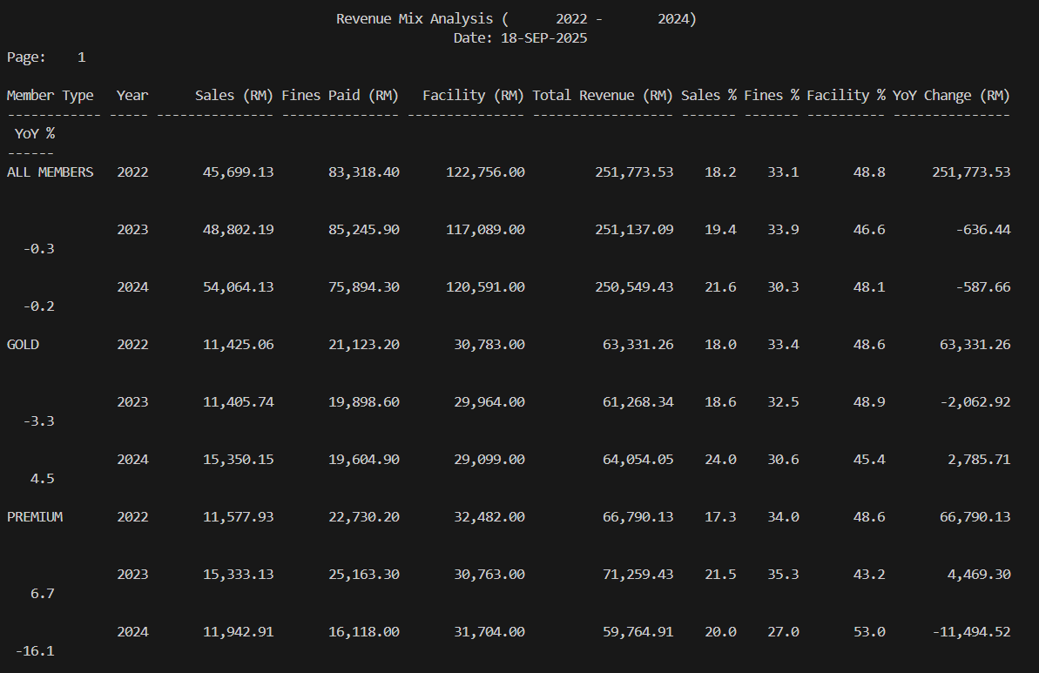
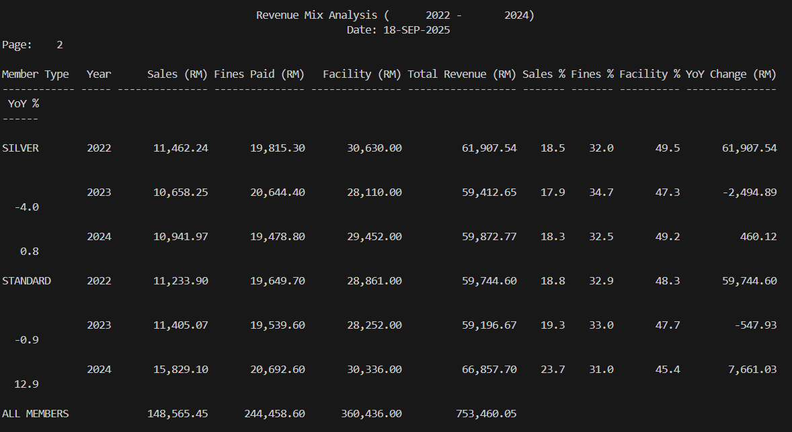
Over three years, the overall revenue is generally level but slightly declining from RM251,773.53 to RM251,137.09, then dropping to RM250.549.43. The change in composition is greater than the aggregate, share of sales increases around 18.2% to 21.6%, and fines share decreases around 33.1% to 30.3%, and facility is almost equal to half of income. Segmentally, Standard increases at a good rate, year over year change at +12.9% in 2024 and GOLD increases +4.5%, their sales are strong as continue rise from 2022 to 2024, and SILVER is more or less an even score, increase +0.8% led by facility, and Premium is declining steeply at -16.1% with a sizeable decrease in fines. The negative driver at the “All Members” line is fines paid with an approximate value of -RM9.35K in 2024 and hence the deceleration in totals despite gains in other parts. This is important as it reveals fines-dependence as compliance is enhanced or the enforcement comforts the revenue declines unless the value streams like sales, facility compensate. 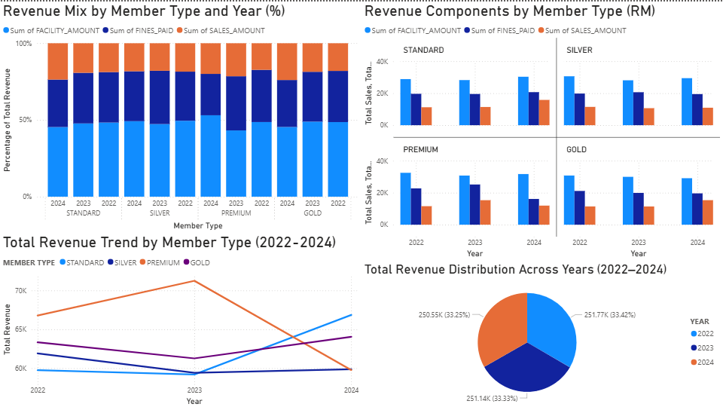
According to the visualization above, it is apparent that total revenue between 2022-2024 is trending straight, but composition is changing. The Revenue Mix by Member Type and Year chart indicates that sales are increasing, and fines are decreasing, with the facility fees representing about half of the mix. The small-multiple charts cause the drivers to be clear, Standard and Gold are on the rise on sales, Silver is on the rise on facility, Premium is falling mostly because fines are declining, and the trend line confirms the revenue trend like Standard has a big increase on revenue from 2023 to 2024 even there is a small drop from 2022 to 2024, and Premium has a big drop from 2023 to 2024 whereas the year-share donut indicates that totals are similar by year, and the problem is mix, not volume. This is important, as a budget based on the fines is fluctuating when compliance increases or the enforcement is softer, then cash will decline unless value streams like sales and facility revenue fill in. This is why 2024 softens even with increases in Standard and Gold. This is probably due to successful campaigns that targeted sales based on Standard that was not expanded in other levels, better payment and behavior of Premium that lowers fines and consistent facility pricing that has failed to optimize on yield. The decision is to reduce the mix risk by target fines less than 25% of revenue and increase sales in Gold and Silver with bundles of Standard, recoveries and add-ons. Initiate a Premium recovery program with facility bundles like Weekend Focus10 with 10 weekend hours at 20% off, preference access like 72-hour priority booking, one-click +30 minutes automatic extension when the next time slot is free, and curated sales like course starter pack, save about 10% on Premium to replace the fines decline and introduce light peak and off-peak pricing and add-ons to increase facility yield without restriction. Monitor execution using cards of year over year change percentage by type of member and Sales, Fines, and Facility percent and a Main Driver indicator using the small-multiple and trend charts that the growth in revenue on sales and facility and not penalties is achieved by each segment.

3.2.3 Facility Utilization Summary Report (2023-2024)
SQL CODE:
SET LINESIZE 130
SET PAGESIZE 35
SET TRIMSPOOL ON
SET VERIFY OFF
SET FEEDBACK OFF
SET SQLBLANKLINES ON
SET TAB OFF
ALTER SESSION SET NLS_DATE_FORMAT = 'DD-MON-YYYY';

COLUMN run_dt NEW_VALUE _run_dt
SELECT TO_CHAR(SYSDATE,'DD-MON-YYYY') AS run_dt FROM dual;

ACCEPT p_year NUMBER PROMPT 'Enter Year to Analyze: '
ACCEPT p_fac_type CHAR DEFAULT 'ALL' PROMPT 'Facility type (or ALL): '
ACCEPT p_wkend CHAR DEFAULT 'ALL' PROMPT 'Day type [WEEKDAY/WEEKEND/ALL]: '

COLUMN start_year NEW_VALUE _start_year
SELECT &p_year - 1 AS start_year FROM dual;

TTITLE CENTER 'Facility Utilization Summary Report (&_start_year - &p_year)' SKIP 1 -
CENTER 'Facility: &p_fac_type | Day: &p_wkend' SKIP 1 -
LEFT 'Date: &_run_dt' RIGHT 'Page: ' FORMAT 999 SQL.PNO SKIP 2

COLUMN facility_type FORMAT A20 HEADING 'Facility Type'
COLUMN day_type FORMAT A9 HEADING 'Day'
COLUMN cal_year FORMAT 9999 HEADING 'Year'
COLUMN bookings FORMAT 999,990 HEADING 'Bookings'
COLUMN members FORMAT 999,990 HEADING 'Members'
COLUMN total_fee FORMAT 999,999,990.00 HEADING 'Fee (RM)'
COLUMN avg_fee FORMAT 999,990.00 HEADING 'Avg Fee'
COLUMN yoy_change FORMAT 999,999,990.00 HEADING 'YoY Change (RM)'
COLUMN yoy_pct FORMAT 990.0 HEADING 'YoY %'

CREATE OR REPLACE VIEW vw_facility_utilization AS
SELECT
f.facility_type,
d.cal_year,
CASE WHEN UPPER(d.weekend_ind) = 'Y' THEN 'WEEKEND' ELSE 'WEEKDAY' END AS day_type,
fb.member_surrogate_key,
fb.fee
FROM fact_facility_booking fb
JOIN dim_facility f ON f.facility_key = fb.facility_key AND f.is_current_flag = 'Y'
JOIN dim_date d ON d.date_key = fb.booking_date_key;

BREAK ON facility_type SKIP 1 ON day_type SKIP 1

WITH data AS (
SELECT
cal_year,
facility_type,
day_type,
COUNT(*) AS bookings,
COUNT(DISTINCT member_surrogate_key) AS members,
SUM(fee) AS total_fee,
AVG(fee) AS avg_fee
FROM vw_facility_utilization
WHERE cal_year IN (&p_year - 1, &p_year)
AND (UPPER('&p_fac_type') = 'ALL' OR UPPER(facility_type) = UPPER('&p_fac_type'))
AND (UPPER('&p_wkend') = 'ALL' OR day_type = UPPER('&p_wkend'))
GROUP BY cal_year, facility_type, day_type
),
ranked AS (
SELECT
facility_type,
day_type,
cal_year,
bookings,
members,
total_fee,
avg_fee,
LAG(total_fee) OVER (PARTITION BY facility_type, day_type ORDER BY cal_year) AS prev_total_fee
FROM data
)
SELECT
facility_type,
day_type,
cal_year,
bookings,
members,
total_fee,
avg_fee,
(total_fee - prev_total_fee) AS yoy_change,
CASE WHEN prev_total_fee = 0 THEN NULL
ELSE ROUND(100 * (total_fee - prev_total_fee) / prev_total_fee, 1)
END AS yoy_pct
FROM ranked
ORDER BY facility_type, day_type, cal_year;

CLEAR COLUMNS
TTITLE OFF
BTITLE OFF

SQL Output:
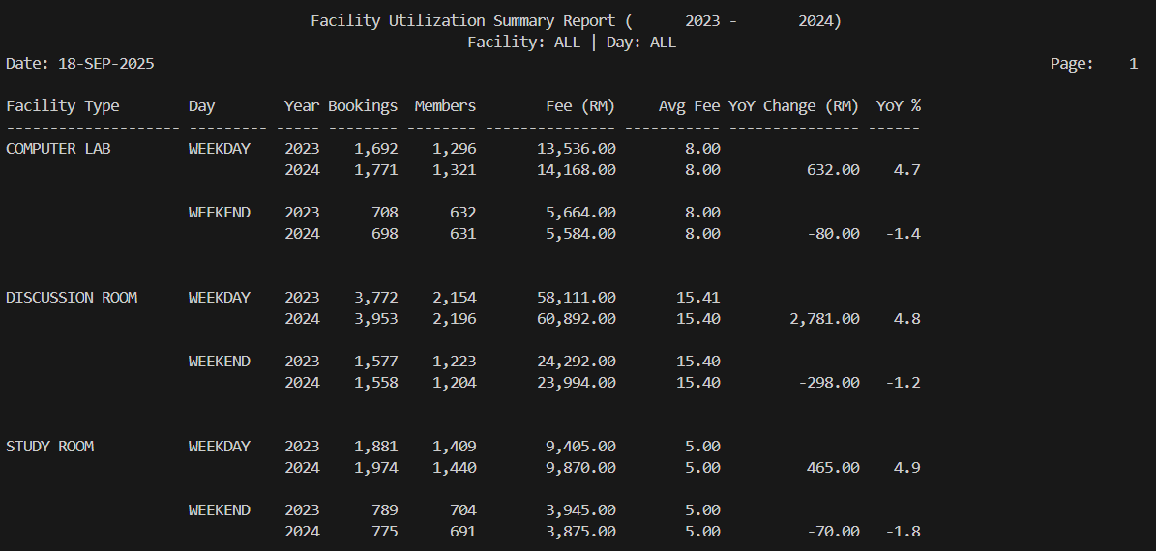
According to the query, there is a clear tendency in all the facilities. The revenue and bookings on weekdays grew by about 4 to 5 percent, whereas on weekends, the same figure dropped by about 1 to 2 percent. As an illustration, the Computer Lab increased on weekdays as fees increased from RM13,536 to RM14,168, +4.7% change, total bookings from 1,692 to 1,771 and decreased on weekends as fees drop from RM5,664 to RM5,584. Our largest earner, Discussion Rooms, increased during weekdays as fees increased from RM58,111 to RM60,892, +4.8% change and decreased a little on weekends like −1.2%. The same split is exhibited in Study Rooms as +4.9% change on weekdays, -1.8% change on weekends. Mean booking price remained constant approximately RM8 per lab, RM15.4 for a discussion room, RM5 for a study room, making volume rather than price to be a motivation behind the change.
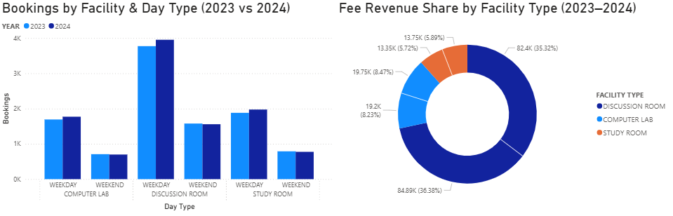In all facilities, there is an evident change in the weekday demand. Discussion Rooms, increase back on weekdays in 2024, and decrease on weekends. Computer Lab and Study Rooms are similar. Since charges are charged by the facility, it is a volume-oriented change, which has the risk of congestion in the weekdays and a low use of weekends. The donut validates that Discussion Rooms drive about 70 percent of the fee income, therefore, this can be influenced by minor usage shifts in the Discussion Rooms to a large degree. Strike on two sides, safeguard peak weekdays, slightly decrease peak slots, distribute bookings among hours, and match personnel to the busiest windows, particularly Discussion Rooms. Second, rebalance to weekends, test off-peak incentives such as weekend discounts and bundles, include weekend-only benefits like longer block, priority rooms, small freebies, and place booking nudges which offer similar weekend times when weekday blocks are occupied. Calculate weekend share, peak-hour utilization, and turn-away and wait cards to determine impact tracking that will keep weekends off with the peak load and not cause it to become weekday pressure.

3.3.1 TOP 3 Borrowing Trends Report By Member (2022 to 2025)
SQL CODE:
SET SERVEROUTPUT ON
SET LINESIZE 130
SET PAGESIZE 35
SET FEEDBACK OFF
SET VERIFY OFF
SET SQLBLANKLINES ON

TTITLE CENTER 'TOP 3 Borrowing Trends Report By Member (2022 to 2025)' SKIP 1 -
LEFT 'Report Date: ' _DATE RIGHT 'Page: ' SQL.PNO SKIP 2

BREAK ON cal_year SKIP 1 ON member_type SKIP 1

COLUMN cal_year FORMAT 9999 HEADING 'Year'
COLUMN member_type FORMAT A12 HEADING 'Member Type'
COLUMN genre FORMAT A20 HEADING 'Book Genre'
COLUMN selection_reason FORMAT A20 HEADING 'Selection Reason'
COLUMN total_borrowings FORMAT 999,999 HEADING 'Total Borrowings'
COLUMN avg_borrow_days FORMAT 99.9 HEADING 'Avg Borrow Days'
COLUMN avg_popularity FORMAT 99.9 HEADING 'Avg Pop Score'

WITH base AS (
SELECT
dd.cal_year AS cal_year,
dm.member_type_name AS member_type,
db.genre_name AS genre,
CASE
WHEN fb.was_reserved = 'Y' THEN 'High Demand'
WHEN db.popularity_scores >= 8 THEN 'Popular'
WHEN db.popularity_scores < 5 THEN 'Niche'
ELSE 'Standard'
END AS selection_reason,
CASE
WHEN fb.return_date_key IS NOT NULL THEN (rd.cal_date - bd.cal_date)
ELSE (NVL(nd.cal_date, od.cal_date) - bd.cal_date)
END AS borrow_days,
db.popularity_scores AS pop_score
FROM fact_borrowing fb
JOIN dim_member dm ON fb.member_surrogate_key = dm.member_surrogate_key
JOIN dim_book db ON fb.book_key = db.book_key
JOIN dim_date dd ON fb.borrow_date_key = dd.date_key
JOIN dim_date bd ON fb.borrow_date_key = bd.date_key
LEFT JOIN dim_date rd ON fb.return_date_key = rd.date_key
LEFT JOIN dim_date nd ON fb.new_due_date_key = nd.date_key
JOIN dim_date od ON fb.original_due_date_key = od.date_key
WHERE dm.is_current_flag = 'Y'
AND db.is_current_flag = 'Y'
AND dd.cal_year BETWEEN 2022 AND 2025
),
agg AS (
SELECT
cal_year,
member_type,
genre,
selection_reason,
COUNT(*) AS total_borrowings,
ROUND(AVG(borrow_days),1) AS avg_borrow_days,
ROUND(AVG(pop_score),1) AS avg_popularity
FROM base
GROUP BY cal_year, member_type, genre, selection_reason
),
ranked AS (
SELECT a.*,
ROW_NUMBER() OVER (
PARTITION BY cal_year, member_type
ORDER BY total_borrowings DESC
) AS rk
FROM agg a
)
SELECT
cal_year,
member_type,
genre,
selection_reason,
total_borrowings,
avg_borrow_days,
avg_popularity
FROM ranked
WHERE rk <= 3
ORDER BY cal_year, member_type, total_borrowings DESC;

TTITLE OFF
SET FEEDBACK ON
SET VERIFY ON

SQL Output:
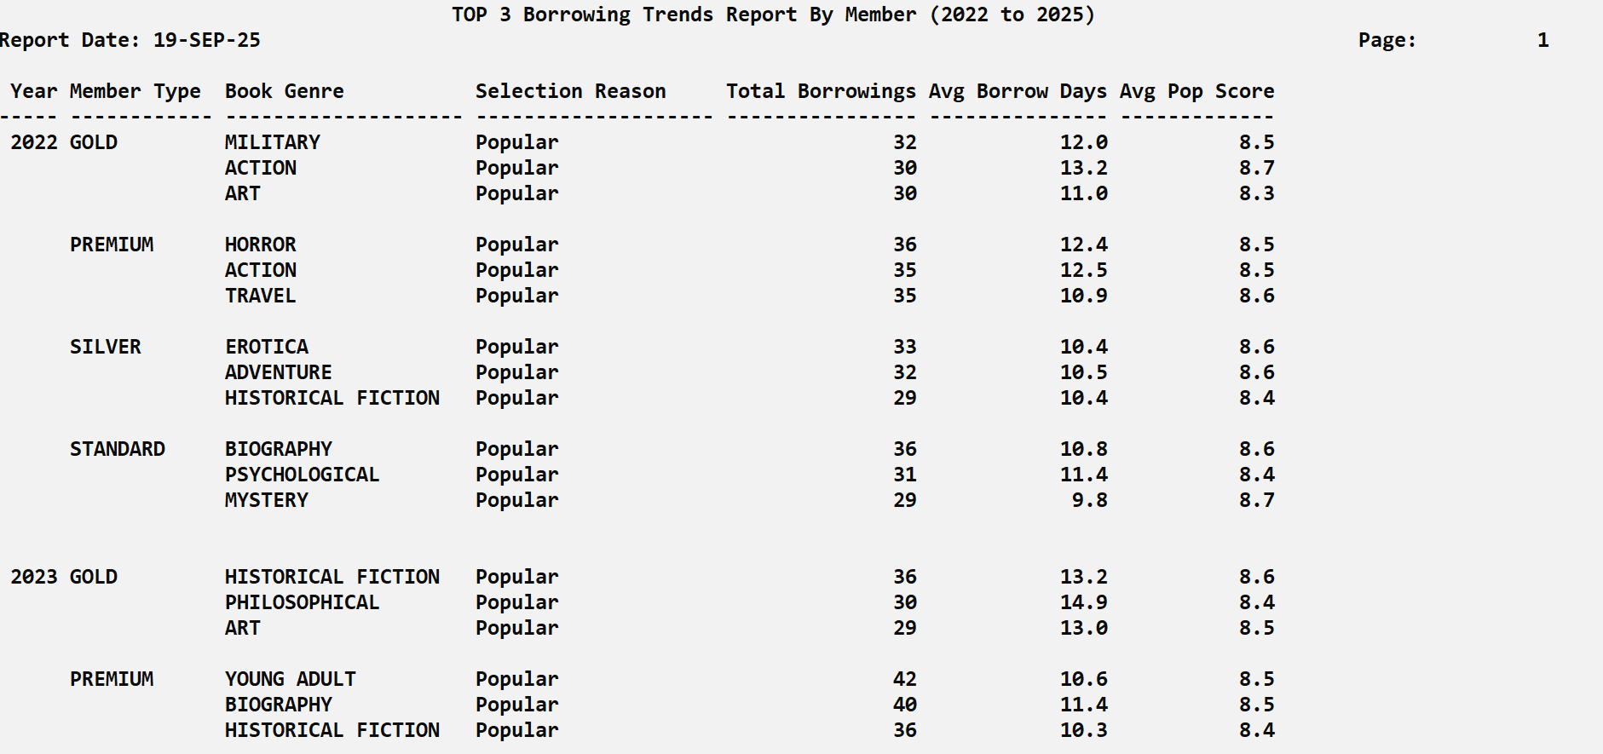
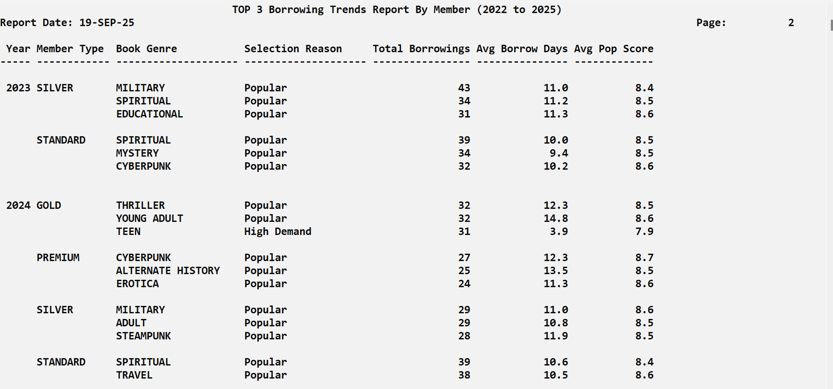
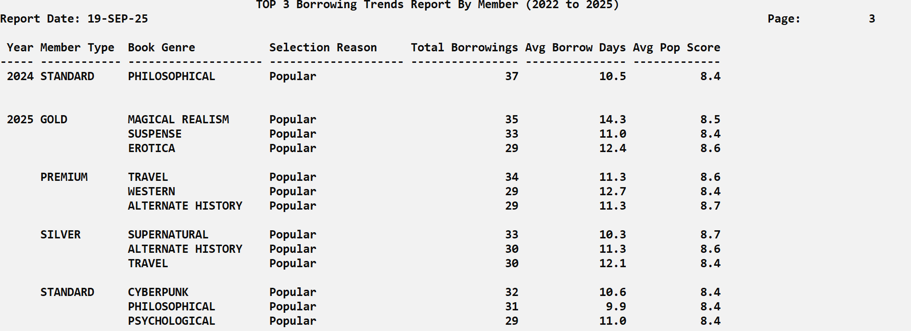

Within this query, the selection reason column is derived from a rule that combines reservation status with popularity scores. If a book was reserved, it is classified as “High Demand”, reflecting titles that trigger strong user urgency. Books with an average popularity score of 8 or above are labeled as “Popular”, emphasizing their broad appeal across readers. Conversely, books with a score below 5 are categorized as “Niche”, indicating more specialized or limited-interest content. All other titles are marked as “Standard”, representing typical borrowing activity.
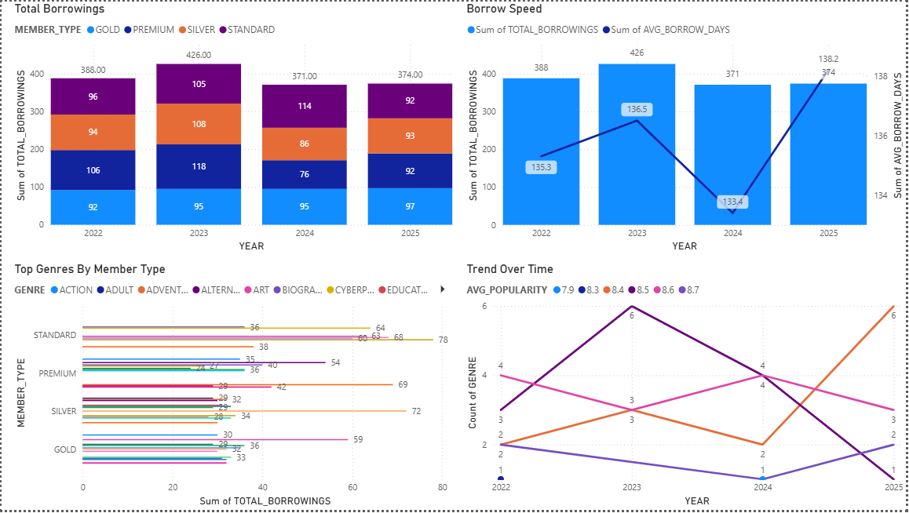
Between 2022 and 2025, borrowing activity showed both reliability and imbalance across member tiers. Premium and Gold members consistently provided the most stable circulation, borrowing steadily and returning titles within reasonable timeframes. In contrast, Silver members tended to hold books longer, slowing down availability, while Standard members remained the least engaged, contributing minimally to overall activity. Borrowing speed peaked in 2023, when books moved quickly through the system, but slowed in 2024 as average holding days rose sharply. Genre patterns added to this pressure: Standard members clustered around popular titles such as Action and Adventure, while Premium and Gold members spread their choices more evenly across genres. Over time, reliance on “hot” titles created preference fatigue, with demand narrowing and diversity declining. Looking ahead, this imbalance poses risks. Slower circulation from larger groups, coupled with heavy demand for the same few genres, may reduce member satisfaction and limit access. To sustain healthy turnover, the library should refine loan policies for slower-returning members, encourage exploration of less-borrowed genres, and design incentives that reward balanced borrowing. These steps will help maintain circulation efficiency, protect genre diversity, and keep engagement strong across all tiers.

3.3.2 Membership Growth And Retention Report (2022 to 2025)
SQL Code:
SET SERVEROUTPUT ON
SET LINESIZE 130
SET PAGESIZE 35
SET FEEDBACK OFF
SET VERIFY OFF
SET SQLBLANKLINES ON

TTITLE CENTER 'Membership Growth And Retention Report (2022 to 2025)' SKIP 1 -
LEFT 'Report Date: ' _DATE RIGHT 'Page: ' SQL.PNO SKIP 2

BREAK ON cal_year SKIP 1 ON type SKIP 1

COLUMN cal_year FORMAT 9999 HEADING 'Year'
COLUMN type FORMAT A12 HEADING 'Member Type'
COLUMN status FORMAT A10 HEADING 'Status'
COLUMN new_members FORMAT 9,999 HEADING 'New Members'
COLUMN total_members FORMAT 9,999 HEADING 'Total Members'
COLUMN total_borrowings FORMAT 9,999 HEADING 'Total Borrowed'
COLUMN avg_borrowings FORMAT 999.9 HEADING 'Avg Borrowed'

WITH base AS (
SELECT
EXTRACT(YEAR FROM m.registration_date) AS cal_year,
m.member_type_name AS type,
m.membership_status AS status,
m.member_id AS member_id,
COUNT(fb.borrowing_id) AS borrowed
FROM dim_member m
LEFT JOIN fact_borrowing fb
ON m.member_surrogate_key = fb.member_surrogate_key
WHERE m.is_current_flag = 'Y'
AND m.registration_date BETWEEN TO_DATE('2022-01-01','YYYY-MM-DD')
AND TO_DATE('2025-12-31','YYYY-MM-DD')
GROUP BY
EXTRACT(YEAR FROM m.registration_date),
m.member_type_name,
m.membership_status,
m.member_id
),

total_reg AS (
SELECT
EXTRACT(YEAR FROM registration_date) AS cal_year,
member_type_name AS type,
membership_status AS status,
COUNT(*) AS total_members
FROM dim_member
WHERE registration_date BETWEEN TO_DATE('2023-01-01','YYYY-MM-DD')
AND TO_DATE('2025-12-31','YYYY-MM-DD')
GROUP BY
EXTRACT(YEAR FROM registration_date),
member_type_name,
membership_status
),

aggregated AS (
SELECT
cal_year,
type,
status,
new_members,
SUM(new_members) OVER (
PARTITION BY type, status
ORDER BY cal_year
ROWS BETWEEN UNBOUNDED PRECEDING AND CURRENT ROW
) AS total_members,
total_borrowings,
avg_borrowings
FROM (
SELECT
b.cal_year,
b.type,
b.status,
COUNT(DISTINCT b.member_id) AS new_members,
SUM(b.borrowed) AS total_borrowings,
ROUND(AVG(b.borrowed),1) AS avg_borrowings
FROM base b
GROUP BY b.cal_year, b.type, b.status
) g
)

SELECT
cal_year, type, status,
new_members, total_members, total_borrowings, avg_borrowings
FROM aggregated
ORDER BY cal_year, type, status;

TTITLE OFF
SET FEEDBACK ON
SET VERIFY ON

SQL Output:
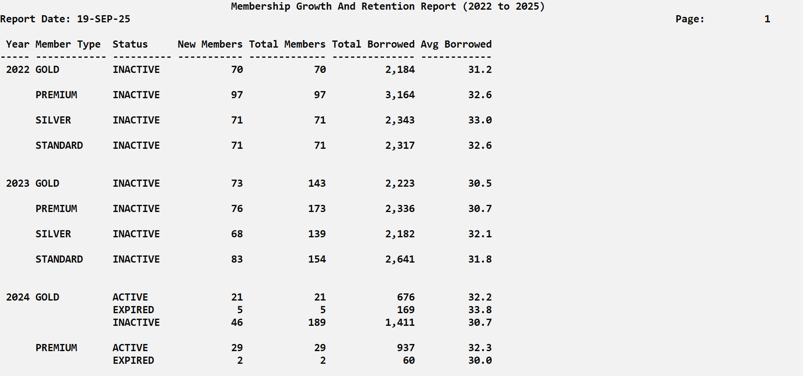
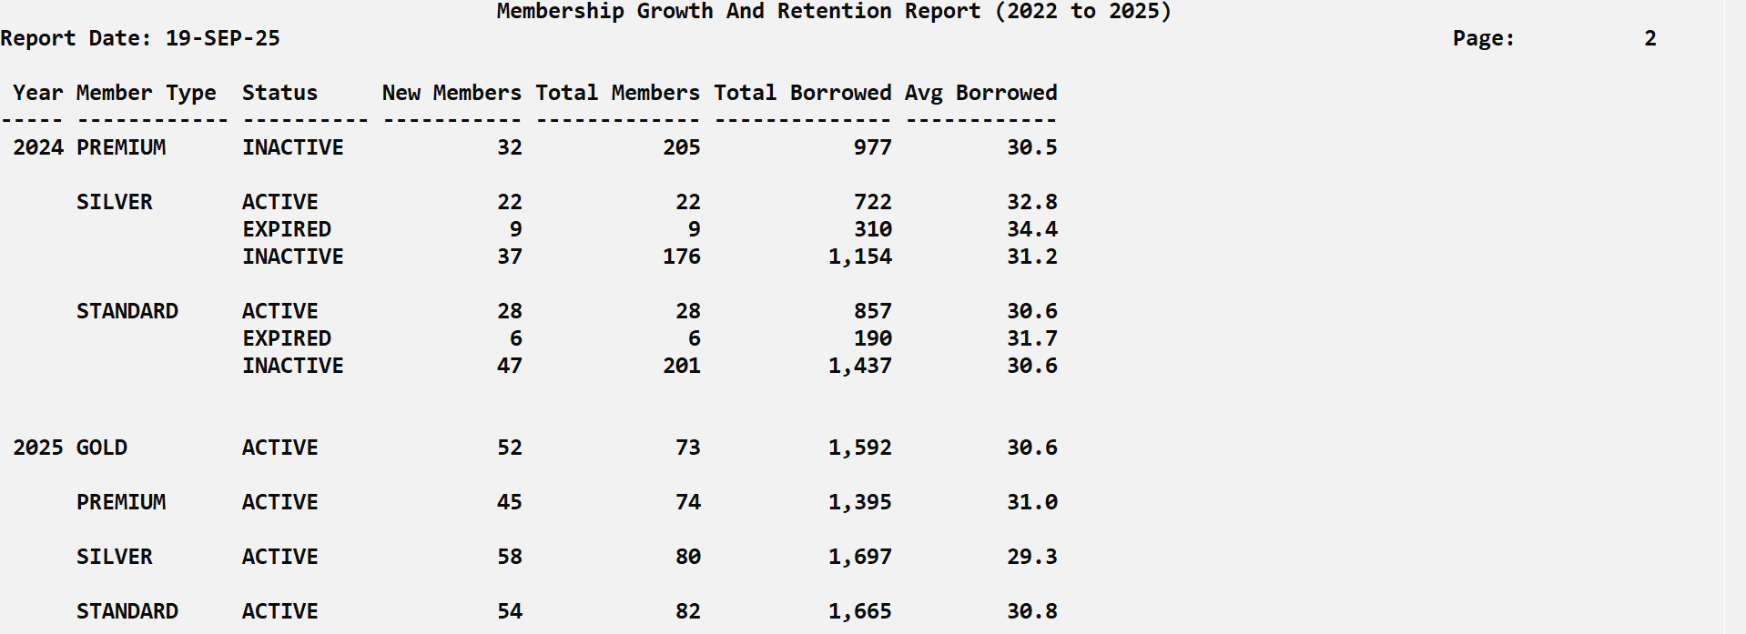

In this query, “New Members” represent the number of individuals who registered during a specific year, segmented by membership type and status, while “Total Members” show the cumulative sum of all new members from the first observed year up to the current year. In other words, New Members highlight annual recruitment performance, whereas Total Members reflect the long-term growth of the membership base over time.

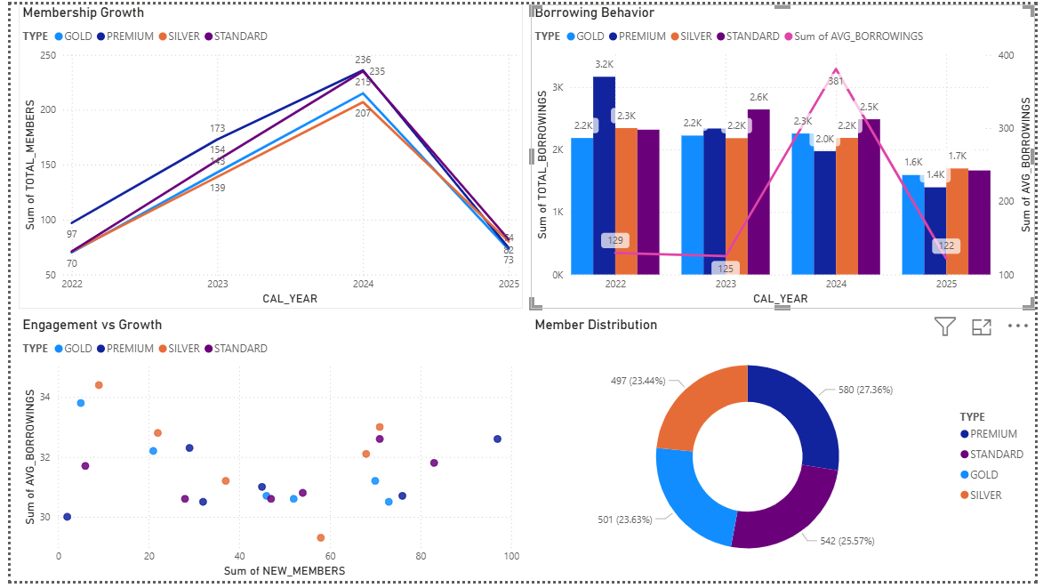
During 2022–2025, membership and borrowing dynamics revealed strong growth early on but gave way to instability by 2025, when both new sign-ups and borrowing activity dropped sharply. Premium and Gold members consistently stood out as the most engaged, borrowing frequently and showing loyalty despite market shifts. By contrast, Standard and Silver members, although larger in number, produced weaker engagement, contributing to a mismatch between overall membership volume and actual borrowing value. Borrowing patterns spiked in 2024, fueled by rapid growth and high activity, but this surge was unsustainable, leading to a steep contraction in 2025. Engagement versus growth data confirmed that new members, particularly in Standard and Silver tiers, did not translate into proportional borrowing, highlighting a gap in value realization. The member distribution further underscored this imbalance, with lower-tier groups holding significant shares but delivering limited returns. If this trajectory continues, the library faces growing risks of over-reliance on less committed members, higher churn, and declining circulation efficiency. The key insight is that resilience rests with Premium and Gold, whose steady activity sustains the system. To strengthen performance, the library should deploy targeted campaigns during weak periods, reward sustained borrowing to reinforce loyalty, incentivize upgrades from Standard and Silver to higher tiers, and balance resources to encourage consistent participation across all segments. These steps would stabilize growth, reduce lapses, and secure long-term sustainability.

3.3.3 Member Segmentation And Behavior Report (2022 to 2025)
SQL Code:
SET SERVEROUTPUT ON
SET LINESIZE 130
SET PAGESIZE 35
SET FEEDBACK OFF
SET VERIFY OFF
SET SQLBLANKLINES ON

TTITLE CENTER 'Member Segmentation And Behavior Report (2022 to 2025)' SKIP 1 -
LEFT 'Report Date: ' _DATE RIGHT 'Page: ' SQL.PNO SKIP 2

COLUMN cal_year FORMAT 9999 HEADING 'Year'
COLUMN member_type_name FORMAT A15 HEADING 'Member Type'
COLUMN members_in_group FORMAT 999,999 HEADING 'Members'
COLUMN total_books_borrowed FORMAT 9,999,999 HEADING 'Books Borrowed'
COLUMN total_facilities_booked FORMAT 9,999,999 HEADING 'Facilities Booked'
COLUMN total_book_sales FORMAT 999,999 HEADING 'Books Purchased'
COLUMN total_fines_amount FORMAT 99,999,999.99 HEADING 'Total Fines'
COLUMN avg_monthly_activity FORMAT 9999.9 HEADING 'Avg Activity'
COLUMN avg_beh_sc FORMAT 9999.9 HEADING 'Avg Behavior Score'

WITH
B AS (
SELECT fb.member_surrogate_key, d.cal_year, COUNT(DISTINCT fb.borrowing_id) AS total_borrows
FROM fact_borrowing fb
JOIN dim_date d ON d.date_key = fb.borrow_date_key
WHERE d.cal_year BETWEEN 2022 AND 2025
GROUP BY fb.member_surrogate_key, d.cal_year
),
BK AS (
SELECT ffb.member_surrogate_key, d.cal_year, COUNT(DISTINCT ffb.facility_booking_id) AS total_bookings
FROM fact_facility_booking ffb
JOIN dim_date d ON d.date_key = ffb.booking_date_key
WHERE d.cal_year BETWEEN 2022 AND 2025
GROUP BY ffb.member_surrogate_key, d.cal_year
),
S AS (
SELECT fbs.member_surrogate_key, d.cal_year, COUNT(DISTINCT fbs.sales_id) AS total_sales
FROM fact_book_sale fbs
JOIN dim_date d ON d.date_key = fbs.sale_date_key
WHERE d.cal_year BETWEEN 2022 AND 2025
GROUP BY fbs.member_surrogate_key, d.cal_year
),
F AS (
SELECT ff.member_surrogate_key, d.cal_year, SUM(ff.fine_amount) AS total_fines
FROM fact_fines ff
JOIN dim_date d ON d.date_key = ff.fine_date_key
WHERE d.cal_year BETWEEN 2022 AND 2025
GROUP BY ff.member_surrogate_key, d.cal_year
),
MEMBER_METRICS AS (
SELECT
dm.member_surrogate_key,
dm.member_type_name,
d.cal_year,
NVL(b.total_borrows,0) AS total_borrows,
NVL(bk.total_bookings,0) AS total_bookings,
NVL(s.total_sales,0) AS total_sales,
NVL(f.total_fines,0) AS total_fines,
ROUND( ( NVL(b.total_borrows,0)
+ NVL(bk.total_bookings,0)
+ NVL(s.total_sales,0) ) / 3.0, 1) AS avg_monthly_activity,
ROUND(
(CASE
WHEN dm.member_type_name = 'PREMIUM' THEN 10.0
WHEN dm.member_type_name = 'GOLD' THEN 9.0
WHEN dm.member_type_name = 'SILVER' THEN 7.0
ELSE 5.0
END)
+ (NVL(b.total_borrows,0) * 0.5)
+ (NVL(bk.total_bookings,0) * 0.3)
+ (NVL(s.total_sales,0) * 0.2)
- (NVL(f.total_fines,0) * 0.1)
, 1) AS beh_sc
FROM dim_member dm
JOIN dim_date d ON d.cal_year BETWEEN 2022 AND 2025
LEFT JOIN B b ON b.member_surrogate_key = dm.member_surrogate_key AND b.cal_year = d.cal_year
LEFT JOIN BK bk ON bk.member_surrogate_key = dm.member_surrogate_key AND bk.cal_year = d.cal_year
LEFT JOIN S s ON s.member_surrogate_key = dm.member_surrogate_key AND s.cal_year = d.cal_year
LEFT JOIN F f ON f.member_surrogate_key = dm.member_surrogate_key AND f.cal_year = d.cal_year
WHERE dm.is_current_flag = 'Y'
),
GROUPED AS (
SELECT
cal_year,
member_type_name,
COUNT(*) AS members_in_group,
SUM(total_borrows) AS total_books_borrowed,
SUM(total_bookings) AS total_facilities_booked,
SUM(total_sales) AS total_book_sales,
SUM(total_fines) AS total_fines_amount,
ROUND(AVG(avg_monthly_activity),1) AS avg_monthly_activity,
ROUND(AVG(beh_sc),1) AS avg_beh_sc
FROM MEMBER_METRICS
GROUP BY cal_year, member_type_name
)

SELECT *
FROM GROUPED
ORDER BY cal_year, member_type_name;

TTITLE OFF
SET FEEDBACK ON
SET VERIFY ON

SQL Output:
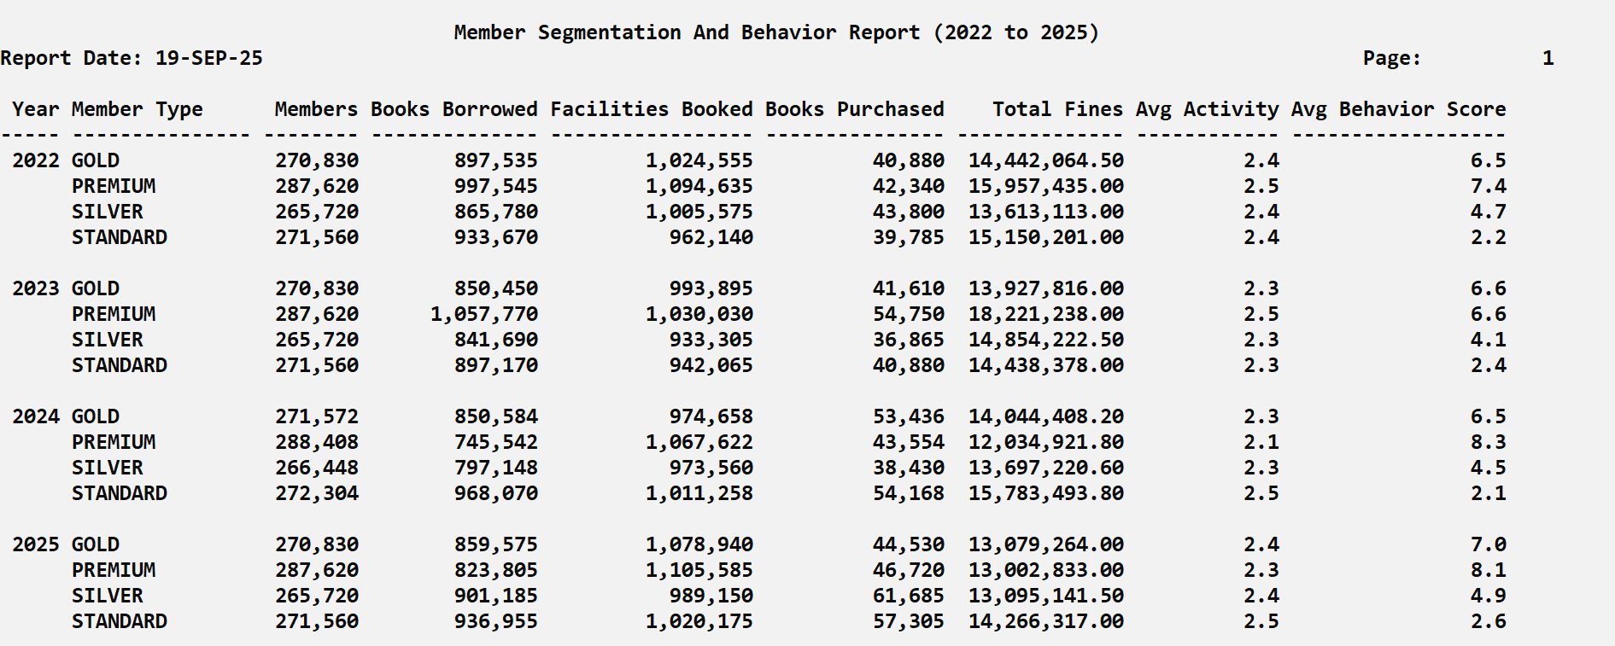
The Monthly Activity Score is calculated by averaging a member’s borrowings, facility bookings, and book purchases, providing a simple measure of overall engagement. The Behavior Score builds on this by starting with a base value determined by membership type and then adjusting it with weighted contributions from activities like borrowing (+0.5 each), facility booking (+0.3 each), and book purchase (+0.2 each) while fines reduce the score slightly (–0.1 per unit). Rounded to one decimal, this score reflects both activity and responsibility in member behavior.
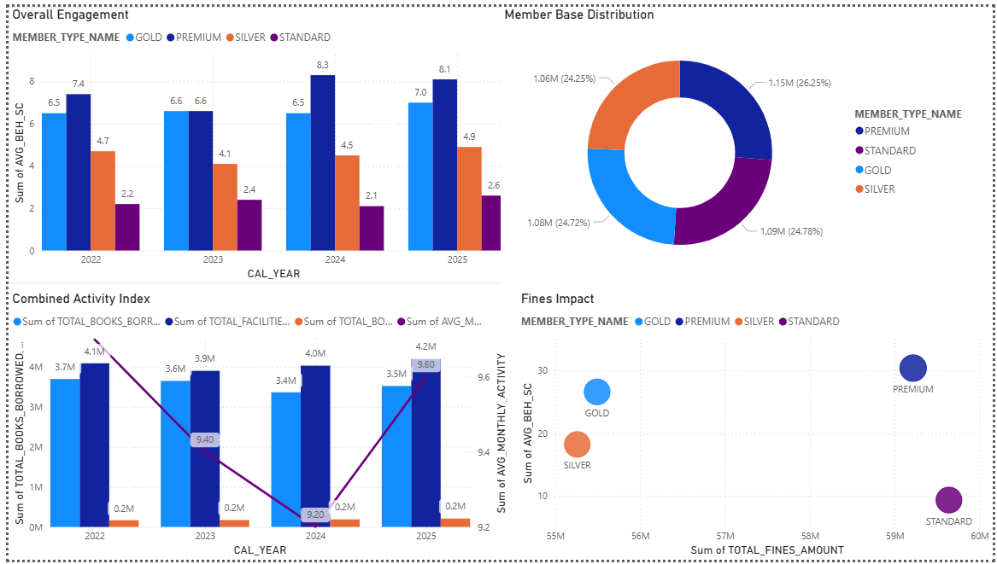
During 2022–2025, engagement patterns revealed consistent imbalances across membership tiers. Premium and Gold members sustained higher activity levels, contributing reliably to borrowing, facilities use, and overall engagement, while Silver and Standard groups lagged, despite holding nearly half of the membership base. This uneven performance created a structural weakness: volume was concentrated in lower-performing groups, while real value was driven by smaller, higher-tier segments. The combined activity index peaked in 2022 but gradually declined through 2024 before rebounding in 2025. However, the recovery was uneven—activity scores improved for Premium and Gold, while Silver and Standard continued to underperform. Fines data reinforced this divide, showing Standard members incurring the heaviest penalties, further eroding their efficiency and contribution. If this trajectory continues, future quarters may see sharper drops in overall engagement as underperforming segments disengage, threatening circulation efficiency and membership sustainability. The key insight is that long-term stability depends on reinforcing top-tier loyalty while addressing weaknesses in the larger but less active segments. To improve outcomes, the library should implement retention and reactivation programs for Silver and Standard members, incentivize consistent participation with targeted rewards, and sustain the momentum of Premium and Gold through tailored loyalty benefits. This balanced approach would strengthen overall efficiency, reduce churn risk, and secure sustainable growth across all tiers.

3.4.1 Festive Event Strategic Performance Analysis (2022-2024)

SET LINESIZE 130
SET PAGESIZE 50
SET TRIMSPOOL ON

COLUMN run_date NEW_VALUE _run_date
SELECT TO_CHAR(SYSDATE, 'DD-MON-YYYY') run_date FROM dual;

TTITLE LEFT 'Date: ' _run_date SKIP 1 -
CENTER 'Festive Event Strategic Performance Analysis (2022-2024)' -
SKIP 1 CENTER 'Revenue Impact and Operational Metrics by Event' -
SKIP 1 RIGHT 'Page: ' SQL.PNO

COLUMN festive_category FORMAT A18 HEADING 'Festive|Category'
COLUMN festive_event FORMAT A22 HEADING 'Festive Event'
COLUMN gross_revenue FORMAT 99,999,999.99 HEADING 'Gross Revenue|(RM)'
COLUMN daily_avg FORMAT 99,999,999.99 HEADING 'Daily Avg|(RM)'
COLUMN vs_baseline FORMAT 9999.99 HEADING 'vs Base|(x)'
COLUMN roi_index FORMAT 999,999.99 HEADING 'ROI|Index'
COLUMN action FORMAT A12 HEADING 'Action'

BREAK ON year SKIP PAGE ON festive_category SKIP 1

WITH festive_data AS (
SELECT
dd.cal_year AS year,
dd.festive_event,

CASE
WHEN dd.festive_event IN ('CHINESE NEW YEAR', 'HARI RAYA AIDILFITRI', 'DEEPAVALI', 'CHRISTMAS')
THEN '1-MAJOR FESTIVALS'
WHEN dd.festive_event IN ('NEW YEAR', 'NATIONAL DAY', 'MALAYSIA DAY')
THEN '2-NATIONAL HOLIDAYS'
WHEN dd.festive_event IN ('WESAK', 'THAIPUSAM', 'HARI RAYA HAJI', 'AWAL MUHARRAM', 'MAULIDUR RASUL')
THEN '3-RELIGIOUS EVENTS'
WHEN dd.festive_event = 'LABOUR DAY'
THEN '4-PUBLIC HOLIDAYS'
ELSE '5-OTHER'
END AS festive_category,
COUNT(DISTINCT dd.date_key) AS event_days,
-- Revenue components
NVL(SUM(fs.totalamount), 0) AS book_sales,
NVL(SUM(ffb.fee), 0) AS facility_fees,
NVL(SUM(CASE WHEN ff.payment_status = 'PAID' THEN ff.fine_amount END), 0) AS fine_collections,
-- Operational metrics
COUNT(DISTINCT fb.borrowing_id) AS total_borrows,
COUNT(DISTINCT COALESCE(fb.member_surrogate_key, fs.member_surrogate_key, ffb.member_surrogate_key)) AS engaged_members
FROM dim_date dd
LEFT JOIN fact_borrowing fb ON dd.date_key = fb.borrow_date_key
LEFT JOIN fact_book_sale fs ON dd.date_key = fs.sale_date_key
LEFT JOIN fact_facility_booking ffb ON dd.date_key = ffb.booking_date_key
LEFT JOIN fact_fines ff ON dd.date_key = ff.fine_date_key
WHERE dd.holiday_ind = 'Y'
AND dd.festive_event != 'NONE'
AND dd.cal_year BETWEEN 2022 AND 2024
GROUP BY dd.cal_year, dd.festive_event
),
baseline_metrics AS (
SELECT
cal_year AS year,
AVG(daily_revenue) AS baseline_daily_revenue
FROM (
SELECT
dd.cal_year,
dd.date_key,
NVL(SUM(fs.totalamount), 0) + NVL(SUM(ffb.fee), 0) AS daily_revenue
FROM dim_date dd
LEFT JOIN fact_book_sale fs ON dd.date_key = fs.sale_date_key
LEFT JOIN fact_facility_booking ffb ON dd.date_key = ffb.booking_date_key
WHERE dd.holiday_ind = 'N'
AND dd.weekend_ind = 'N'
GROUP BY dd.cal_year, dd.date_key
)
GROUP BY cal_year
),
performance_analysis AS (
SELECT
fd.year,
fd.festive_category,
fd.festive_event,
(fd.book_sales + fd.facility_fees + fd.fine_collections) AS total_revenue,
(fd.book_sales + fd.facility_fees + fd.fine_collections) / NULLIF(fd.event_days, 0) AS daily_revenue,
bm.baseline_daily_revenue,
-- Simplified ROI Index based on revenue performance and efficiency
((fd.book_sales + fd.facility_fees + fd.fine_collections) / NULLIF(fd.event_days, 0) / NULLIF(bm.baseline_daily_revenue, 0)) *
(fd.total_borrows / NULLIF(fd.engaged_members, 0)) AS roi_index
FROM festive_data fd
JOIN baseline_metrics bm ON fd.year = bm.year
)
SELECT
year,
SUBSTR(festive_category, 3) AS festive_category,
festive_event,
total_revenue AS gross_revenue,
ROUND(daily_revenue, 2) AS daily_avg,
ROUND(daily_revenue / NULLIF(baseline_daily_revenue, 0), 2) AS vs_baseline,
ROUND(roi_index, 2) AS roi_index,
CASE
WHEN roi_index >= 5 THEN 'MAXIMIZE'
WHEN roi_index >= 3 THEN 'INCREASE'
WHEN roi_index >= 2 THEN 'MAINTAIN'
WHEN roi_index >= 1 THEN 'OPTIMIZE'
ELSE 'REDUCE'
END AS action
FROM performance_analysis
ORDER BY year DESC, festive_category, roi_index DESC;

CLEAR COLUMNS
CLEAR BREAKS
TTITLE OFF

SQL Output:
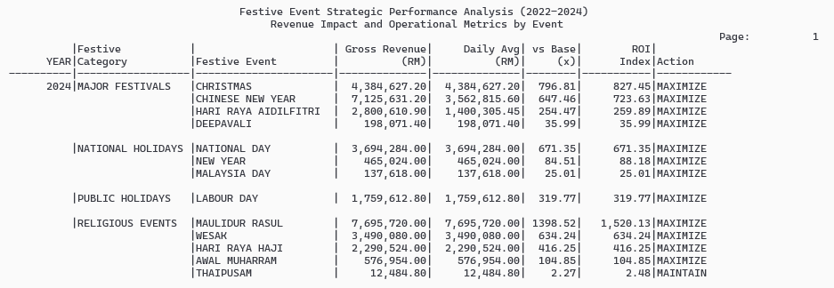
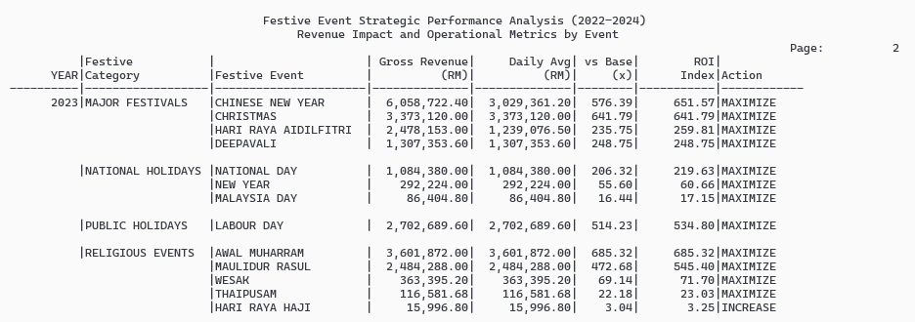
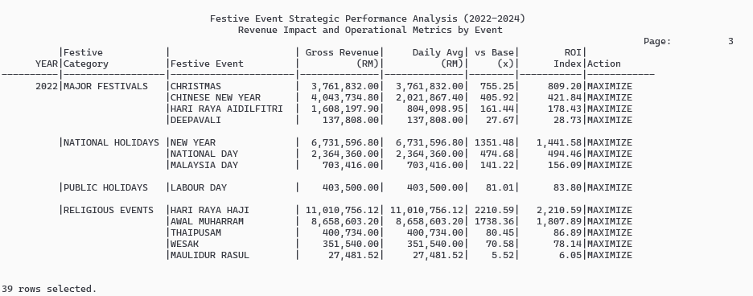

GROSS REVENUE BASED ON FESTIVE EVENT FROM 2022 - 2024

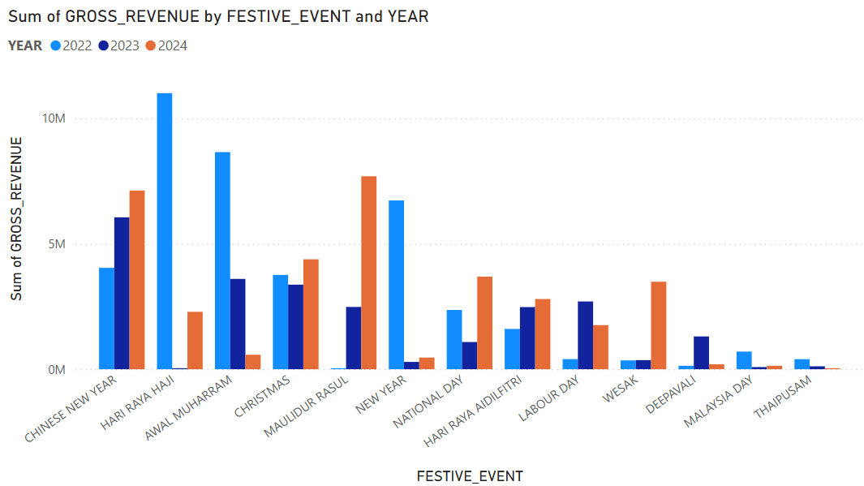
The festive event revenue chart reveals a dramatic shift in cultural engagement patterns across the three years period. In 2022, Chinese New Year dominated with approximately RM4.1 million in revenue, followed by relatively balanced contributions from other major festivals. However, by 2024, a complete reversal occurred where Islamic religious holidays, particularly Hari Raya Haji and Awal Muharram, surged to RM10.8 million and RM8.5 million respectively, while Chinese New Year virtually disappeared from the revenue stream. This transformation suggests either a significant demographic shift in the library's user base or a fundamental change in service offerings during these periods.

The library appears to have successfully captured the Islamic holiday market, possibly through targeted programming, extended hours or culturally relevant collections. The exponential growth in Hari Raya Haji revenue from RM6.8 million to RM10.8 million within one year indicates a successful strategy that should be documented and replicated. Conversely, the collapse of Chinese New Year revenue from a leading position to near-zero demands immediate investigation. This could indicate operational failures, competing services or demographic changes that management must address. The consistent underperformance of national holidays like Malaysia Day and National Day, generating less than RM1 million annually, suggests these patriotic events lack compelling library programming and represent untapped potential.

3.4.2 Top 5 Genre Performance and Investment Priority Comparison Report (2022 - 2024)

SET LINESIZE 130
SET PAGESIZE 50
SET TRIMSPOOL ON
SET VERIFY OFF
SET FEEDBACK OFF

COLUMN run_date NEW_VALUE _run_date
SELECT TO_CHAR(SYSDATE, 'DD-MON-YYYY') run_date FROM dual;

TTITLE LEFT 'Date: ' _run_date SKIP 1 -
CENTER 'TOP 5 GENRE PERFORMANCE AND INVESTMENT PRIORITY COMPARISON' SKIP 1 -
CENTER 'Trend Analysis: 2022-2024' RIGHT 'Page: ' SQL.PNO SKIP 2

BREAK ON year SKIP 2

COLUMN year FORMAT 9999 HEADING 'Year'
COLUMN rank FORMAT 99 HEADING 'Rank'
COLUMN genre FORMAT A16 HEADING 'Genre'
COLUMN total_demand FORMAT 99999 HEADING 'Total|Demand'
COLUMN revenue FORMAT 9999.99 HEADING 'Revenue|(RM)'
COLUMN growth_rate FORMAT 999.99 HEADING 'Growth|%'
COLUMN efficiency FORMAT 99.99 HEADING 'Effic|%'
COLUMN priority FORMAT A15 HEADING 'Action Priority'

WITH annual_performance AS (
SELECT
-- WHEN: Annual periods for 3-year comparison
dd.cal_year AS year,
-- WHAT: Genre performance metrics
db.genre_name,
-- WHO: Member engagement count
COUNT(DISTINCT fb.member_surrogate_key) AS unique_members,
-- WHERE: Library activity metrics
COUNT(DISTINCT fb.borrowing_id) AS borrow_volume,
COUNT(DISTINCT fs.sales_id) AS sales_transactions,
-- HOW MUCH: Financial performance
NVL(SUM(fs.totalamount), 0) AS sales_revenue,
NVL(SUM(ffb.fee), 0) AS facility_revenue,
-- WHY: Service quality for investment decisions
SUM(CASE WHEN fb.is_returned = 'Y' AND fb.is_overdue = 'N' THEN 1 ELSE 0 END) AS on_time_returns,
COUNT(CASE WHEN fb.was_reserved = 'Y' THEN 1 END) AS reservation_demand
FROM dim_date dd
JOIN fact_borrowing fb ON dd.date_key = fb.borrow_date_key
JOIN dim_book db ON fb.book_key = db.book_key
LEFT JOIN fact_book_sale fs ON db.book_key = fs.book_key
AND dd.date_key = fs.sale_date_key
LEFT JOIN fact_facility_booking ffb ON fb.member_surrogate_key = ffb.member_surrogate_key
AND ABS(dd.date_key - ffb.booking_date_key) <= 7
WHERE dd.cal_year IN (2022, 2023, 2024) -- 3-year period
AND db.is_current_flag = 'Y'
GROUP BY dd.cal_year, db.genre_name
),
year_over_year AS (
SELECT
ap.year,
ap.genre_name,
-- Combined demand indicator
(ap.borrow_volume + ap.sales_transactions * 5 + ap.reservation_demand * 2) AS total_demand,
-- Total revenue
(ap.sales_revenue + ap.facility_revenue) AS revenue,
-- Efficiency rate: on-time returns percentage
CASE
WHEN ap.borrow_volume > 0
THEN (ap.on_time_returns * 100.0 / ap.borrow_volume)
ELSE 0
END AS efficiency_rate,
-- Get previous year metrics for growth calculation
LAG(ap.borrow_volume + ap.sales_transactions * 5) OVER (
PARTITION BY ap.genre_name ORDER BY ap.year
) AS prev_year_demand
FROM annual_performance ap
),
ranked_genres AS (
SELECT
year,
genre_name,
total_demand,
revenue,
-- Growth calculation
CASE
WHEN prev_year_demand > 0
THEN ((total_demand - prev_year_demand) * 100.0 / prev_year_demand)
ELSE 0
END AS growth_rate,
efficiency_rate,
-- Ranking by combined score
ROW_NUMBER() OVER (
PARTITION BY year
ORDER BY (total_demand * 0.4 + revenue * 0.4 + efficiency_rate * 0.2) DESC
) AS rank
FROM year_over_year
)
SELECT
year,
rank,
genre_name AS genre,
total_demand,
revenue,
ROUND(growth_rate, 1) AS growth_rate,
ROUND(efficiency_rate, 1) AS efficiency,
-- HOW: Specific investment actions
CASE
WHEN rank = 1 AND growth_rate > 10 THEN 'Buy 50+ copies'
WHEN rank = 1 THEN 'Buy 30+ copies'
WHEN rank <= 2 AND revenue > 1000 THEN 'Buy 20+ copies'
WHEN rank <= 3 AND growth_rate > 5 THEN 'Buy 15+ copies'
WHEN rank <= 5 AND efficiency_rate > 80 THEN 'Keep current'
WHEN growth_rate < -10 THEN 'Sell 20% stock'
ELSE 'Buy 5 popular'
END AS priority
FROM ranked_genres
WHERE rank <= 5
ORDER BY year DESC, rank;

CLEAR COLUMNS
CLEAR BREAKS
TTITLE OFF

SQL Output:

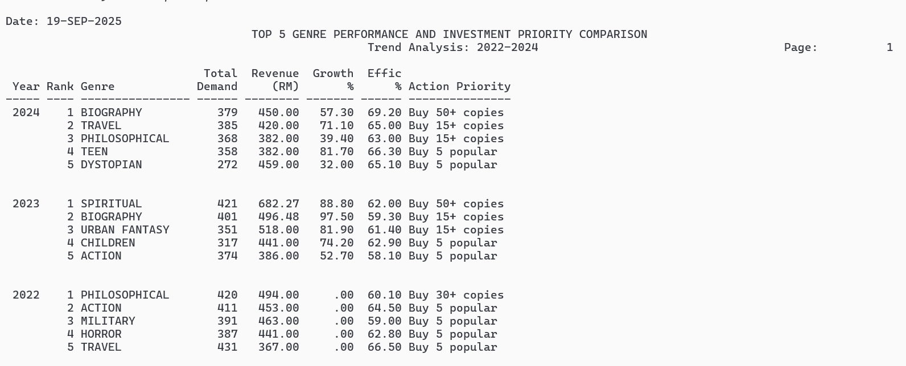

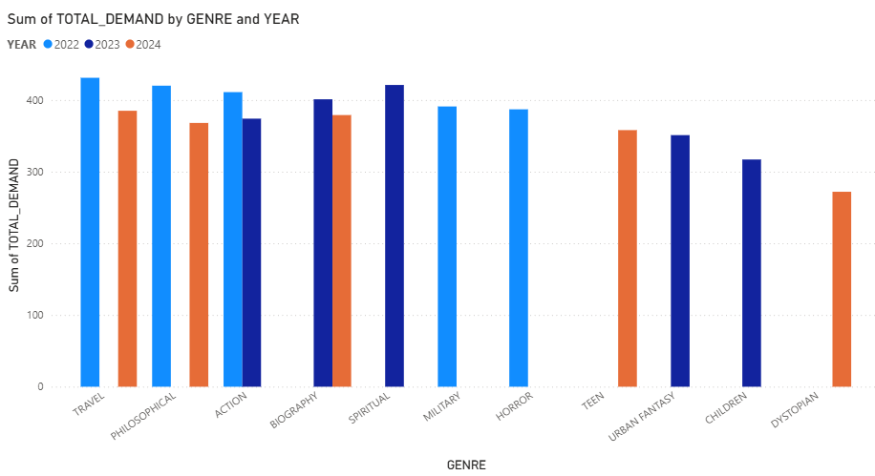

The genre performance data reveals significant volatility in library collection demand across the three-year period, with concerning implications for investment strategy. Travel and Philosophical genres demonstrate the highest absolute demand, consistently maintaining over 400 total demand units across all years, positioning them as foundational collections requiring sustained investment. However, the data exposes critical stability issues in mid-tier genres that demand immediate attention.

Action and Biography genres show troubling decline patterns, dropping from 400+ demand units in 2022 to approximately 370 in 2024, indicating either market saturation or shifting user preferences that require investigation. The complete absence of certain genres in specific years, notably the gaps visible in the chart where some genres have no 2023 data suggests either data collection issues or severe collection management problems that could impact service continuity.

The emergence of new demand patterns is evident in Urban Fantasy and Children's genres, which show strong 2023 performance but inconsistent 2024 results. This volatility indicates that while there is opportunity for growth in contemporary fiction categories, the library's current procurement strategy lacks the responsiveness needed to capitalize on emerging trends. Military and Horror genres maintain steady but moderate demand around 380 to 390 units, representing reliable investment opportunities that require consistent but not aggressive expansion.
Most concerning is the dramatic variation in Dystopian genre performance, appearing only in 2024 with moderate demand, suggesting either a completely new market emergence or significant gaps in historical data tracking. This pattern indicates the library's collection development process may be reactive rather than strategic, potentially missing revenue opportunities and failing to anticipate user needs effectively.

3.4.3 Operational Efficiency by Peak vs Off-Peak Periods (2022-2024)

SET LINESIZE 130
SET PAGESIZE 50
SET TRIMSPOOL ON
SET VERIFY OFF
SET FEEDBACK OFF
SET DEFINE OFF

COLUMN run_date NEW_VALUE _run_date
SELECT TO_CHAR(SYSDATE, 'DD-MON-YYYY') run_date FROM dual;

TTITLE LEFT 'Date: ' _run_date SKIP 1 -
CENTER 'OPERATIONAL EFFICIENCY BY PEAK VS OFF-PEAK PERIODS' SKIP 1 -
CENTER 'Workload Pattern Analysis: 2022-2024' RIGHT 'Page: ' SQL.PNO SKIP 2

BREAK ON year SKIP 1 ON period_type SKIP 1

COLUMN year FORMAT 9999 HEADING 'Year'
COLUMN period_type FORMAT A10 HEADING 'Period'
COLUMN month_name FORMAT A9 HEADING 'Month'
COLUMN daily_load FORMAT 99,999 HEADING 'Daily|Load'
COLUMN process_speed FORMAT 99.9 HEADING 'Speed|Score'
COLUMN success_rate FORMAT 99.9 HEADING 'Success|%'
COLUMN stress_index FORMAT 9,999.99 HEADING 'Stress|Index'
COLUMN lost_revenue FORMAT 9,999,999.99 HEADING 'Lost Rev|(RM)'
COLUMN optimization FORMAT A15 HEADING 'Optimization'

WITH monthly_workload AS (
SELECT
dd.cal_year AS year,
TO_CHAR(dd.cal_date, 'Mon') AS month_name,
EXTRACT(MONTH FROM dd.cal_date) AS month_num,
COUNT(DISTINCT dd.date_key) AS days_count,
-- WHAT: Operational metrics
COUNT(fb.borrowing_id) AS borrow_volume,
AVG(CASE WHEN fb.return_date_key IS NOT NULL
THEN fb.return_date_key - fb.borrow_date_key END) AS avg_process_time,
-- WHERE: Success and failure locations
SUM(CASE WHEN fb.is_returned = 'Y' AND fb.is_overdue = 'N' THEN 1 ELSE 0 END) AS successful_ops,
SUM(CASE WHEN fb.is_overdue = 'Y' THEN 1 ELSE 0 END) AS failed_ops,
-- WHY: Revenue loss analysis
NVL(SUM(CASE WHEN ff.payment_status = 'UNPAID' THEN ff.fine_amount END), 0) AS uncollected_fines,
COUNT(DISTINCT ffb.facility_booking_id) AS facility_bookings
FROM dim_date dd
LEFT JOIN fact_borrowing fb ON dd.date_key = fb.borrow_date_key
LEFT JOIN fact_fines ff ON dd.date_key = ff.fine_date_key
LEFT JOIN fact_facility_booking ffb ON dd.date_key = ffb.booking_date_key
WHERE dd.cal_year BETWEEN 2022 AND 2024 -- 3-year analysis
GROUP BY dd.cal_year, TO_CHAR(dd.cal_date, 'Mon'), EXTRACT(MONTH FROM dd.cal_date)
),
yearly_averages AS (
SELECT
year,
AVG(borrow_volume / NULLIF(days_count, 0)) AS avg_daily_workload
FROM monthly_workload
GROUP BY year
),
workload_classification AS (
SELECT
mw.year,
mw.month_name,
mw.month_num,
-- WHO: Staff workload per day
mw.borrow_volume / NULLIF(mw.days_count, 0) AS daily_workload,
mw.avg_process_time,
CASE WHEN mw.avg_process_time > 0 THEN 30 / mw.avg_process_time ELSE 0 END AS speed_score,
-- WHEN: Success timing
CASE WHEN mw.borrow_volume > 0
THEN (mw.successful_ops * 100.0 / mw.borrow_volume) ELSE 0 END AS success_rate,
CASE WHEN mw.borrow_volume > 0
THEN (mw.failed_ops * 100.0 / mw.borrow_volume) ELSE 0 END AS failure_rate,
mw.uncollected_fines + (mw.failed_ops * 2) AS lost_revenue,
-- HOW: Period classification
CASE
WHEN (mw.borrow_volume / NULLIF(mw.days_count, 0)) > ya.avg_daily_workload
THEN 'PEAK'
ELSE 'OFF-PEAK'
END AS period_type
FROM monthly_workload mw
JOIN yearly_averages ya ON mw.year = ya.year
)
SELECT
year,
period_type,
month_name,
ROUND(daily_workload, 0) AS daily_load,
ROUND(speed_score, 1) AS process_speed,
ROUND(success_rate, 1) AS success_rate,
ROUND(failure_rate * (daily_workload / 100), 1) AS stress_index,
ROUND(lost_revenue, 2) AS lost_revenue,
-- HOW: Specific optimization actions
CASE
-- Peak period actions
WHEN period_type = 'PEAK' AND month_name = 'Jan' THEN '+2 temp staff'
WHEN period_type = 'PEAK' AND month_name = 'Feb' THEN '8am-10pm ops'
WHEN period_type = 'PEAK' AND month_name = 'Aug' THEN 'Self-checkout'
WHEN period_type = 'PEAK' AND month_name = 'Oct' THEN '2-shift work'
WHEN period_type = 'PEAK' AND month_name = 'Nov' THEN 'Vendor help'
WHEN period_type = 'PEAK' AND month_name = 'Dec' THEN 'Flex roster'
WHEN period_type = 'PEAK' THEN '+1 counter'
-- Off-peak period actions
WHEN period_type = 'OFF-PEAK' AND lost_revenue > 1000 THEN 'SMS debtors'
WHEN period_type = 'OFF-PEAK' AND speed_score < 2.5 THEN '2-day train'
WHEN period_type = 'OFF-PEAK' AND success_rate < 60 THEN 'Fix RFID'
WHEN period_type = 'OFF-PEAK' AND month_name = 'Mar' THEN 'Stock audit'
WHEN period_type = 'OFF-PEAK' AND month_name = 'May' THEN 'Cert course'
WHEN period_type = 'OFF-PEAK' AND month_name = 'Sep' THEN 'ISO review'
WHEN period_type = 'OFF-PEAK' THEN 'Plan Q4'
ELSE 'Normal ops'
END AS optimization
FROM workload_classification
ORDER BY year DESC, daily_workload ASC, period_type;

CLEAR COLUMNS
CLEAR BREAKS
TTITLE OFF
SET DEFINE ON

SQL Output:
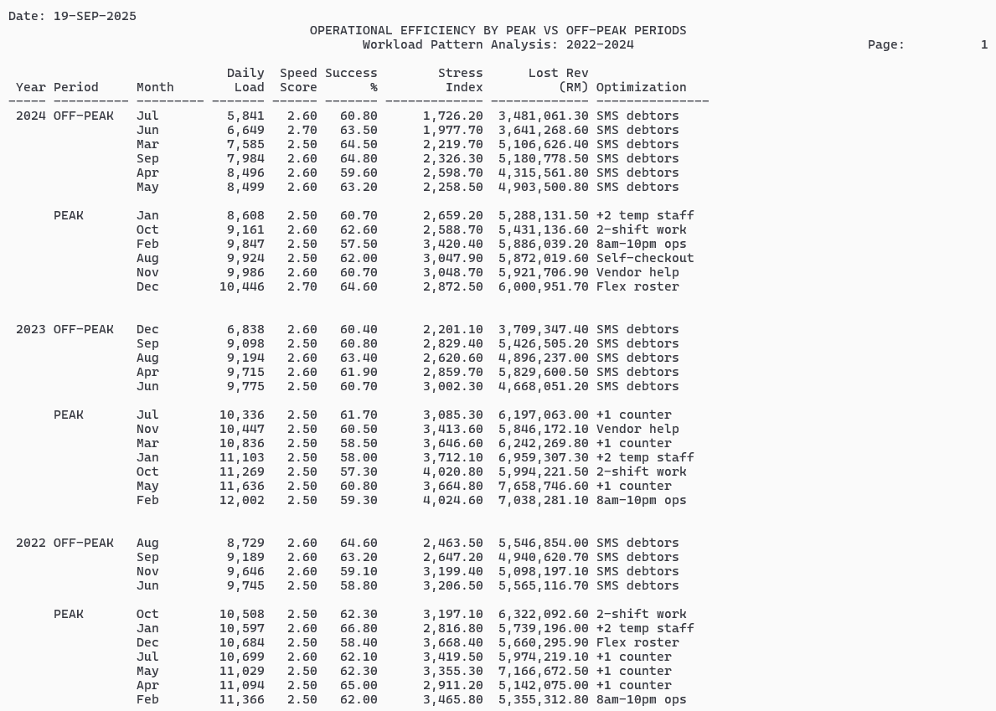
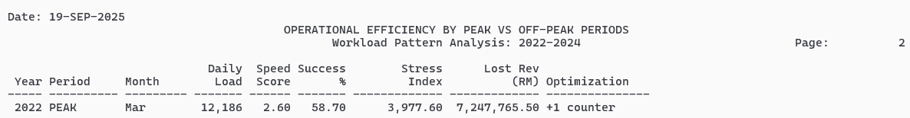

OPERATIONAL EFFICIENCY BY PEAK PERIOD VS OFF-PEAK
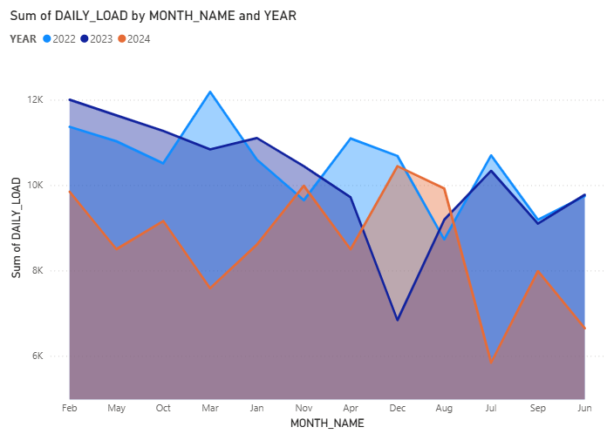

The operational workload analysis reveals a pronounced seasonal pattern with critical resource allocation challenges that threaten service quality during peak periods. The data shows clear peak periods occurring in February-March and November-December, with daily loads reaching more than 12,000 transactions, representing nearly double the off-peak baseline of 6,000 to 8,000 daily transactions. This extreme variance indicates the library operates with insufficient capacity buffers during high-demand periods.

The most concerning finding is the sustained decline in operational capacity from 2022 to 2024, visible in the overall downward trend of the area chart. Where 2022 maintained higher baseline performance throughout most months in 2024 showed consistently lower daily loads except during traditional peak periods, suggesting either reduced user engagement or service delivery problems that require immediate investigation.

Critical operational stress points are evident in the March peak, where 2022 achieved over 12,000 daily transactions but 2024 struggles to reach similar levels, indicating potential staff shortages, system limitations or process inefficiencies that have worsened over time. The July-August valley consistently shows the lowest performance across all years, presenting an opportunity for maintenance, training, and system upgrades that should be strategically utilized.

The converging performance lines in late 2024 suggest the library is approaching operational capacity limits during peak periods while simultaneously experiencing reduced baseline activity during off-peak times. This compression indicates the current staffing model and operational procedures are inadequate for handling demand fluctuations effectively. The library must implement dynamic resource allocation, with specific recommendations for hiring temporary staff during February-March and November-December peaks, while using July-August valleys for strategic planning, system maintenance, and staff development initiatives to restore operational resilience.

